Class.Net – Help Document

Agent’s commission not showing on the Commission report.

This document explains why a commission relating to
a student’s booking could be missing from either the agent commission report or from an agent’s record within the commissions tab.

Agent record / Commissions tab:

The commission will only be displayed once the final invoice has been produced.
If only the proforma has been produced the commission will not appear.
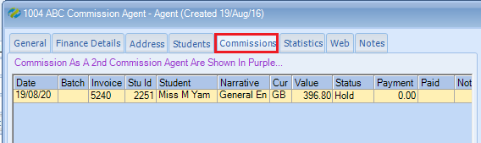

You can check to see if the final invoice has been produced within the student’s enrolment. Go to the finance screen and check:

- That the finance line is greyed out as this indicates that the final invoice has been produced.
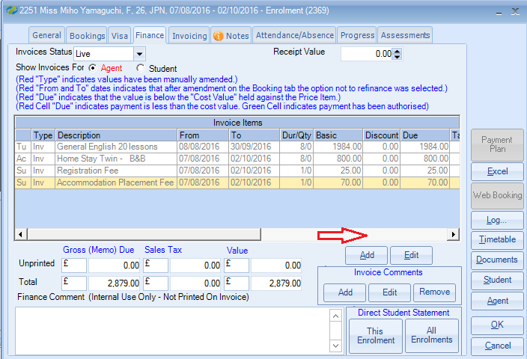

- Scroll across the screen to ensure the commission value has actually been calculated.
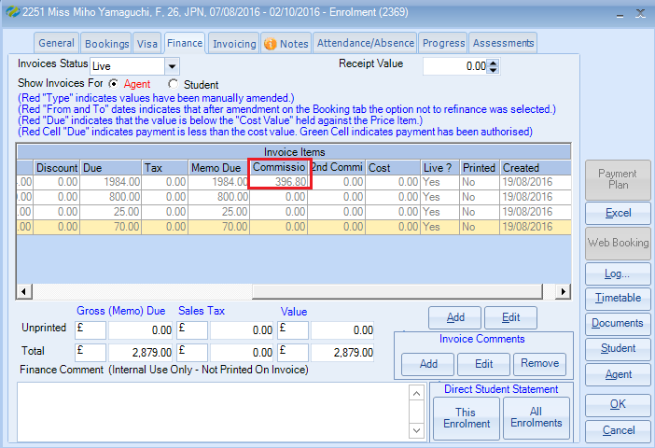

If the finance is not greyed out you will need to go to the Invoicing screen and print the invoice, or alternatively advise your accounts department so they can arrange for the invoice to be processed.

If the final invoice has been produced but the commission value is not showing on the invoicing screen you will need to check the agent’s record to ensure the agent is set as a Gross Agent.

Within the agents record go to the Finance Details / General.
Gross Agent (Reserve Commission) – ensure this option is selected.

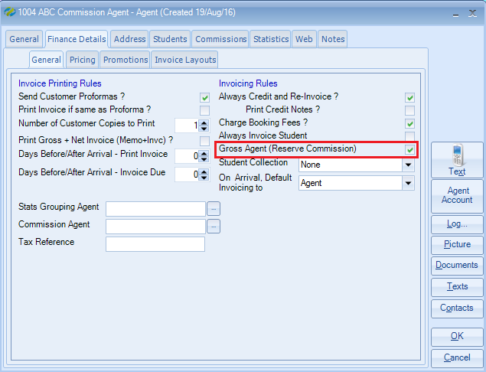

If the commission is still not showing please contact support@infospeed.co.uk for further assistance.

