Class.Net – Help Document

Quick Reports - Host Family Mailing Labels

How to produce labels for Host Families?

This can be achieved by using the Quick Reports.

The example below explains how to produce mailing labels for all active families.
It also shows how the criteria can be used to give a further breakdown!!!!

From the main menu select: Reporting / Quick Reports
Alternatively, use the shortcut picture

Report Type – select ‘Accomm’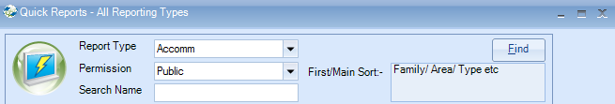

Click ADD to create a new report.

Report owned by – this will show your Class login and is linked to the Permission.
Permission:
- Public – other users can amend the criteria and run this report.
- Public Read Only – other users can run this report but not amend the criteria.
- Private – only the ‘owner’ can amend and run the report.

Name: Give your report a name
Code: a suggestion is to enter your initials

Date Filter – this is not applicable for ‘Accomm’ type reports.

Now you can add the required fields to the report

Select Add Item

Open Accommodation / Accommodation
Highlight the fields to be included in the labels….

Example:
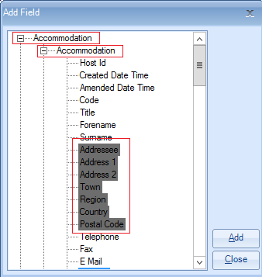

Select ADD to place the fields in to the report.
Select Close

The report must contain at least one sort field
Select Add Sort -

Open Accommodation / Accommodation
Highlight ‘Surname’
Select Add
Select Close

Example:

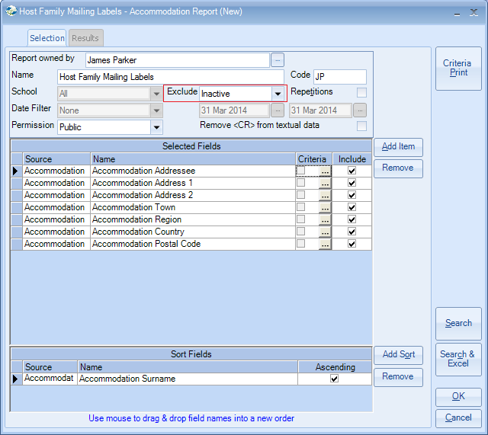

Exclude: ‘Inactive’
Within an accommodation record there are up to four available status options:
Active, Prospective, Inactive, Suspended
(nb if you have no accommodation with a particular status they will not appear in the list)

If your report is set to ‘exclude inactive’ it will include only accommodation that is active, prospective and suspended.
Therefore, if you wish to send labels to only ‘active’ accommodation and/or ‘prospective’ accommodation you must add a further field with criteria to your report.

Select Add Item

Open ‘Accommodation / Accommodation Status’
Highlight ‘Name’

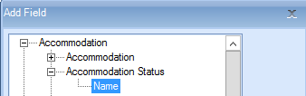

Select ADD to place the field in to the report.
Close

Untick the Include box so that the status does not print on to the labels

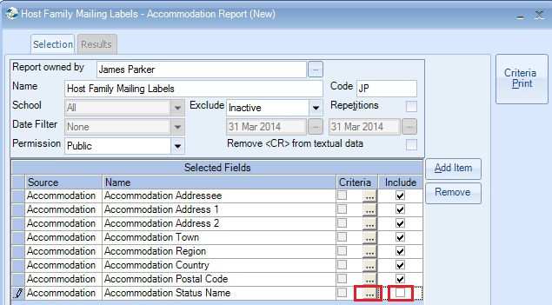

To add the criteria, select the box with three dots.

Criteria:

For Active only accommodation, highlight Active
Select Set
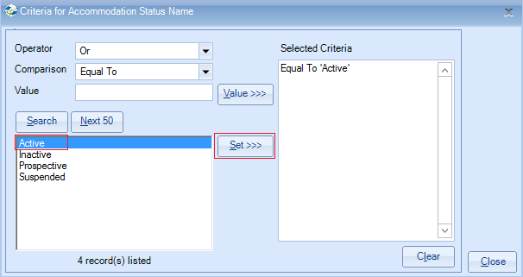
Close

Alternatively for both Active and Prospective accommodation, highlight both items
Select Set
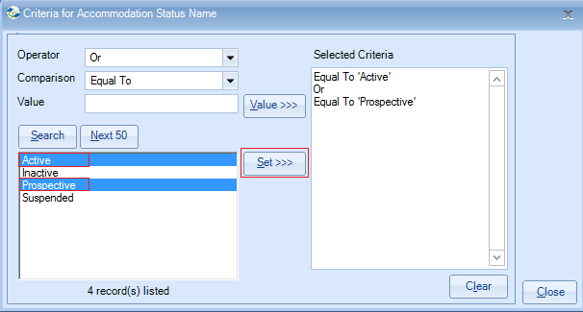
Close

Within the accommodation database each item is set up with the type of accommodation.
For example this is often set to: Host Family, Residence, Hotel.
You may wish to produce labels for Host Families only and therefore you will need to add the specific field and criteria as follows:

To do this select Add Item

Select Accommodation / Accommodation Type – Name
Add
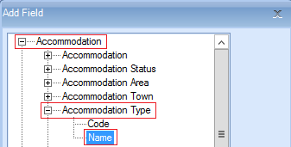

Untick the ‘include’ box

Add criteria to include the required accommodation type.

Select Host Family
Select SET
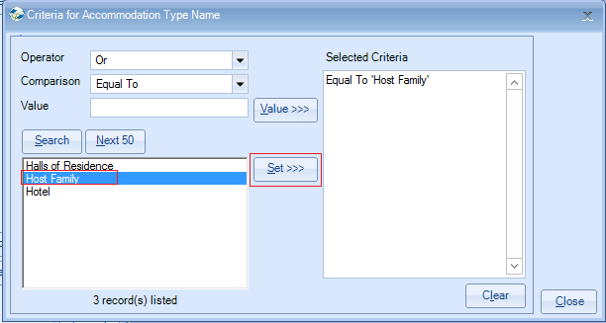

Once happy with your selection select Search.

This will display the list of host families that match your selection criteria.
The number of records found is listed at the top of the screen.

Select Send As Labels
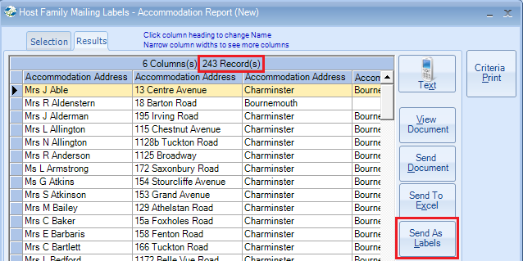

Label Format Choose your required label size from the list given.

If your label size is not listed, select User Defined and type the code in the Label Code field.

New Line After - untick any items that you wish to appear on the same line as the next field.
e.g. untick Accommodation Address1 if you want Accommodation Address 2 to appear on the same line.

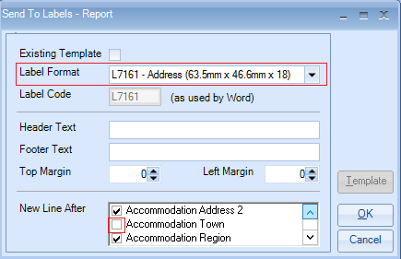
Select OK
Please read the following message which explains about using <Alt><Tab> if the screen appears to freeze.
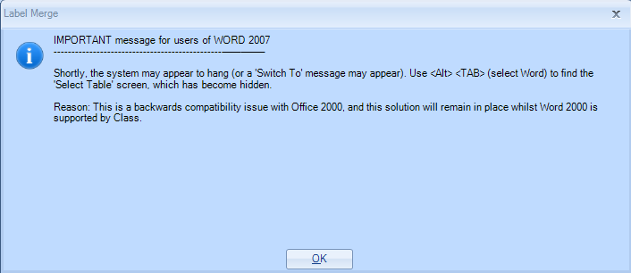
Select OK.

(This is the message that can be hidden and <Alt><Tab> is required to display it)

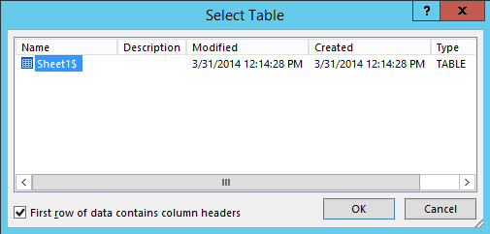
Select OK

This will go through a process of creating an Excel Spreadsheet listing the selected records and then create a Word label document with the merged names and addresses ready for printing.

Example merged labels
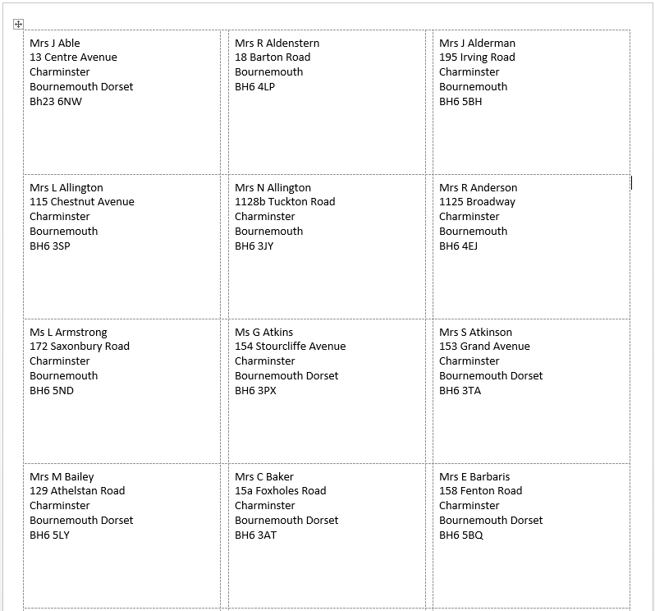

This document can be saved for future use.

Alternatively close both the Word document and Excel sheet.

TIPS:
Within an ‘Accomm’ quick report you can also use the criteria to be selective by a number of other fields. Some examples are:
Town, Area, Grade, School, Preferences, Analysis Fields.

