Class.Net – Help Document

Statistics - Forward Sales (Also known as Deferred Income)
This document explains how to produce the correct report in relation to forward sales.

General:

Values from invoices/credits are normally credited to the Management Accounts in the month they are produced, meaning an invoice dated 31/Jan/2019 for £12,000 for a course from 07/Jan/2019 to 31/Dec/2019 will initially show as £12,000 income in January 2019.

This clearly overstates the income in January, because this income has not yet been earnt, as the student has only been in the school for one month, and in order to more accurately reflect the true sales for the month it would be necessary to reduce the income by 11 months. This is achieved by running an Invoicing Statistics report to calculate the amount of forward sales.

In this example the student is here from 31/12/2018 to 27/12/2019 with a total value of £12000.Over the 12 month stay it works out at £1000 per month for the course.

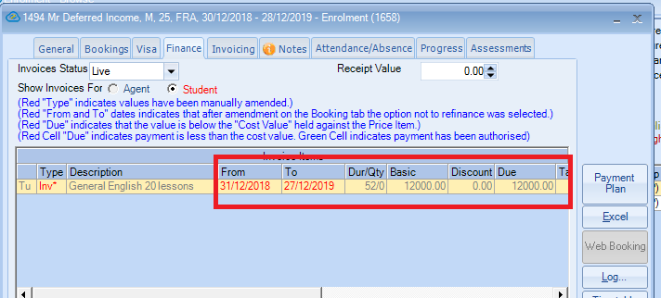

At the end of each month when running the report for the accounting months, the forward sales for this student will decrease until they finish the course.

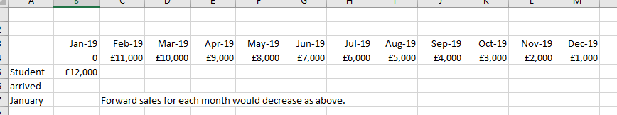

January accounts forward sales show in February as £11000.00, February accounts forward sales show in March as £10000.00, March accounts forward sales show in April as £9000.00 and so on.

Before running the statistics report ensure all proformas for arrivals up to the period end date have been converted to final invoices.

This is done by running the Batch Invoice process – Accounting/Ledger > Invoicing - Batch Print and dating the invoices for the month that you are running the accounts for. See help sheet SQL182 for further information on batch printing.

For the purpose of this example:

The accounts are being prepared from 01/Jan/2019 to 31/01/2019 and the forward sales is from 01/Feb2019.

To create the report go to:
Reporting / Reporting Module
Select: Invoicing Statistics

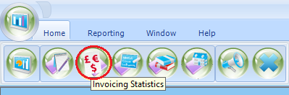

ADD a new report

Set all the fields similar to the example below:

General screen (For January 2019 Accounts)

Basis – Date Spread (will spread values over the duration of the students stay)
From Date – 01 Feb 2019 forward sales start date.
Period Type – Years - For this report we suggest you always use Years
Periods – as required (in this example 3 years)
Include Cancelled – tick this option, this allows for cancellation fees to be included, if charged.

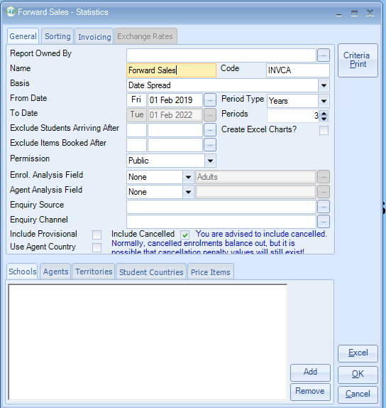
Sorting screen

Add the required field(s)
The most popular fields are:
- Invoice Line Category.
- Price item Name (Course name, homestay/residence, etc)
- Price Item Account (Account/Nominal Code)
Depending on your requirements, Cost Centres and Departments can also be included.
(At year end Student ID/Name or Invoice number may be added to provide a much more detailed report for audit purposes).

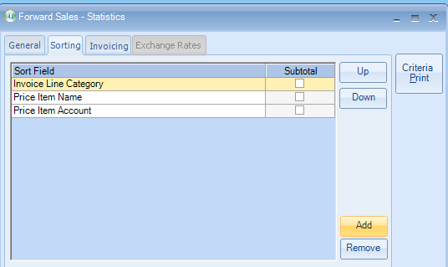

If required tick box for Sub Total on Price Item Account to get a sub total of all nominal codes.

Invoicing screen

Include Invoices: Invoiced
Proformas should not be included, although if invoicing had not be run for “weeks” a separate run for Proformas would provide figures for “Sales not yet invoiced’.

Invoiced From: 01 Aug 2009 - Invoiced To: 31 Jan 2019
Leave the start date unchanged but set the end date to the period end date.
This will ensure invoices/credits raised after 31 Jan 2019 are not included in the calculation.

Category: Each category (Tuition/Accomm/Transfers/Sundry) can be run separately,
As we have included Invoice Line Category in ‘Sorting’ option one report will suffice for All.

Packages: Include

Include Type: All

Values Used: Agent Net (Gross - Discount), this is the most popular selection.
This is the value to be used for the forward sales figures.

If the Gross figure is also required the ‘Gross’ box could also be used.
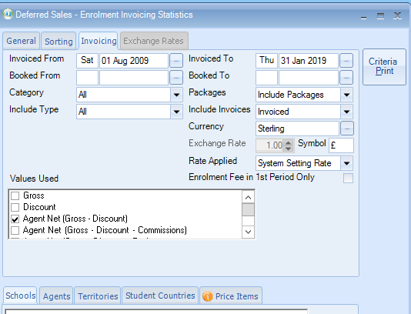

Further sort options are available:

Highlight the tab and select Add to choose further filters.

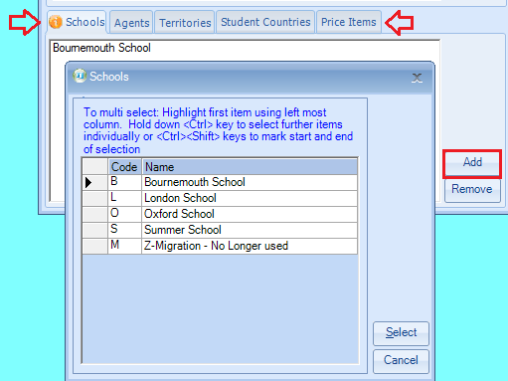

Send report to Excel to see the report results.

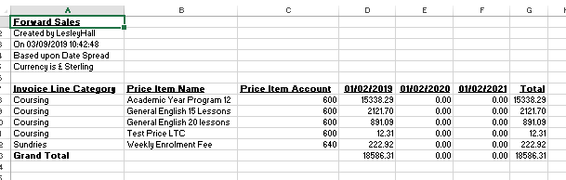

Anything appearing from 1/02/2019 is your forward sales.

In this example the figures for your accounts would be in column G.
This is the figure your accountant would use for your accounts.

‘Accounting information, when running the report for the next period (February 2019) the above figure would be reversed in the accounts and the new figure (from 1st March) would be entered.’

