Class.Net – Help Document

Class - Workstation Installation

This document gives instructions for upgrading Class on a workstation and also installing Class for the first time on a new workstation. It also explains what is required when a workstation is running Class via a terminal Server.

Table of Contents
What should have been supplied to me prior to an install? 1
Standard Client Installation 1
First-time install (ini file) / Server Migrations 4
Installing on a Terminal Server? 6

What should have been supplied to me prior to an install?
- This installation document
- A path to your Installation File (Setup.msi)
- The path of your server.ini (if a new installation or server migration)

Standard Client Installation

Are you planning to install Class.net on a Terminal Server?
If so, please refer to ALL sections of this document before attempting to install or upgrade your software.

Installation for Class.net is extremely simple. Run the installation located on your CFWSQL share of your Class Server – The Engineering department at Infospeed will provide details for you.

Simply run the installation file (setup.msi). If you already have an older version of the software installed it will prompt you to uninstall the old version before the new version is installed. This can all be carried out by the installation program.

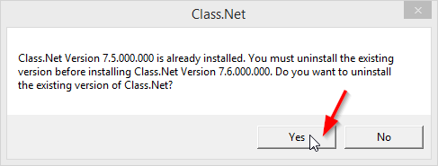
Click ‘Yes’ to begin the installation

The old version of Class.net will be removed from the system (if it already existed). You will then be greeted with the Class.net Installation

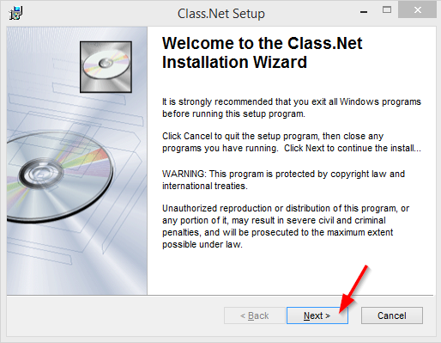
Click ‘Next’ to take you to the next install screen within the Class.net installation.

Review the destination folder. We would strongly suggest that you keep this to the default values but can be changed if required.

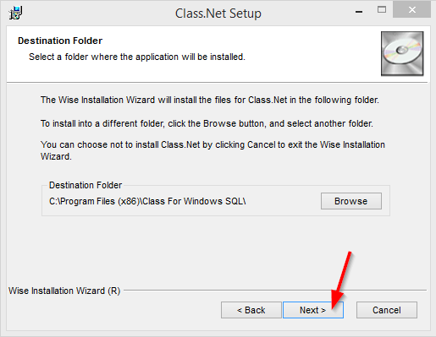
Click ‘Next’ to Install Class.net.

The installation will now start. It will notify you when the software has been installed.
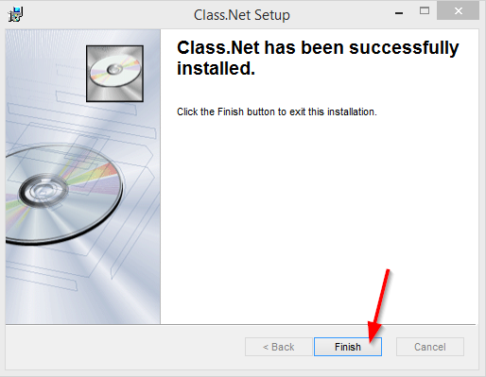
Class.net has now been installed.
Click ‘Finish’

A new Icon should also appear on your desktop:

You can now load (and log in to Class)

First-time install (ini file) / Server Migrations

If this is the first time that Class.net has been installed on this PC (or you have migrated your Class SQL Server then this section must also be completed.

Once the installation has been completed you will then need to copy the server.ini file from its master location (the Engineering department at Infospeed will make you aware of this) to your local installation directory.

Example:
Copy \\class-server\cfwsql\server.ini to c:\program files (x86)\Class For Windows SQL

Go into your mapped drive (or Server Share) that contains your CFWSQL Data.
This is typically X:\
(or included in the same email as this documentation if sent from Infospeed)

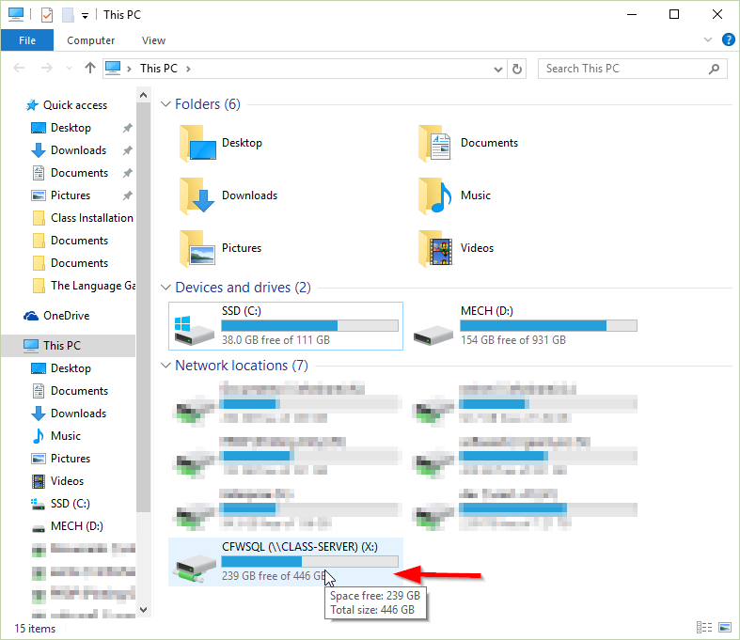

Right click on the server.ini located within the share and then select copy

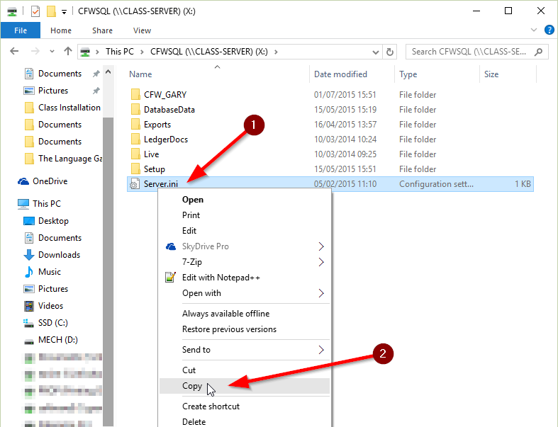

Next go into your c:\program files (x86)\Class for Windows Directory
Paste the file into this location, overwriting the file if it currently exists.

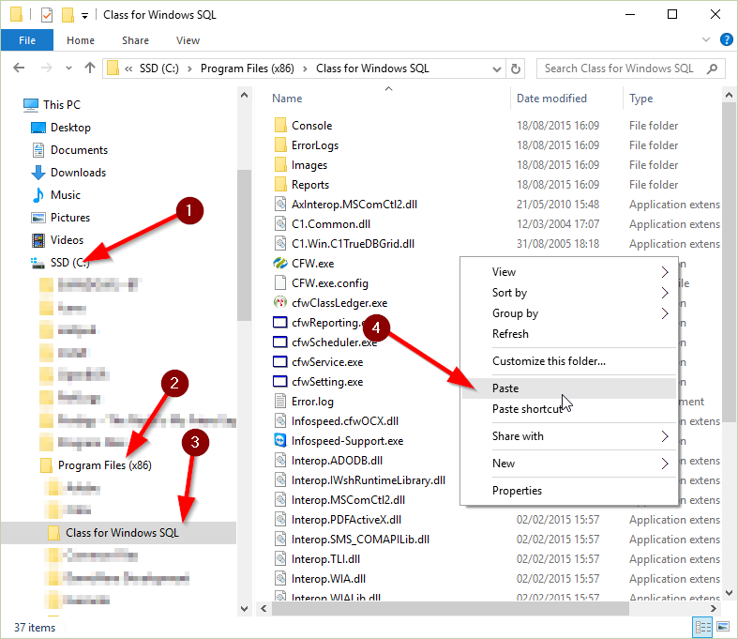

You are now ready to use the Class.net application.

Installing on a Terminal Server?

Please bear in mind that performing installations on a terminal server may have an impact to other users of the server.
The process for a Terminal Server installation would be as follows:

- Ensure all users of the application are not running the software during the install / upgrade process
- Run Change user /Install from an elevated command prompt
- Perform Standard Client Installation
- Run Change user /Execute from an elevated command prompt

If you are unsure of this, please contact Infospeed’s engineering department before attempting an install or upgrade.

