Class.Net – Help Document

Quick Reports - Agent Mailing Labels

How to produce labels for agents?

This can be achieved by using the Quick Reports.

The example below explains how to produce mailing labels for all active agents.
It also shows how the criteria can be used to give a further breakdown!!!!

From the main menu select: Reporting / Quick Reports
Alternatively, use the shortcut picture

Report Type – select ‘Agent’
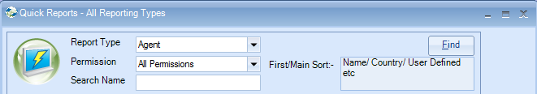

Click ADD to create a new report.

Report owned by – this will show your Class login and is linked to the Permission.
Permission:
- Public – other users can amend the criteria and run this report.
- Public Read Only – other users can run this report but not amend the criteria.
- Private – only the ‘owner’ can amend and run the report.

Name: Give your report a name
Code: a suggestion is to enter your initials
Date Filter – this is not applicable for Agent type reports.

Now you can add the required fields to the report.

Select Add Item

Open ‘Agent’ / ‘Agent’
Highlight the fields to be included in the labels….

Example:
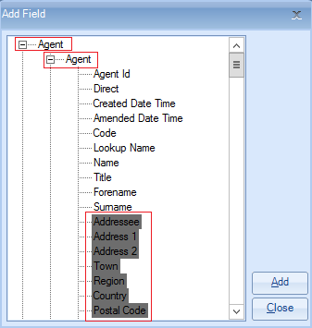

Select ADD to place the fields in to the report.
Select Close

The report must contain at least one sort field
Select Add Sort -

Open Agent / Agent
Highlight ‘Name’
Select Add

Select Close

Example:

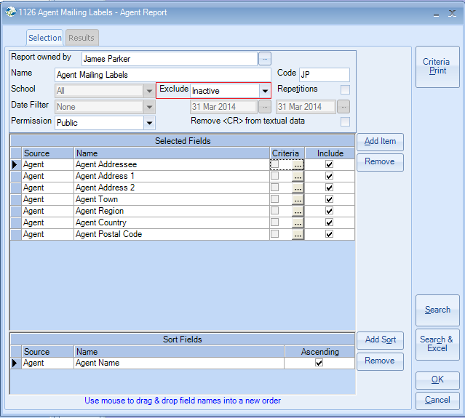

Exclude: ‘Inactive’
Within an agents record there are up to four available status options:
Active, Prospective, Inactive, Suspended
(nb if you have no agents with a particular status they will not appear in the list)

If your report is set to ‘exclude inactive’ it will only include agents that are active prospective and suspended. Therefore, if you wish to send labels to only ‘active’ agents and/or ‘prospective’ agents you must add a further field with criteria to your report as follows:

Select Add Item

Open ‘Agent’ / ‘Agent Status’
Highlight ‘Name’

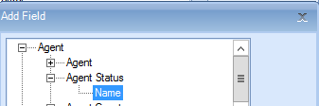

Select Add to place the field in to the report.
Select Close

Untick the Include box so that the status does not print on to the labels

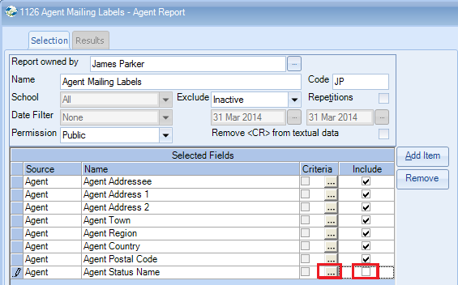

To add the criteria, select the box with three dots.

Criteria:

For Active only agents, highlight ‘Active’
Select Set
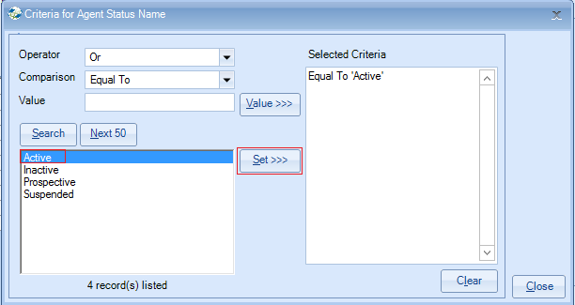
Select Close

Alternatively for both Active and Prospective agents, highlight both items
Select Set
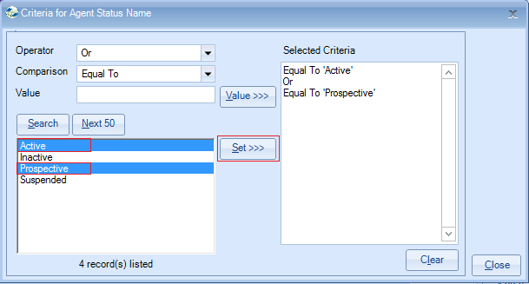
Select Close

You may wish to produce labels for agents from a specific country or countries.

To do this select Add Item.

Select ‘Agent’ / ‘Agent Country – Name’.
Select Add
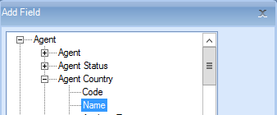

Untick the Include box.

Add criteria to include the country/countries required.

Select the required country/countries.
Select SET.
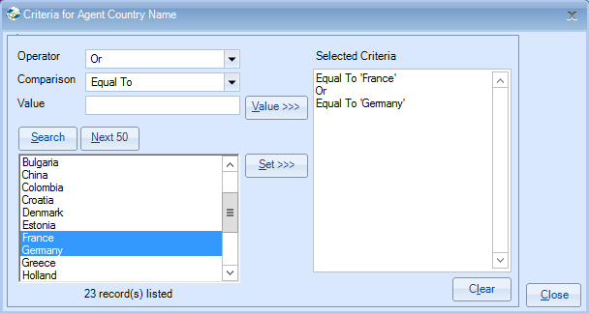
Close

Once happy with your selection select Search
This will display the list of agents that match your selection criteria.

The number of records found is listed at the top of the screen.

Select Send As Labels
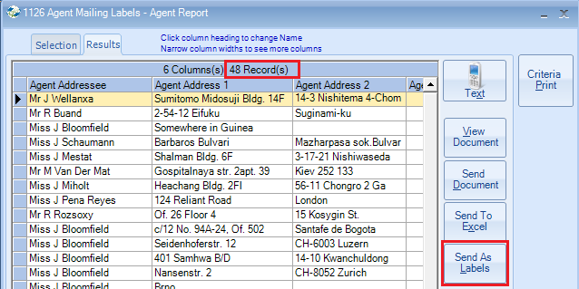

Label Format Choose your required label size from the list given.

If your label size is not listed, select User Defined and type the code in the Label Code field.

New Line After - untick any items that you wish to appear on the same line as the next field e.g. Untick Agent Address 1 if you want Agent Address 2 to appear next to it.
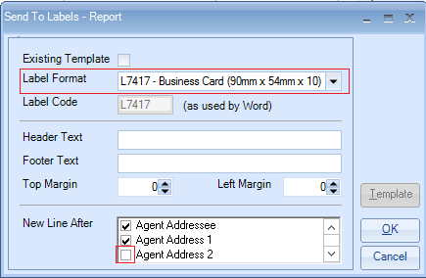
Select OK

Please read the following message which explains about using <Alt><Tab> if the screen appears to freeze.

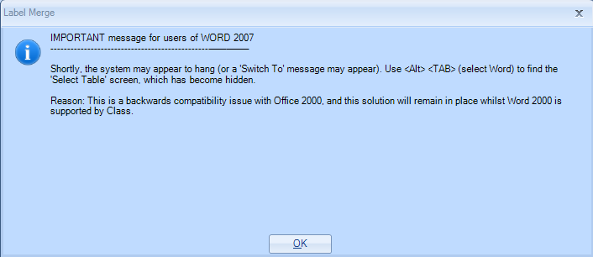
Select OK.

This is the screen that is hidden and <Alt><Tab> is required to display it.

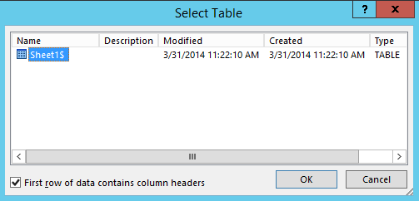
Select OK

This will go through a process of creating an Excel Spreadsheet listing the selected records and then create a Word label document with the merged names and addresses ready for printing.

Example merged labels
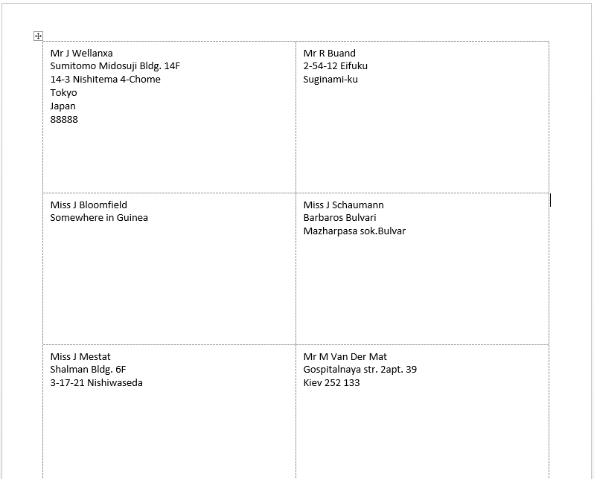

This document can be saved for future use.

Alternatively close both the Word document and Excel sheet.

TIPS:
Within an ‘Agent’ quick report you can also use the criteria to select by Analysis Fields.

