Class.Net – Help Document

User Login Password – Add/Change

How to set up users passwords or change the password if a user has forgotten theirs.

Users with Administrator privileges in Class no longer have to enter (and will not see) the ‘Old Password’ field when changing a user’s password.
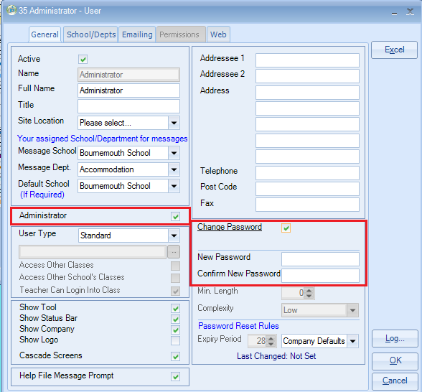

Non-administrator users will still have to supply the existing password before it can be changed.
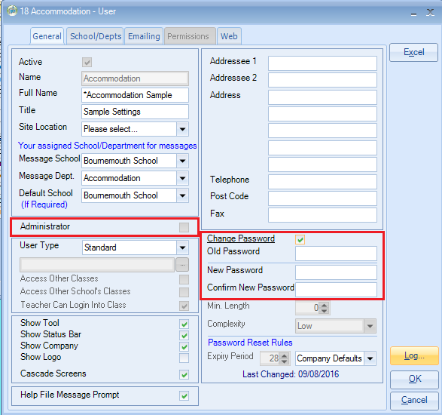
There are some rules that need to be applied to activate the password reset options.

Maintenance/Settings > General Settings
Company > Company
General > Password Defaults
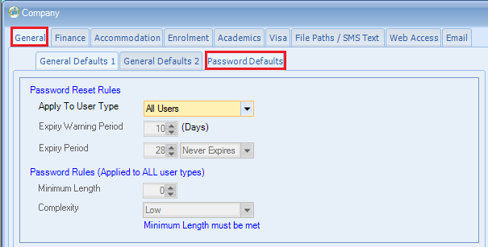
Password Reset Rules: This can be applied to the user types:
All Users, Standard Users or Teacher Users.

Expiry Warning Period: When users login, this will allow warning messages to be presented a certain number of days before the password is due to expire.

Expiry Period: This will allow you to set the duration for when passwords expire and require changing. There is also a “Never Expires” option which won’t force an expiry date.

Password Rules are applied to all user types.

Minimum Length: This will enable you to set the minimum number of characters a password must contain. Currently there is a maximum of 30 characters available so a min/max limit of 1-30 will be accepted.

Complexity Level: Three levels of complexity are available -
Low – The minimum password length is met
Medium – The minimum password length is met and the password must contain both Alpha and Numerical characters.
High – The minimum password length is met and the password must contain Alpha, Numerical and Symbol characters.

When switching on the password option for the first time there is a prompt to ask how you would like to initially set the last password changed date for all current users.

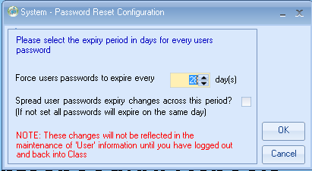

Force Users passwords to expire every … days: Enter the number of days, so 28 for example would force users to change their password in 28 days time.

Spread user password changes across this period:
Ticked/Unticked – Instead of all users being forced to change their passwords on the same day, if this option is ticked the system will spread the users password changes evenly across the period specified in the number of days specified above.

