Class.Net – Help Document

Documents – Homestay Confirmation Letters

This document explains how to produce host family confirmation letters as a batch.

Please refer to help document HS056 for producing host family confirmation letters for groups.

There are two stages to this process:
- Create a document template
- Create a quick report to find the hosts in order to merge the documents

- CREATE A MASTER DOCUMENT
Go to: Documents / Enrolment
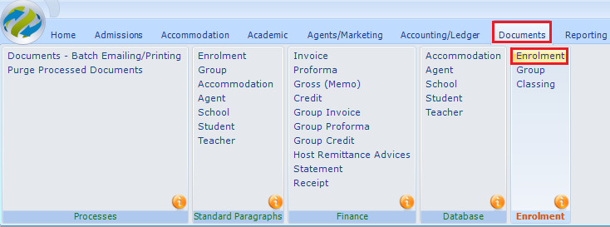

A list of your existing master documents will be displayed.
Select ADD to create a new document

Input the document details:
Send To – Accommodation (if sending the documents to the host family)
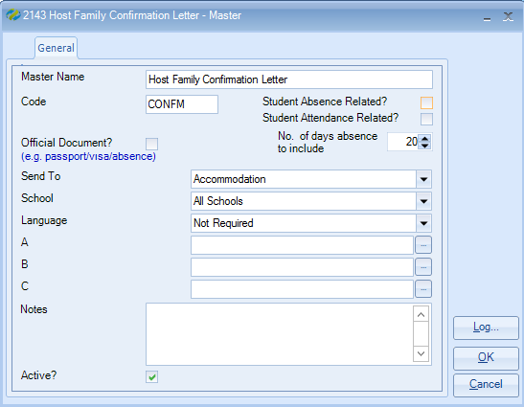

A new blank document will be displayed on screen together with a “Word Edit” box.
To add merge fields to the host family confirmation letter click to the left of the required category to open up the available fields.
To add the hosts name click to the left of ‘Accommodation Booking’ and double click to the left of ‘Accommodation-Booking-Host’
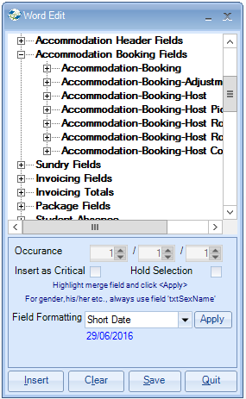

Click on the relevant field to insert the code into the document, e.g. txtForename, txtSurname.

Alternately, highlight the required field(s) and select ‘Insert’

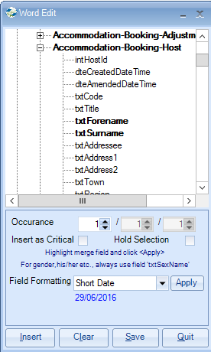

Add all the required text and merge fields to the document.
Below is an example of a master host family confirmation letter with all text and merge fields:
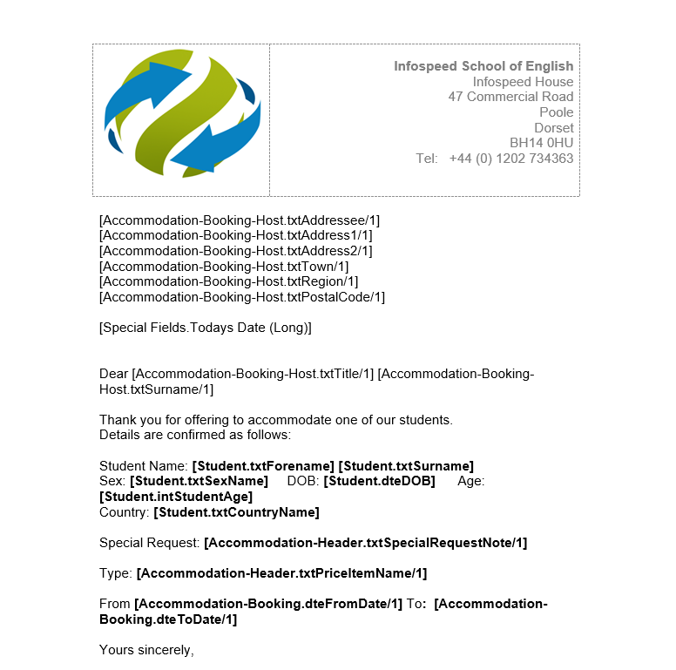
Once the text and merge fields have been added to the document it must be saved.
It is important to save the document by selecting “SAVE” within the “Word Edit” box.

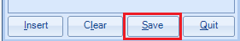

- CREATE A QUICK REPORT
Go to: Reporting / Quick Reports
Report Type = Accomm - Booking

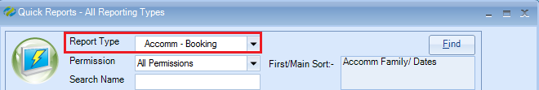

Select ADD to create a new report.

Name: Enter the report name
School: If you have multiple schools select the required school
Date Filter: set to “Starting” to capture the new accommodation arrivals
Dates: Ensure you include the Saturday & Sunday dates as students generally arrive at the weekend. It is a good rule to select Wednesday to Wednesday dates as this will capture mid-week arrivals.
Selected Fields: add the required fields. Ensure to include the field:
‘Accommodation - Booking E Host Booking Id’

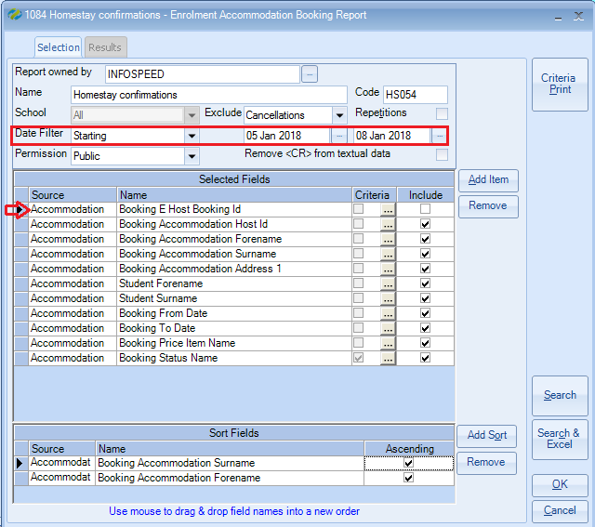

To add the fields to the report click on the “Add Item” button

Within the “Add Field” box click to the left of the required category to open up the available fields.

To add the host family name click to the left of ‘Accommodation’ and then click to the left of ‘Booking Accommodation’ and double click on the relevant fields to insert the code into the report, e.g. Host Id, Forename, Surname.

Alternately, highlight the required field(s) and select ‘Add’
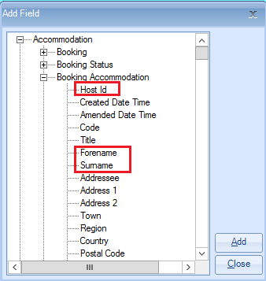
In order to find just the students who have been booked with a host family you will need to add the field ‘Accommodation – Booking Status Name’ to the report:
Within the report the field will look like this:

Add Criteria to this field by clicking on the criteria box as shown above:
Highlight “Booked” and “Changed”
Select “Set>>>”
Selected Criteria = Equal To ‘Booked’ Or ‘Equal To ‘Changed’
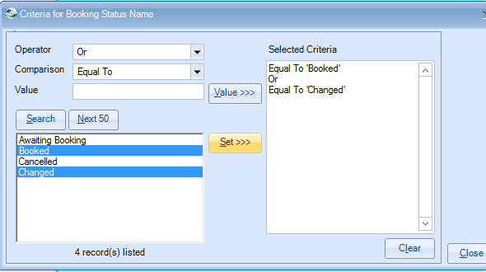
Select Close
At least one sort field must be added to the report:

When the report selection and criteria is completed select SEARCH.

This will display a list of hosts with students based on the date selection.

Merging the host family confirmation letters:

Select “Send Document“

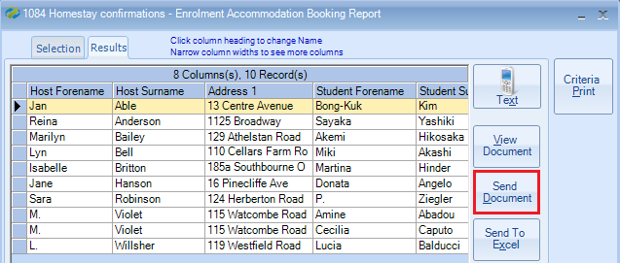

Master Document: select the master host family confirmation document
Send By: Default – this will look at the host families send method and if a host is set to email the document will be emailed and if a family is set to printer the document will be printed.
If you wish to print all documents change to printer.
Send To All: tick this to print the confirmation letters for all selected host families.
Send Now: the documents will be produced now

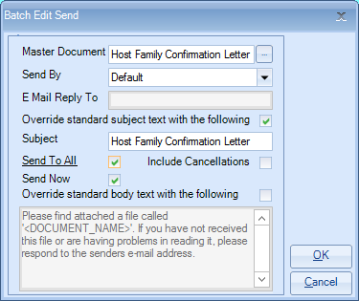

Select OK to email/print the host family confirmation letters as a batch.

Note: If the email option is chosen and a message is displayed similar to the one below showing an id number and Email Address is Required, please ensure you have included the field in your report: Accommodation – Booking E Host Booking Id
(see page 4 above)

