Class.Net – Help Document

Quick Report – Birthday List

How to produce a list of present students who celebrate a birthday whilst studying in the school.

This can be achieved by using the Quick Reports.

From the main menu select: Reporting / Quick Reports
Alternatively, use the shortcut picture

Report Type – select ‘Enrolment-General’

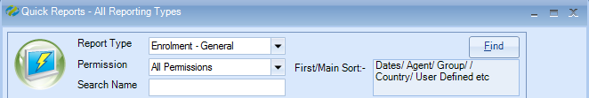

Click ADD to create a new report.

Report owned by – this will show your Class login and is linked to the Permission.
Permission:
- Public – other users can amend the criteria and run this report.
- Public Read Only – other users can run this report but not amend the criteria.
- Private – only the ‘owner’ can amend and run the report.

Name: Give your report a name
Code: a suggestion is to enter your initials

Date Filter = Present
Add the required date selection to pick up the present students

Now you can add the required fields to the report

Select Add Item

Open Enrolment
Scroll down
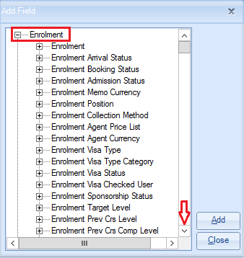

Open Student
Highlight Forename & Surname
Select ADD
Scroll down
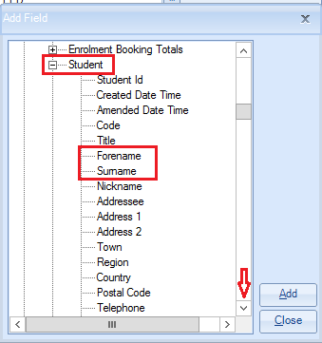

Add DOB
Scroll down
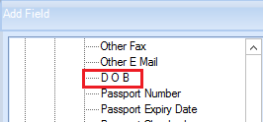
Add Age
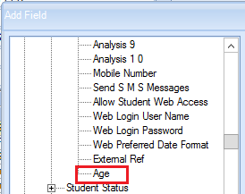

Add any other fields that you would like to appear in your report.

Once all the fields are added in the Add Field list select Close

The report must contain at least one sort field
Select Add Sort -
Open Enrolment / Student
Highlight Surname
Select Add
Highlight Forename
Select Add
Select Close
Example of report: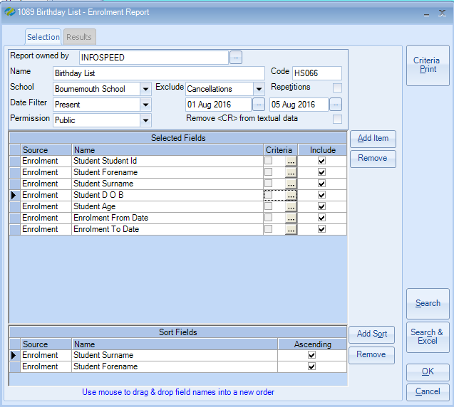

Criteria:

Criteria needs to be added to the DOB field in order to find students with a birthday.

To add the criteria select the box with three dots:

This can only be set per month using:

Comparison = Similar To
Value – type the first 3 characters of the month required, e.g. Aug
Select Value>>>

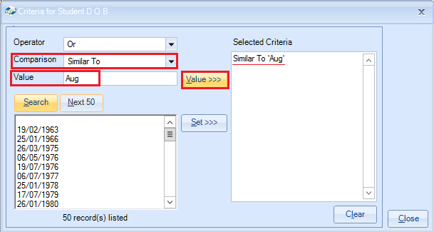
Select Close

Once happy with your selection select Search.

This will display a list of students that match your selection criteria.
The number of records found is listed at the top of the screen.
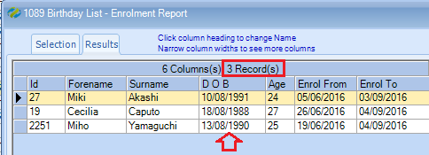

Select Search & Excel to produce the list in an Excel Spreadsheet.

