Class.Net – Help Document

HOST FAMILY MANUAL PAYMENTS

Why might you need to create a manual payment?
To write off a payment
For example: A family owes the school money, but the school is unable to collect the money for whatever reason. The value will be displayed in the ‘Outstanding Transactions’ section of the accommodation payment Run Results page.
If the value to be written off is a minus value, i.e. -£80, then when adding the Manual Payment to cancel out the payment you would input the value as £80 (+)
If the value to be written off is a plus value, i.e. £80, then when adding the Manual Payment you would input the value as -£80 (-)

To pay Compensation or Extra Payment
When adding a Manual Payment for compensation the value is always entered as a plus value, i.e. £80.

A payment was made to a family in advance of the payment run
If a payment has been made to a family in advance of the payment run and you do not want to pay the family this value again, add a manual payment for the same amount as a minus value, i.e. -£80.

How to add a manual payment to a host family.

Open the host record and click on the ‘Payments’ button
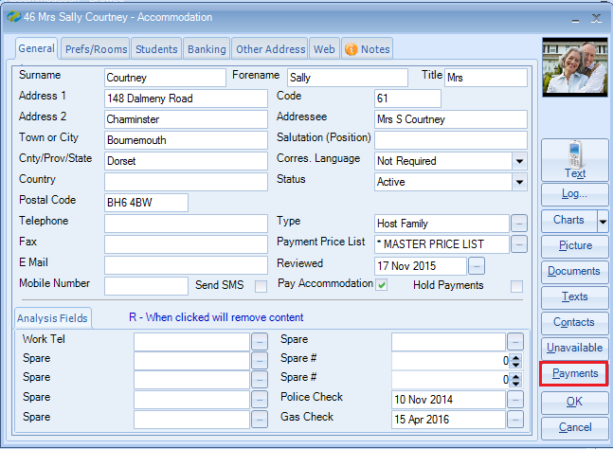
This will display the history of payments.
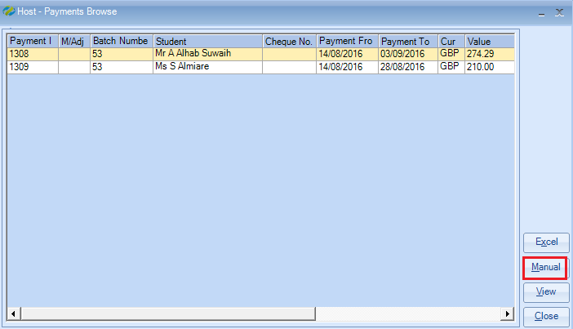
If the student that you wish to add the manual payment against is listed, highlight the student name and select ‘Manual’.
You will then be asked if you want to attribute this manual payment to ‘the selected student name’
Select YES if you wish to continue.
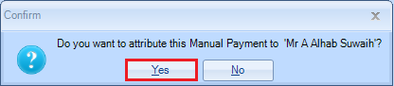
Note: If the student that you wish to add the manual payment against is not listed, select ‘Manual’ and then choose NO to the above message.
Enter the required fields:
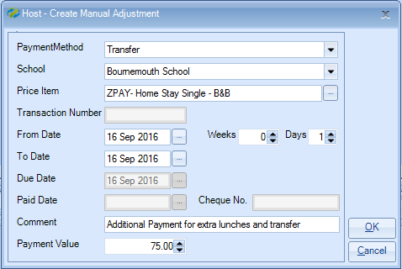
Payment Method – Cheque or Transfer
Price Item – Select the item you wish the manual payment to go against
(if the price item does not exist select any item)
From/To Date – enter the period that the adjustment relates to.
Comment – a short explanation about the manual payment.
Payment Value – enter value +/-

The manual payment will be included with the next Accommodation payment run.
The manual payment will not be displayed on the Provisional report, but will be included on the Manual Adjustments report, so ensure this report is printed.

