# 

# Class.Net – Help Document

**Warning Dates */* School Closures**

If a course start date falls on a national holiday/school closure, dates can be added to display a warning message to stop the user from selecting this date for the start of a course.

Warning dates can be added within:

Maintenance/Settings > General Settings > Company > Warning Dates

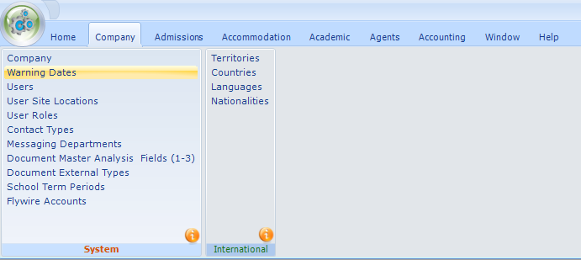

ADD the Date and Narrative of the national holiday(s)

Ensure to use “/” as the date separator

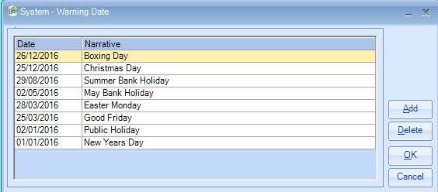

When adding an enrolment where the national holiday is the **course start date** the following warning will be displayed:

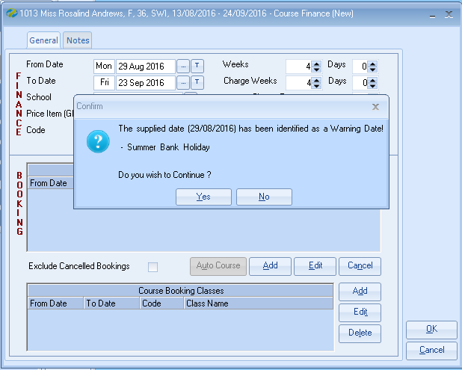

This is only a warning message and therefore the From Date will need to be amended manually.

Note:

This message will only be displayed if the warning date corresponds to the course start date.

If the warning date falls in the middle of the course, then no warning will be displayed.

*Also refer to Help Document: HS160 Maintenance_Settings - Valid Start Dates:  
Valid start dates can be set up to ensure courses are booked to start on the correct day or within the correct week.*