Class.Net – Help Document

Agent – Pricing Discounts & Commissions
This document explains how to set up the different discount and commission options within the agents pricing screen.

In the UK agents generally receive a discount or commission off the gross price of the tuition they book. Sundry items are occasionally discounted, for example the registration/booking fee.

There are three different price types for setting agent discounts & Commissions. These are set up directly within the agents record in Class.

General
This is the ‘default’ discount given to an agent for all course bookings.
For example an agent could receive 20% off the gross selling price for all tuition.

Group
This provides a method of grouping price items together.
For example a price group called ‘General English’ could consist of GE15, GE20 and GE25 lessons in order to apply a special rate of discount/commission.

Item
This provides a method of giving an additional discount/commission to a specific price item, i.e. one tuition item.
For example an agent general discount is 20%, but you wish to give a bigger discount for a specific course.
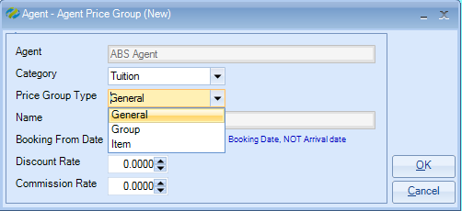

Setting up General prices
When a new agent is created the default discount and commission percentages are automatically set to 0% as shown in the example below:
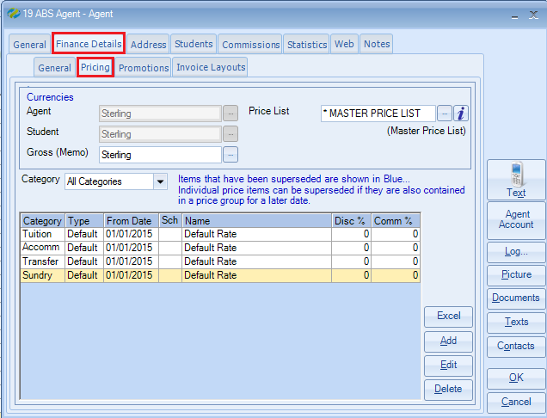

Your organisation may agree discount and commission rates with each individual agent.

Often an agent will have just one General discount/commission rate for tuition only.
To set this, double click on the Tuition Default line. Enter the date that the item is to begin and enter the percentage within both the discount and commission rates

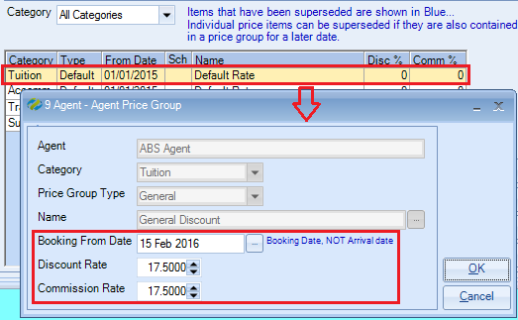

If at a later date the agents General rate changes, ADD a new default line.
Do not amend the existing line as this will remove the history and could give incorrect calculations on existing student bookings.

ADD a new line
Enter the new booking from date and percentage:

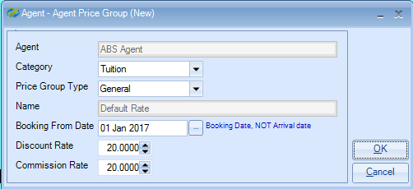

The ‘old’ default rate will change to blue and the new rate will be applied from the date provided:

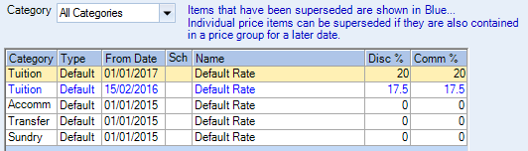

Setting up Group prices

Select ADD
Category: enter as required (default = Tuition)
Price Group Type: Group
Name: enter the name of the Group to receive a different percentage
Booking From Date: the date that the new disc/comm is to start
Discount Rate/Commission Rate: enter the agreed percentage

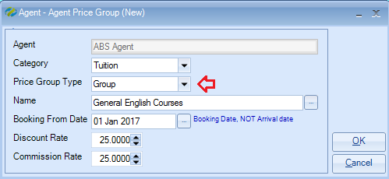

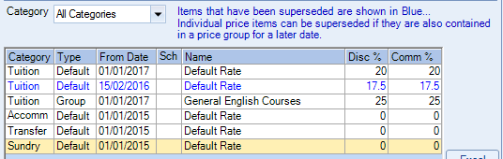

Please refer to help document HS094 to learn how to create the price groups.

Setting up Item prices

Select ADD
Category: enter as required (default = Tuition)
Price Group Type: Item
Name: enter the individual tuition price item to receive a different percentage
Booking From Date: the date that the new disc/comm is to start
Discount Rate/Commission Rate: enter the agreed percentage

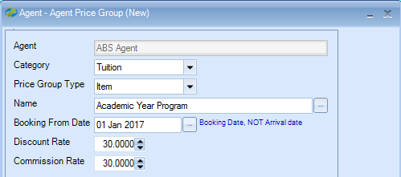

Alternatively, if a net value is required then click on the “Load Price” button.
This will display the week 1 price for the selected price item.
Input the net amount that you wish to charge the agent into the “Net Value” box and click on “Calc %” to update the discount and commission rates with the percentage.

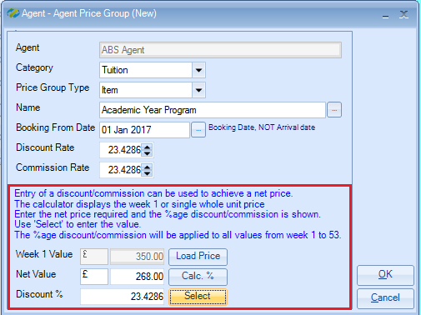

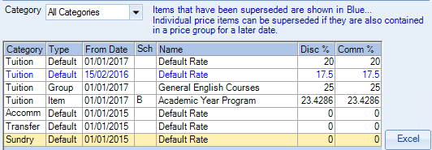

Generally sundry items do not apply for discount/commissions, however, an agreement can be made with an agent to give a discount off the registration/booking fee.

This could be half price - 50%
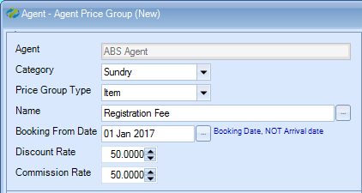

Or an agreement could be made so the agent does not pay for the registration/booking fee at all.

In this can you can set the item to have 100% discount/commission.
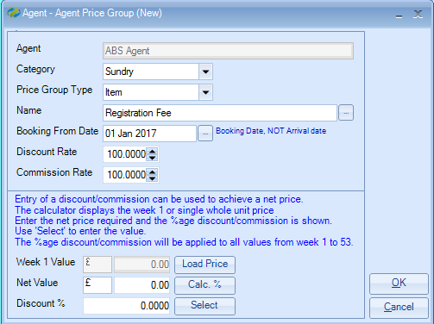

The option to enter a “Net Value” is always available when adding an “Item”.
The different discounts and commission rate set for the agent are shown in the screen below:

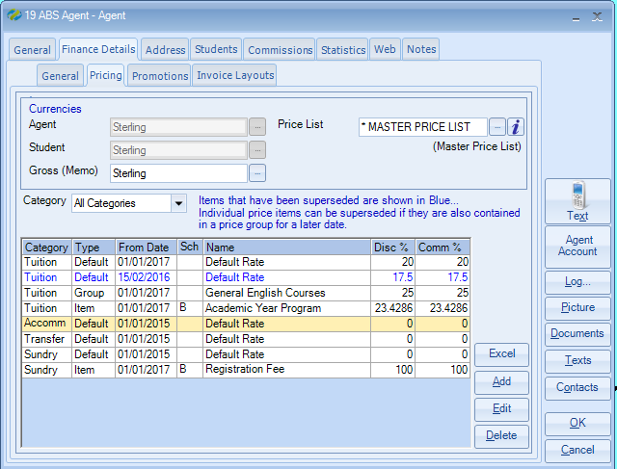

Remember: each time the rate changes ADD a new item to keep the history.
The superseded items will be displayed in blue.

Please refer to help document HS094 to learn how to create the price groups.

Please refer to help document HS009 to understand the difference between agent discount and agent commission, as far as Class is concerned.

