Class.Net – Help Document

Statistics – Discount & Commission Analysis
This report details the amount of Discount and/or
Commission given over a specific period.
To produce this information go to: Reporting / Reporting Module.
Reporting / Discount & Commission Analysis (Booking & Production)
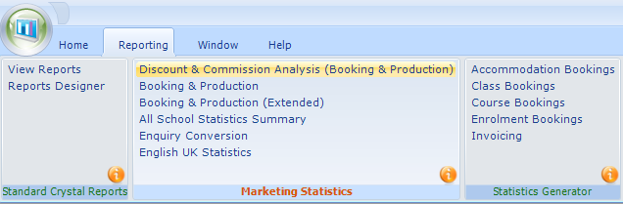
Complete the Selection Screen as required:
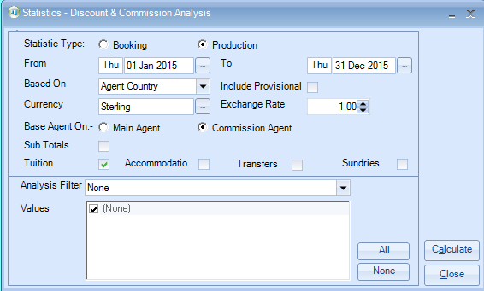

Booking Based - based on the date the booking item was entered into the system.
This refers to the course/accommodation/etc, and not the date that the student’s enrolment was entered in to Class.
Production Based - based on spreading the enrolment element (eg. Tuition) over the duration of the study/stay (dates attended).
From/To: Enter the required date range.
Based On: chooses are – agent country, Student country, Enrolment Analysis
Include Provisionals: select as required
Tuition/Accommodation/Transfer/Sundries: Choose the options as required.
Analysis Filter: If required you can report by a specific analysis field which is picked up from the Agent records.
Values: this is linked to the analysis filter and allows you to narrow your selection even further, if required.
Select Calculate to produce an Excel Spreadsheet.
The Discount and/or Commission figures are given in these columns
The example below based on Tuition only
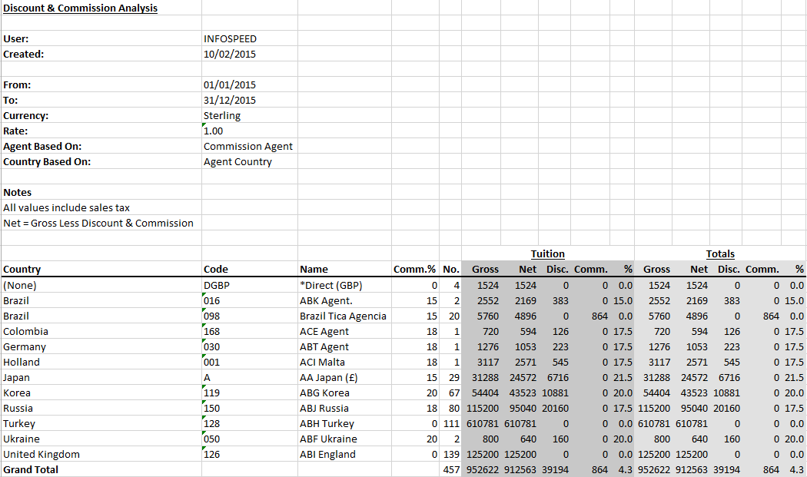

The results show a breakdown by each agent: Gross / Net / Discount / Commission, together with the percentage.
Net = Gross value minus Discount minus Commission.

Other Column headings:
Code: Agents code
‘No.’: number of students that make up the figures

