Class.Net – Help Document

Linked Price Items

What is a Linked Item?

When a price item is entered into an enrolment which also has a Linked Item, the Linked Item is automatically entered by the system at the same time.
This allows for example, an accommodation price item to automatically be linked to an accommodation placement fee.
The fee can be set to ‘once per enrolment’ or ‘every time’.
Example:
When a student books ‘Home Stay Twin - B&B’ accommodation they are also charged an Accommodation Placement Fee.
To set the accommodation placement fee as a linked item go to: Maintenance/Settings > Maintenance.
Select the school
Click on the ‘Accommodation’ tab.
Open the accommodation price item to have the Linked Item and click on the
‘Linked Items’ tab
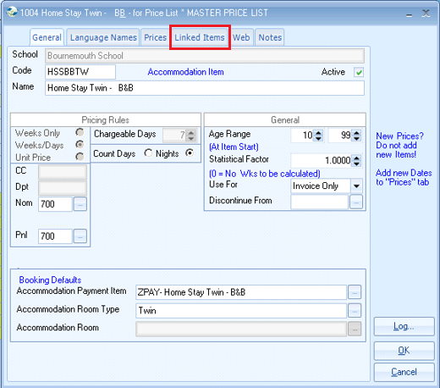
Select ADD
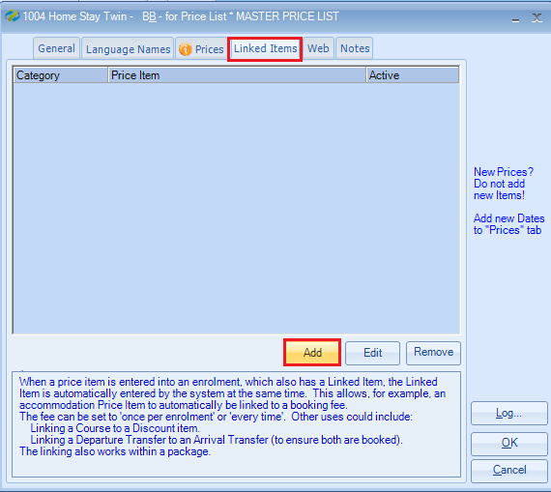

Category = Sundry
Linked Item = Accommodation Placement Fee
Automatically include sub price item…
Once Per Enrolment
Every Time
Select One Per Enrolment to charge the student once.
Automatically include this sub price item…
Booking Dates
Enrolment Dates
Select Booking Dates to charge the fee based on the accommodation dates.

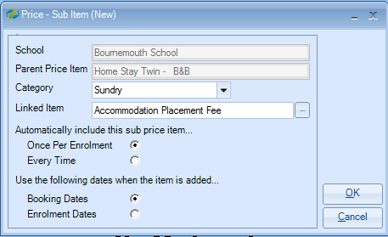
Select OK and close the price item.

Enrolment
When adding the accommodation price item to a student’s enrolment, the sundry Accommodation Placement Fee will automatically populate.
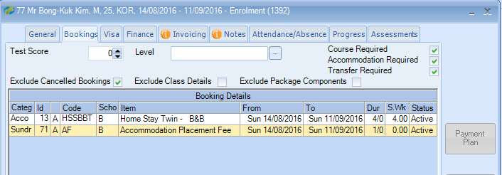

Other examples for using linked prices:

- When a student books a Cambridge Exam course they will automatically be charged for an exam.
- When a student books a certain course they may need to purchase a specific book.
- When a student books a course or accommodation in the summer there is a high season supplement to be shown separately. (see below)

A linked price item can be set to appear during certain periods only:
For example, be linked only during the summer months
Within the price item which is to be linked, i.e. Summer Supplement, you would enter the Inactive Periods:
Example: based on c) above – course fees with a summer supplement.
Go in to the summer supplement price item which is usually a sundry item.
Click the ‘Prices’ tab
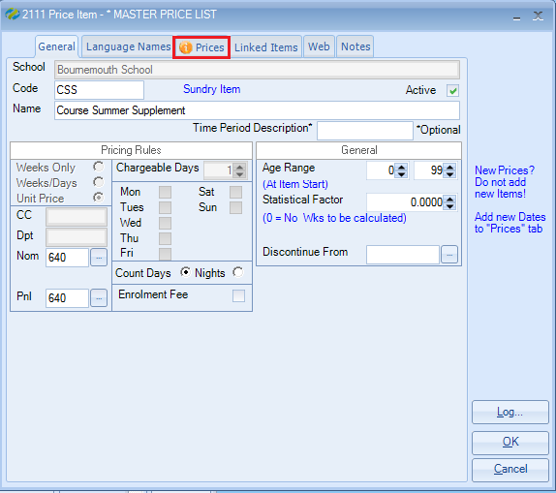

Select ADD
In here you should add the date ranges for when the linked item is INACTIVE, the dates that the supplement does not apply.

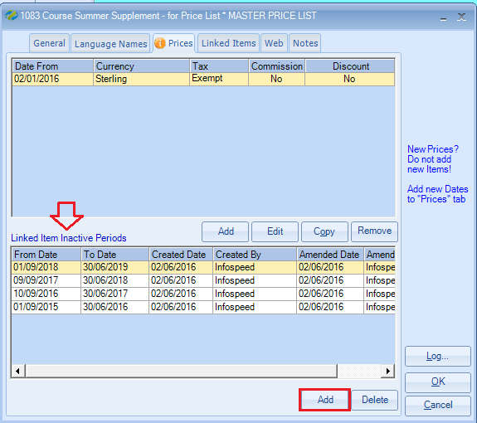
When booking a course which falls within a period that is ACTIVE the summer supplement will apply.
When booking a course or accommodation that fall within a period that is INACTIVE, then the supplement will not apply.

