Class.Net – Help Document
Accommodation Room Temporary Reservation Option

This function gives the option to reserve an accommodation room.
A room can be put on hold for a short period of time in order for the student/agent to confirm their booking dates.

This function needs “switching on” first and is done as follows:

Maintenance/Settings > General Settings > Company > Company
Go to the ‘Accommodation’ tab

There you will find the following settings:
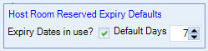

Select ‘Expiry Dates in use’ to switch on the feature and enter the number of days that an unavailability entry will expire after (No. of days until the held room expires).

Please note: the ‘Default Days’ run from Mon-Fri and do not include Sat-Sun.
(The reason for this is explained on the following pages of this document)

User Settings:
Once the above settings are in place and saved you can then apply them to any Class user by editing the user’s profile and switching on the permission -

Maintenance/Settings > User Settings.
Select the user and go to the permissions screen:

‘Accommodation Room Reserve Force Expiry Date’ - ensure this option is unticked.
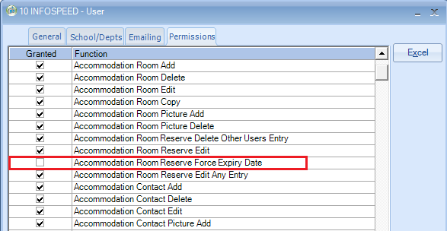

If the user is an Administrator the above permission MUST still be set correctly.
To do this for an Administrator, untick the Administrator option:

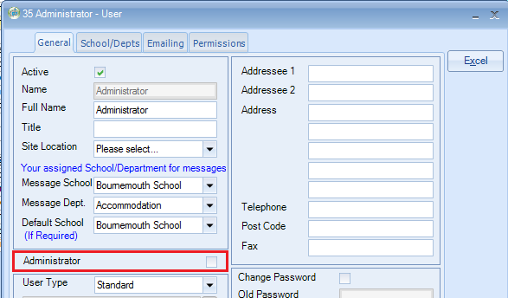

Go to the Permissions tab and ensure the option is unticked:
‘Accommodation Room Reserve Force Expiry Date’

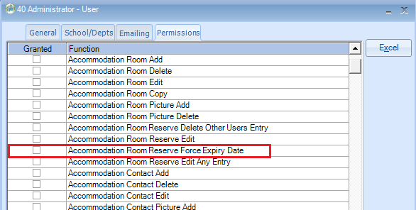

Ensure to go back to the users General screen and set the Administrator option:

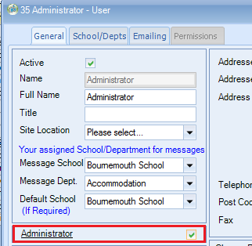

Host record - Room Unavailability:
When a user with the above permission switched on (not an administrator) adds an unavailability entry against an accommodation room, the expiry date (Expires) will automatically be set based on the company setting and their name assigned (Created By).

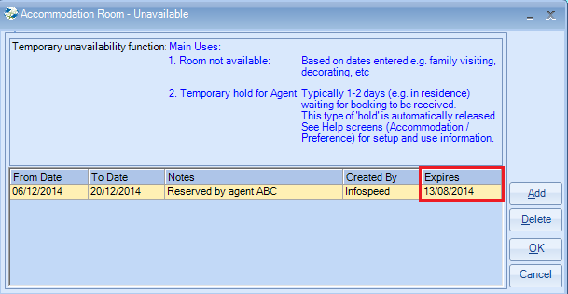

When a user with Administrator rights adds an unavailability entry against an accommodation room, the expiry date (Expires) will be left blank giving the user the option to select any date they wish.

When set automatically, the ‘Expires’ date is calculated by taking ‘todays date’ (date of computer) and adding the number of ‘Default Days’ set within the company settings.
If a weekend falls within the calculation of the days then do not count the Sat-Sun.

When users log into Class, room unavailability that has expired will be purged from the system and unavailability that is due to expire the following day (for that user) will automatically be displayed on the screen, giving the user the option to extend the expiry of any entries listed.

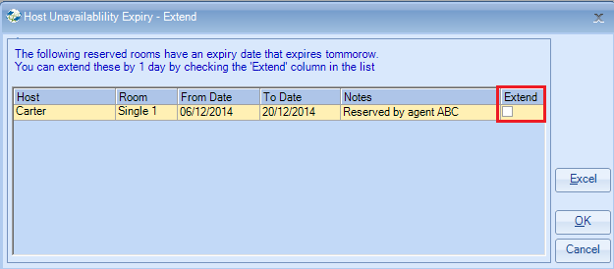

If the Extend option is selected, the expiry date will be extended by one day.
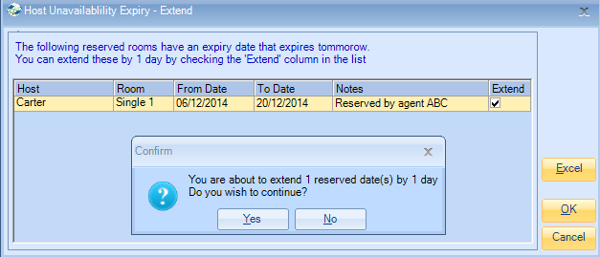

The option to extend an entry is only available once; it cannot be extended a second time. Therefore, the following day when the user logs in the unavailability will be automatically purged. This means that the unavailability line within the families’ record will be removed.

Accommodation Charts:

When making a room unavailable with an expiry date, this is displayed within the booking charts as shown in the examples below:

Accommodation > Booking Chart – Daily

Reserved room with an expiry date is displayed in orange.
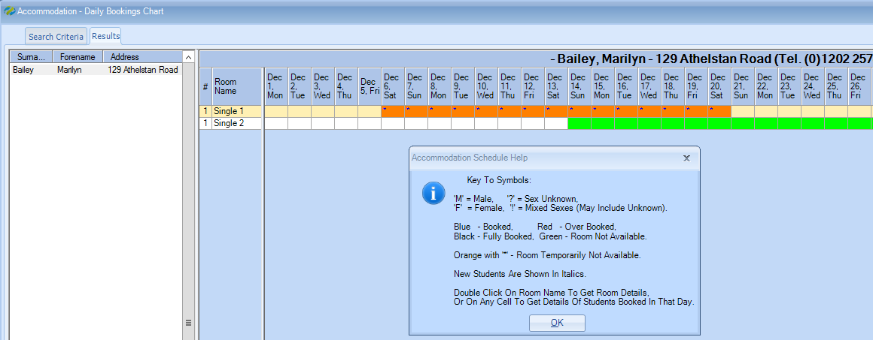

Accommodation > Advanced Accommodation Chart

Reserved room with an expiry date is displayed in orange with the expiry dated (31 Aug)
