Class.Net – Help Document

Embassy Bookings - Terms

How to add Embassy Bookings using the ‘Terms’ option for invoicing 12 weeks at a time.

The ‘Terms’ option within Class can be used for Embassy bookings where the Embassy pays 12 weeks at a time (or 4 weeks). This allows the full course dates to be entered at the time the enrolment is entered rather than adding the first 12 weeks then invoicing, then adding the next 12 weeks and invoicing, and so on.
Setting up the Terms:
Firstly the terms need to be set up. An Embassy booking can start on any Monday of the year, therefore each period from Monday-Friday for the whole of the year will need setting up, as follows: Maintenance/Settings > General Settings
Company > School Term Periods (System)
ADD a new Term List
Enter a Code and Name.
Active – tick the box.
Enter the From and To dates for a long period (e.g. a year)
Select ADD
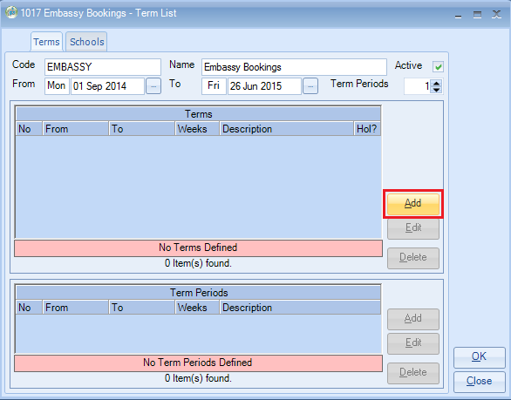
Description – type some text, example ‘Week Tuition’
From and To – this needs to be set for the first Monday-Friday of the term period
(Weeks/Days should show 0/5)
Select ADD
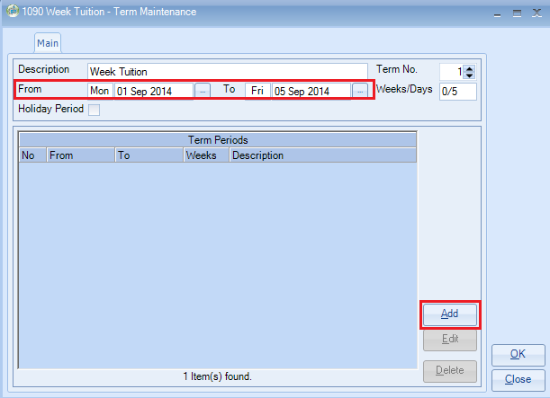
Description – Enter ‘Week Tuition’.
The From and To dates will default to the same as the week entered above.
Select OK
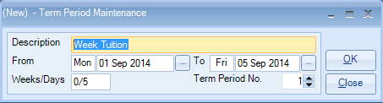

You will see the following screen for the first week of the term.
The two sets of dates should be the same.
Select ADD
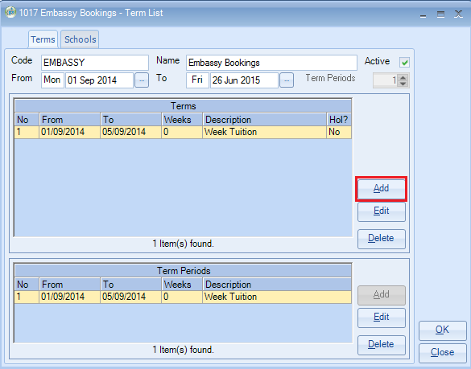
Select ADD
The From date will default to the Saturday of the following week.
The To date will defaults to the end of the term settings, as follows:
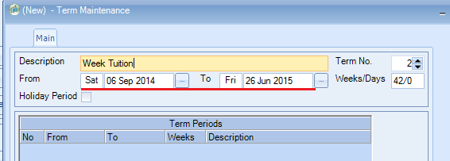
Description - ‘Week Tuition’
Amend the From date to show the Monday date, 08 Sept 2014
Amend the To date to show the Friday of the same week 12 Sept 2014
Select ADD
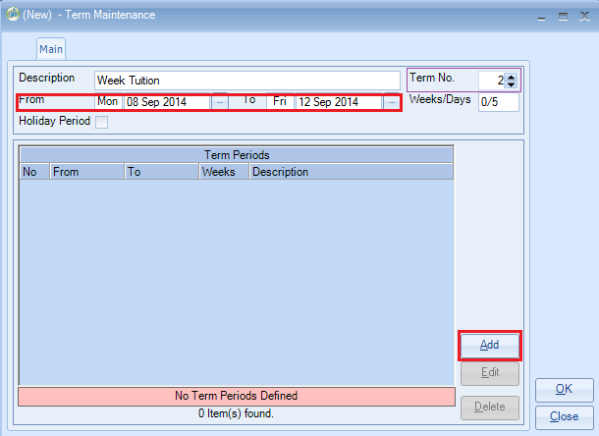
Enter the Description - ‘Weeks Tuition’
The dates will be defaulted correctly to the ones entered in the previous screen.
Select OK
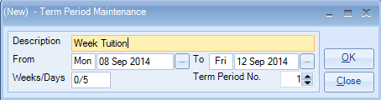

Tip: The text ‘Week Tuition’ will be used quite a bit during the process of setting up the embassy terms and therefore it is a good idea to use the Copy & Paste option to enter this repetitive information.

Check that both sets of dates are correct and select OK
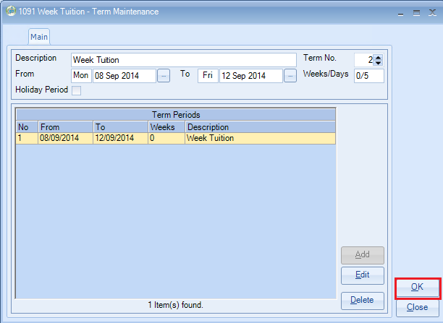
The ‘Terms’ list will now show 2 weeks of data.
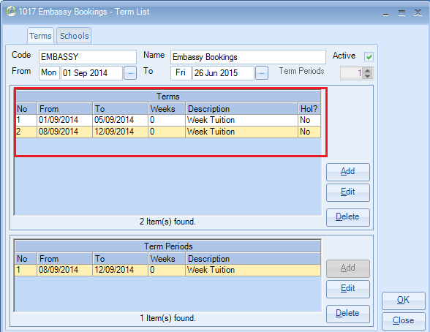
Select ADD again and continue to build the list entering every week Monday-Friday within the term period so eventually you have a list with all the items.
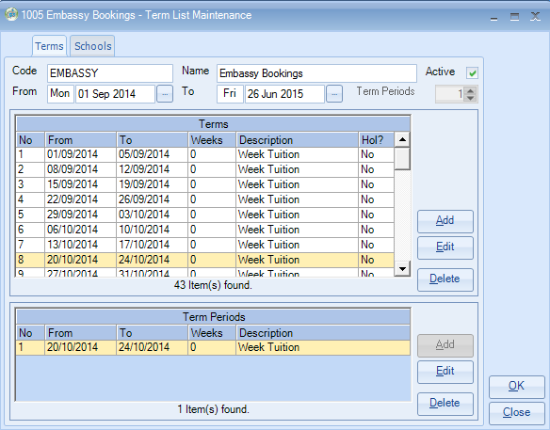
You should also include and weeks that the school is closed, i.e. Christmas.
These should be added in the same way, but the Holiday Period option should be ticked. The terms period dates will be automatically entered.
Holiday Booking Items – when a holiday period is selected a new tab is displayed.
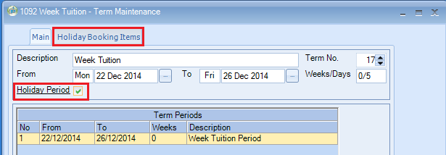

Click in to this tab
Highlight an option from the Available Holiday Items and use the arrows ‘<<’ to move the item to the Selected Holiday Items.
Select OK
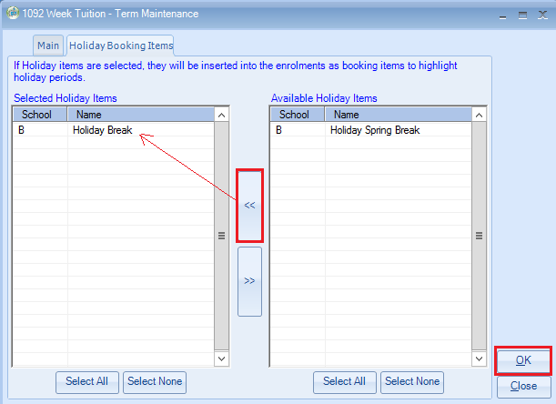
The holiday weeks are displayed in the list with a pale blue highlighted background.
The column Hol? Shows: Yes
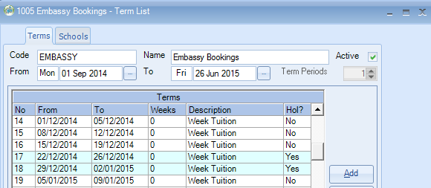

To complete the Term List click in to the Schools tab.
Highlight an option from the Available Schools and use the arrows ‘<<’ to move the item(s) to the Selected Schools list.
Select OK
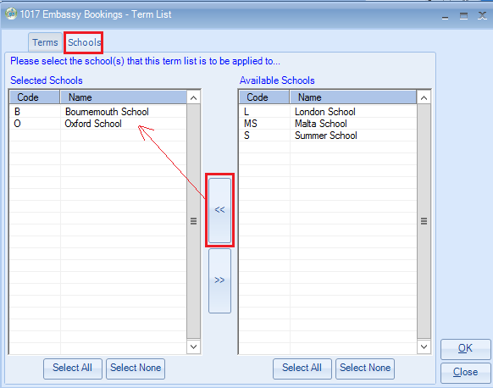

Using the Terms to set up an Embassy Booking
The example below is based on a student studying for 32 weeks and will require 3 x invoices each of 12 weeks (the last invoice for less).
When adding the enrolment use the Term button to select the Terms for the Arrival and Departure Dates. This will pick up Monday and Friday dates but you can change these dates for the weekend.
ADD a new enrolment
Arrival Date: click on the ‘T’erms button
School – select from the list
Term List – select the Embassy Bookings term
Select the term date for the first week of the student’s enrolment:
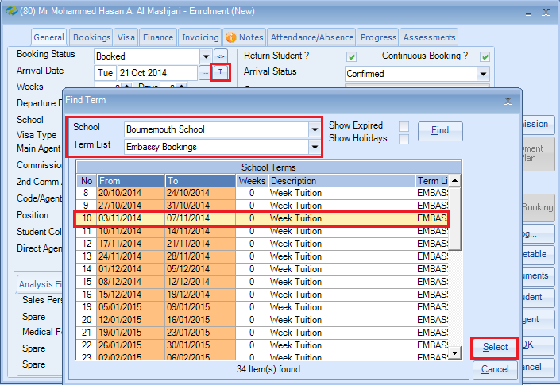
The Monday date of the term is displayed.
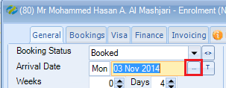

If the student is arriving on the Saturday or Sunday before this date amend the arrival date manually.
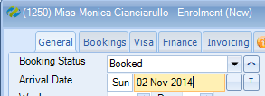
Departure Date: click on the ‘T’erms button
Select the term date for the last week of the student’s enrolment:
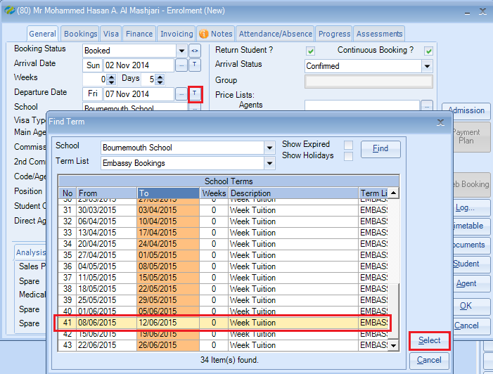
If the student is departing on the Saturday or Sunday after this date amend the departure date manually.
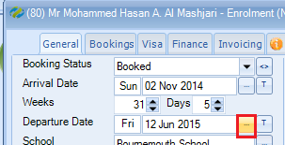
Main Agent: select the Embassy agent. This is the agent who will be invoiced.
2nd Commission Agent: This is the agent who will receive a commission.
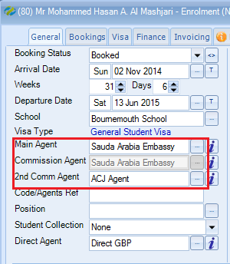
Bookings screen
Select COURSE to add the course
Enter the dates for the first 12 weeks of the course.
This must be done by using the ‘T’erms buttons against the From and To dates.
Select the price item.
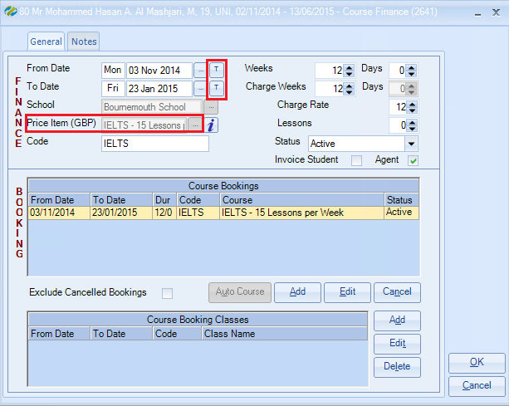
ADD the next 12 weeks of the course, again using the ‘T’erms button.
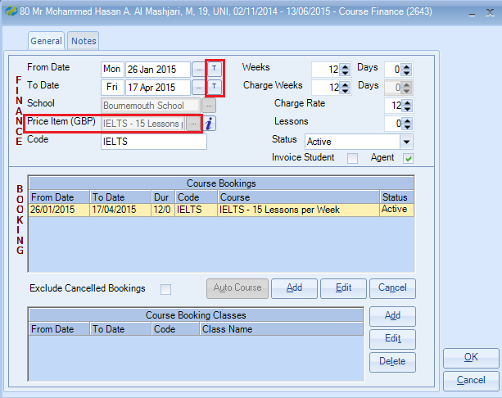
Keep adding the 12 weeks of course lines until the booking is complete.
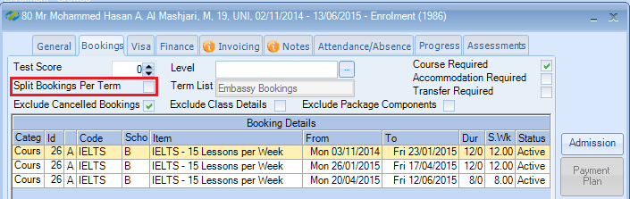

Note: DO NOT tick the option to ‘Split Booking Per Term’ when using terms for Embassy bookings.
You have the option to display the Finance screen to check the prices.

Invoicing screen
On the Invoicing screen select “Invoice Per Term”
Select ‘Print to screen’ and ‘Create & Send’
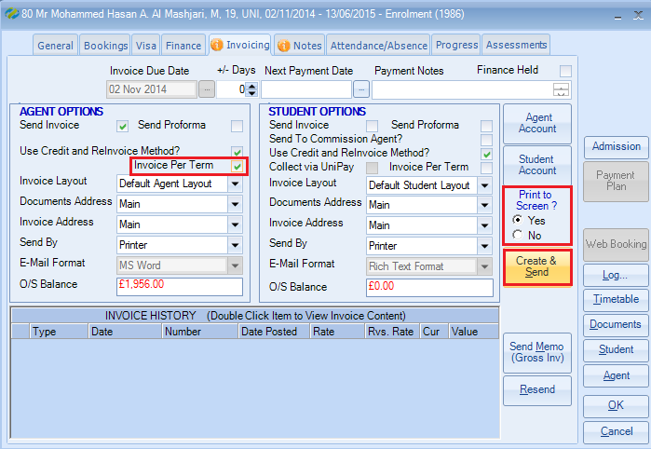
Choose the first term start date from the list to produce the invoice for the first 12 weeks.
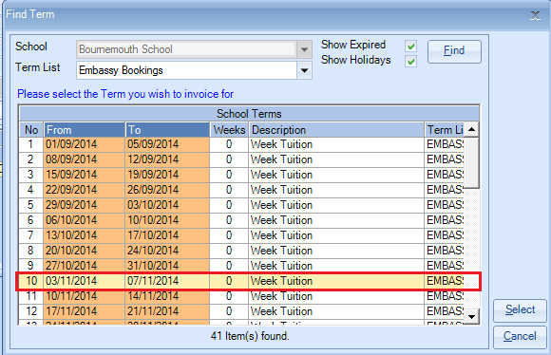

When the next 12 week invoice is to be produced, again ensure “Invoice Per Term” is selected and “Print to Screen” to see the option to choose the next term.
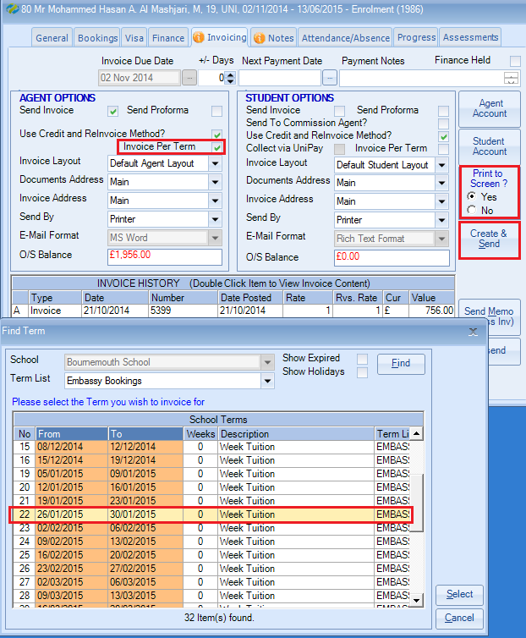
…and so on.

Finance screen
All invoices for each12 week period have been produced:
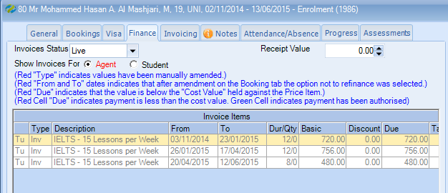

Invoicing screen
Separate invoices for each 12 week period:
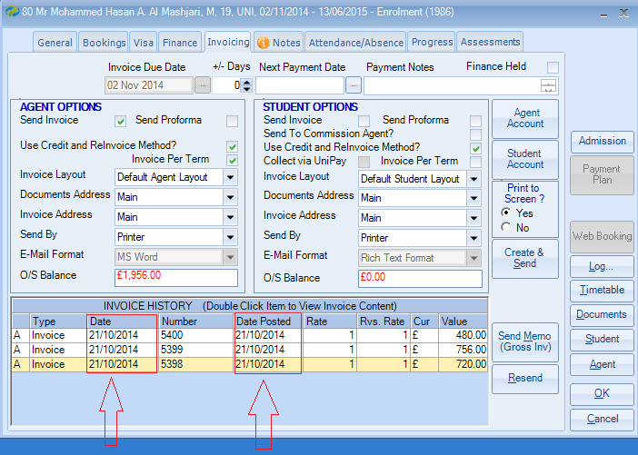
The example screen above shows the same invoice date for each line, however, in real time the dates will be every 12 weeks.

The 2nd Commission Agents commission will be added to the record for each 12 week invoice.
