Class.Net – Help Document

Flexible Payment Plans

This feature allows you to set payment plans for student bookings.
It is not available for agent bookings. You can schedule instalment payments for a student for all or part of their booking. This feature is only available if the Class Ledger is in use.

Setting Up
There are 3 permissions within the user settings that need to be granted.

To set these active go to: Maintenance Settings > User Settings.
Open up the users name and within the ‘permissions’ tab tick the highlighted items below:

Note: There is a ‘view only’ option.

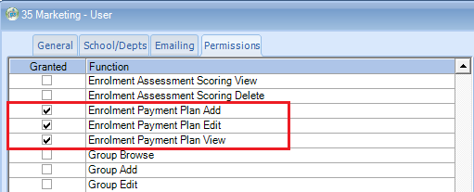

How to use this function:

In this example today’s date (the computer date) is set as 23rd January 2015.

When a student wishes to pay by instalments add the booking details in the usual way, i.e. course, accommodation, transfer, sundry.

Then click on the “Payment Plan” button on the right hand side of the screen.

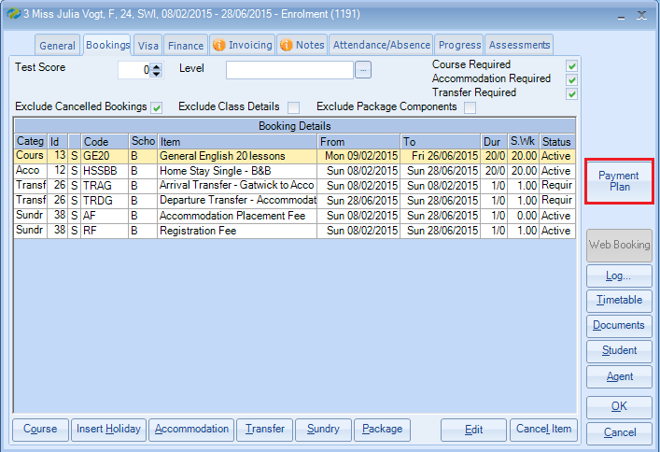

NOTE: When a Payment Plan is already in use then there will be an information displayed within the button.

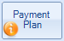

Include – Each line of the students booking will be displayed in the list.
Tick the items that you wish to include within the payment plan.

Plan Total – this automatically calculates the total for the items selected in the plan.

Payment Plan Start Date - select the date for when the payment plan will start.
The default is the student’s arrival date.

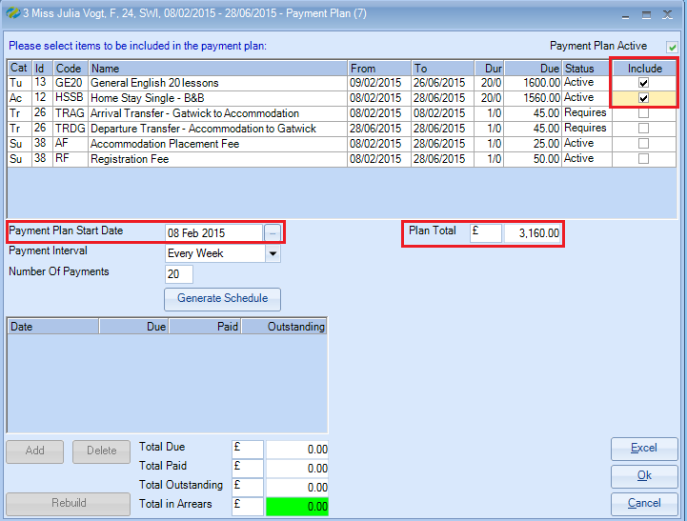

Payment Interval - select from the drop down box how often payments will be paid.
(Options: every week, every 2 weeks, every 3 weeks, every 4 weeks, every month, every 2 months)

Number of Payments – The number of payments the plan is to be spread over is automatically calculated.

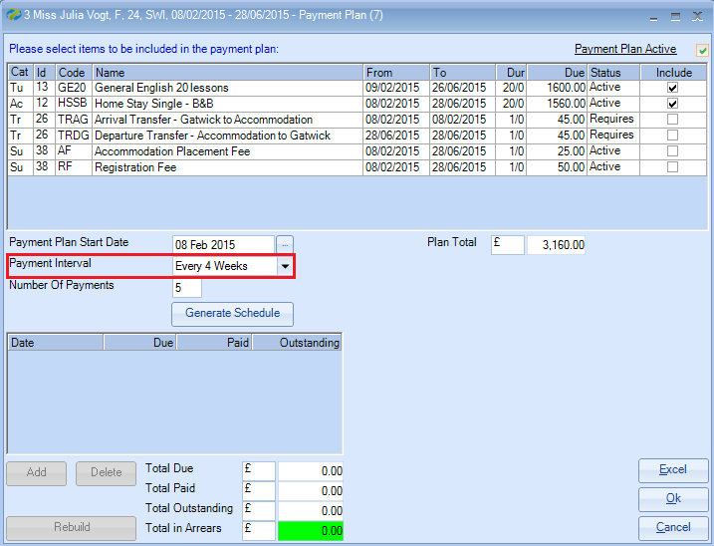

Generate Schedule - Click on this and the payment values will be calculated based on the selected criteria.
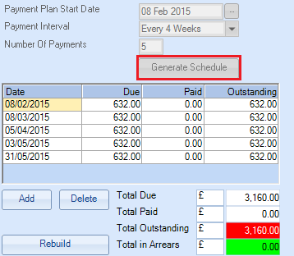
Totals
Red= amount outstanding for payment
Green = nothing in arrears

NOTE: The dates cannot be outside of the students arrival / departure dates.
Select OK to save the Payment Plan.

Making amendments to a payment plan

Editing Due values
Any of the payment values can be manually changed to reflect your agreement with the student. Overtype the values within the ‘Due’ column.
Ensure the amended values equal the Plan Total

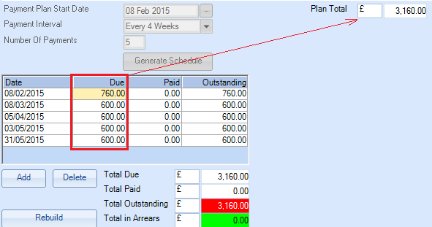

Removing a Plan and starting again
If you wish to remove the plan then delete all the Payment Plan items by using the “Delete” button. Once they are all deleted the “Generate Schedule” button will become available.

Editing a Payment Plan
If you change a Payment Plan a box is displayed to allow you to add the reason for the change. This information will be included in the enrolment Audit Log.

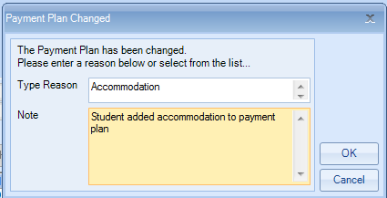

Adding an item to an Enrolment
When adding an item to an enrolment that has a Payment Plan attached to it a message is displayed asking if you wish to add this item to the Plan.

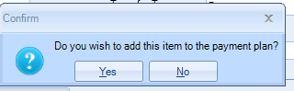

Removing an item from an Enrolment
If you remove an item from an enrolment that has a Payment Plan attached you will see the following message displayed which advised that the values will be adjusted accordingly.

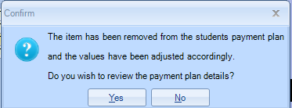

Amending an item within an Enrolment
If the students booking components change the following message will be displayed advising that the values will be adjusted accordingly.

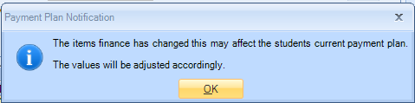

Agent Enrolments
If a student adds an item to their enrolment which is via an agent but now the student is going to be liable for the additional items/payments then (Invoice Student) - this can be added to a Payment Plan. E.g. Departure Transfer, additional lessons, exams etc.

Class Ledger
The Payment Plan can be accessed via the Bookings tab within the student account.

When going into the student’s account, if a Payment Plan is in use and the student is in arrears with payments, a message will be displayed to inform the user.

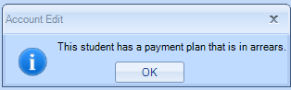

By clicking on the “Payment Plan” button at the bottom of the screen within the account you can open up the student’s Payment Plan and make any alterations.

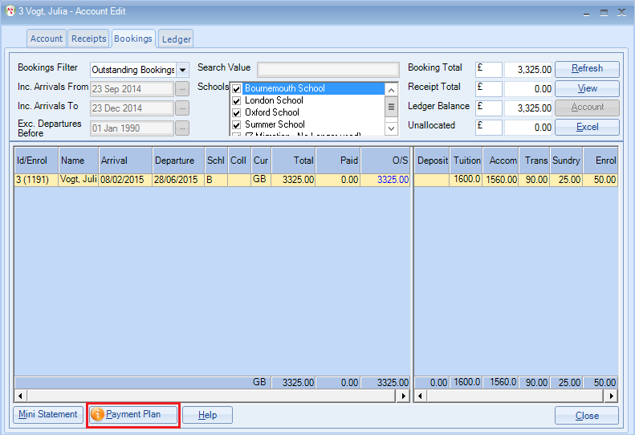

Adding/Allocating Receipts
As Receipts are added to the account the Payment Plan will be updated.

Once an allocation has been made against a student’s enrolment the value is automatically spread across the payment plan’s un-paid entries, starting from the earliest first.

The Payment Plan will show the payments made and the new outstanding value.

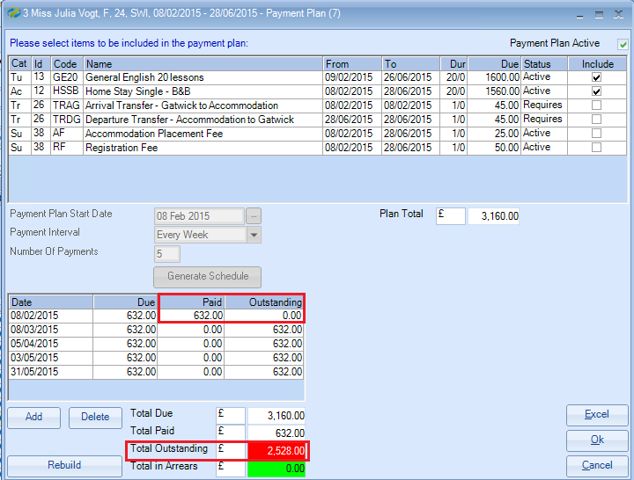

If the student has a payment plan and items have not been paid on time the items are displayed in red and the total in arrears is also highlighted.

Example:
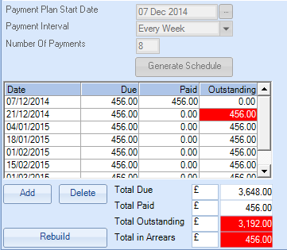
Ledger - Student Statements
When producing a statement for a student there is a prompt to allow the Payment Plan details to be shown on the statement.

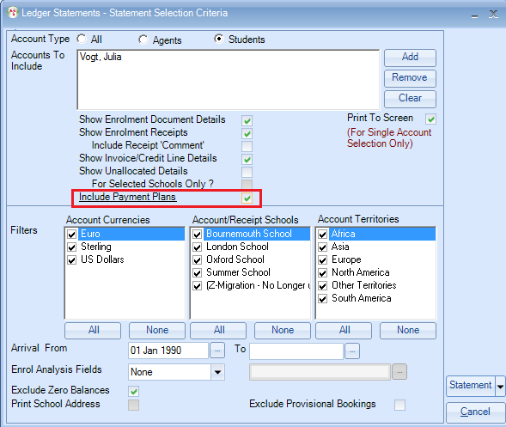

Example:
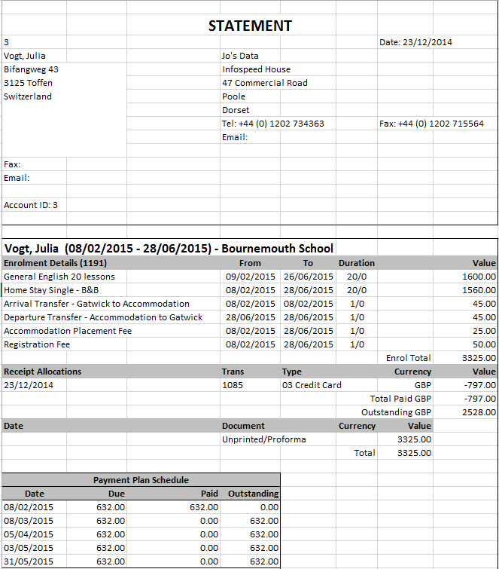
Debtors List – Aged Debt Report
When producing the aged debt report there is a prompt to ‘Apply Payment Plan Rules’. This is only available if the ‘Students’ button at the top of the criteria screen is selected.
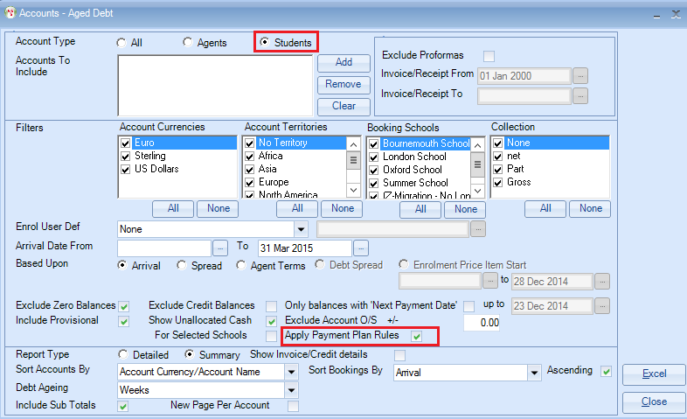

The Debtors list splits the amount due from both within and outside of the Payment Plan.

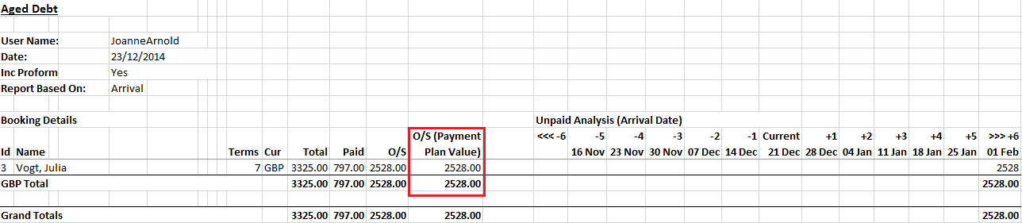

In this example the total debt is: | £3,325.00
Paid | £797.00
Payment Plan O/S | £2528.00

Payment Plan Report
This will produce a list of payments due filtered by the criteria available on the selection screen.

Accounting Ledger > Ledger
Reporting > Payment Plans
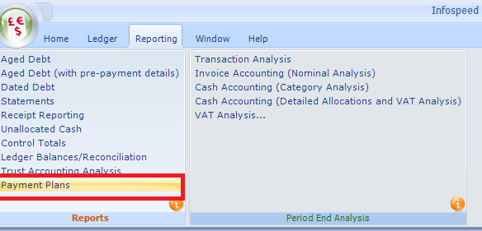

Selection screen:
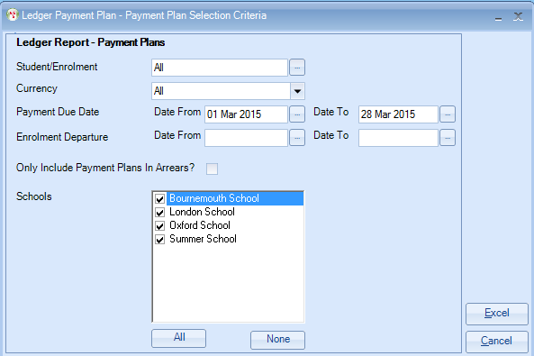

Students/Enrolments - select ALL or select a specific student from the drop down list. The list displays only the students with a payment plan.

Payment Due Date - will allow you to select payments that are now due according to the Payment Plan.

Enrolment Departure - this allows you to report on all the students who will be leaving the school to ensure all payments are made.

Only Include payment Plan Arrears - this will include only those payments that are overdue.

In this example the report has been selected to include all payments due up until end March 2015.

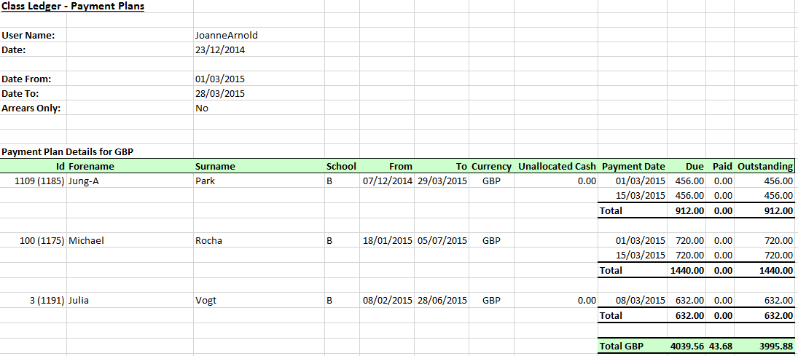

Producing Documents - Word Merge
Merge fields are available in both Financial and Enrolment based documents.

The fields are found under: Enrolment Fields / Payment Plan and Payment Plan Schedule:

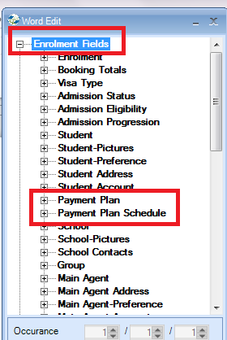

Open up the headings to see the fields that can be merged in to the documents.

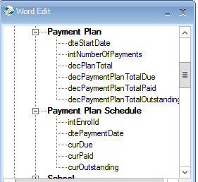

Quick Reports - Fields
Merge fields are available within the quick reports

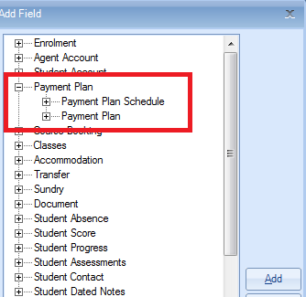

Open up the headings to see the fields that can be selected in the reports.
