Class.Net – Help Document

Price Import Module

PURPOSE:
This is a process designed to simplify and reduce the time taken to update prices in Class. Simply output “this year’s” prices to Excel using the Class Price List Export option, update them with the new dates and prices. Then import the updated prices back into Class.
This module allows existing prices to be imported. You cannot add new price items to the exported list and then import them. New prices must be added directly within Class via Maintenance/Settings > Maintenance.

Process:
First of all, you must export your current price list.

To do this select Maintenance/Settings
Price Lists / Export

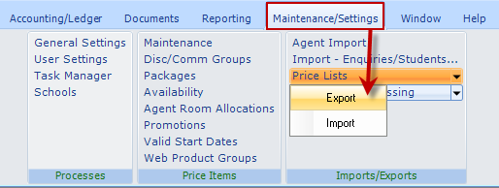

Make your required selection:
- Choose your price list
- Choose your category (tuition, accommodation, transfer or sundry)
- Choose one of the Price Dates for copying
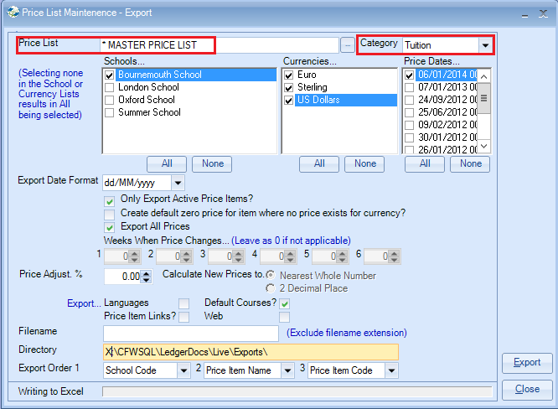
Price List: Select the Price List you wish to update.
Category: Select from the drop-down list. Each category needs to be done
individually.
Schools/Currency: Select relevant schools and currencies.
Price Dates… Highlight the date of prices to be exported.
Export Date Format: There are two formats available
dd/MM/yyyy or MM/dd/yyyy
Create default zero price for item where no price exists for currency:
Example: If you have a price item which only has UK Sterling prices added but you now wish to add Euro prices you can tick this box and then a line will be created within the spreadsheet similar to the following:

Export All Prices: If ticked this will include all prices from the Price Item:
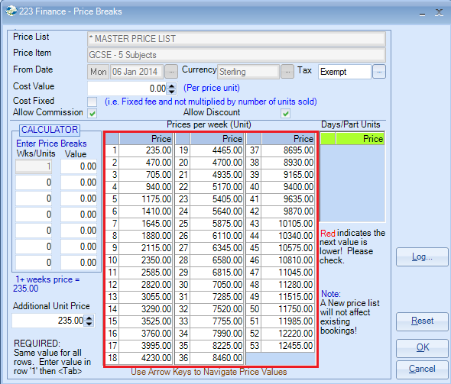

If not ticked then you can input the weeks that you want included i.e. when your prices change.

In the example below the prices change at week 8, week 16, week 24.
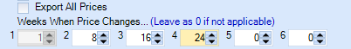

Price Adjust %: If you select a value within this field then the ‘Calculate New Prices’ options to the right are made available for you to choose whether you wish the new prices to be calculated to the nearest whole number or two decimal places. If your Price List goes up annually by a percentage you can add the percentage figure and the prices will calculate automatically (in the ideal world).

EXPORT
Underneath the Price Adjust % option are 4 tick boxes.
Languages / Price Item Links? / Default Courses / Web
These four options are linked to the price item and give the option to export these details in to the Excel spreadsheet. These items can be amended and imported back in to Class as follows:
Languages:
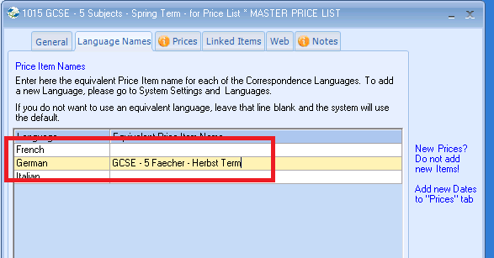
Price Item Links?
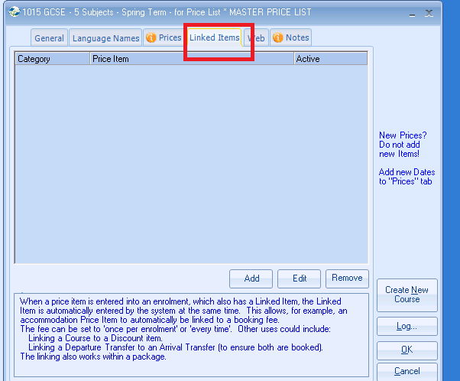
Default courses?
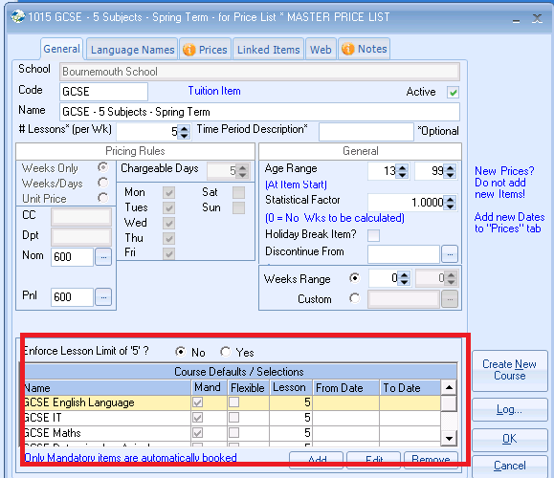
Web:
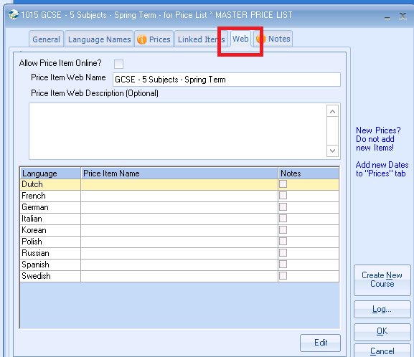

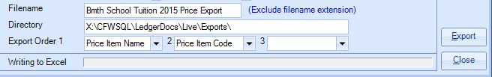

Filename: Enter a filename (excluding the filename extension)
Directory: A default directory will be displayed, however you can choose a
different location if required.
Export Order 1: This is the order that you wish the Excel report to be listed in.

Once happy with the selection select EXPORT
An Excel spreadsheet is saved in the directory selected and then displayed on the screen.
The pink fields are protected and cannot be changed.
The blue fields are not protected and can be changed.

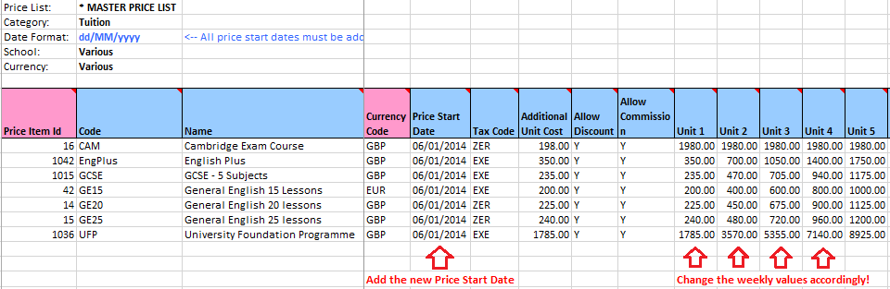
The normal use of this procedure is to update the prices for the following year or when you have a price increase, i.e. during the summer period.
In the example above you would firstly overtype the Price Start Date 01/01/2014 to 01/01/2015 (for next year prices) or say 30/06/14 for summer price increases.
You would then amend the Unit prices from 1 – 53 to show the new prices.
Note: You cannot create new Price Items via this process. They must be added from within the price list within Class in the normal way.
When updating prices (not creating new prices) you can only override the most recent Price List.
IMPORT…
Once happy with all the amendments ensure you SAVE the document.
You are now ready to import the prices.
To do this select Maintenance/Settings
Price Lists / Import
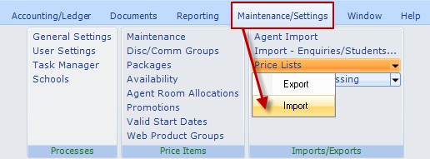

The below screen will be displayed.
Input the file/path where the Excel file was saved or “browse” to the location.
Once the file is located click on “Read File”.
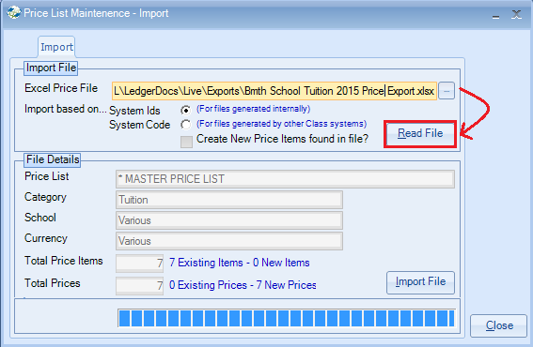

(If you have multiple price lists, these will have to be imported individually).
Select “Import File”
You will be prompted to “Save File Details” which updates the Class Price List.

If the process completes successfully you should see the following message:
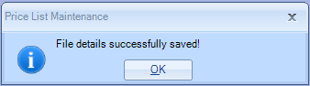
NOTE: If on your Excel spreadsheet the “Start From” date has been amended to a date that is NOT currently used, a new record will be created.
The Import has now completed and the prices will have been updated within Class.
Price List Maintenance:
Example:
The screen shot below shows the new 2015 prices for one of the tuition prices.
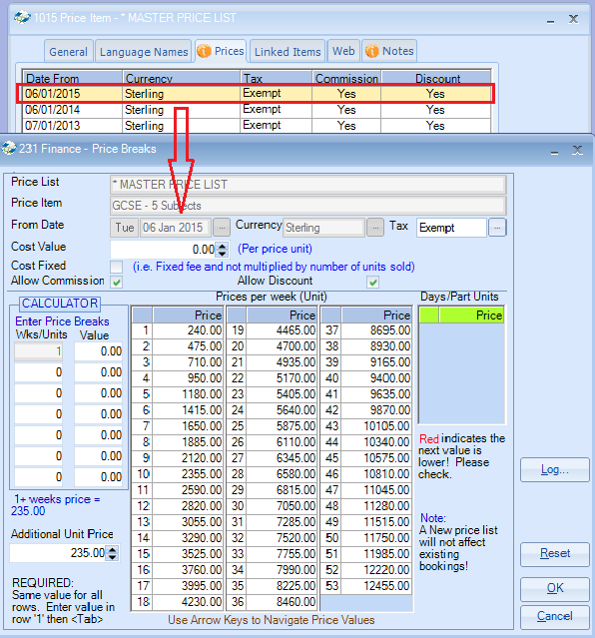

SCHOOLS WITH MULTIPLE DATABASES (only)
“Import Based On:”
This option should be left as System ID’s unless you have multiple databases.
System Id’s:
If you have one Class database. This uses Classes unique system id for the price item.
System Codes (Price Code):
If you have multiple Class databases and you want them to be standardised the standard Price Code e.g. GEN10 is used from a Master database to push into the new database.
If the option to use system codes is selected then you will need to ensure that the field “Force Unique School Price Item Codes” with in company settings is selected.
This can be found in Maintenance/Settings > General Settings
Company > Company
Finance / General
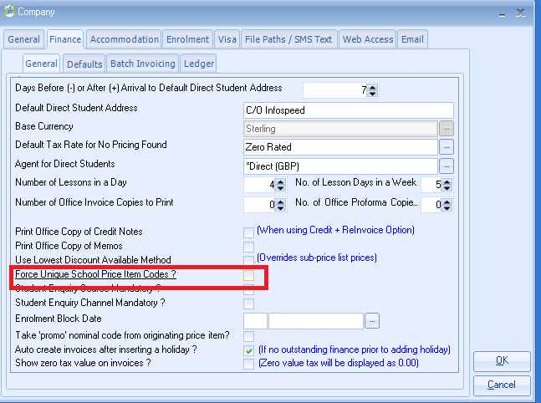
Only when using this option Class will create new price items not found in file. For more details on this option please contact support@infospeed.co.uk

