Class.Net – Help Document

Task Manager

PURPOSE:
The Class Task Manager enables you to run many quick reports, statistics and processes at any scheduled time or at regular intervals in a continuous unattended run, for example during lunch break or overnight. Export/Import files from other systems may also use this function.
Once set up, the Task Manager can automatically set the selection dates forward by the period of the schedule, for example daily, weekly or monthly. This allows reports and processes to be run automatically at the pre-set intervals every day, week, month or year.
They can be printed, emailed or saved.
Excel outputs can be displayed and saved, printed or emailed. For example the weekly statistics could be produced every Monday at 6AM and emailed to all recipients.

Schedule intervals:
Multiple schedules can be created, e.g. 2 x daily admissions schedules, 3 x admissions weekly, monthly and csv annual accounts, monthly marketing etc. If a document batch print was to be run 3 x a day, then 3 schedules could be created, each one starting at a different time e.g. 11AM, 3PM, 7PM.
The sole function of these 3 schedules could be just to process the documents. (Other schedules could be built to do other daily tasks)
In a similar way there could be several weekly reports e.g. 1 running every Monday morning and 1 running every Friday afternoon.

Creating a schedule
Select Maintenance/Settings > Task Manager
The following message will be displayed giving some information regarding the processes.
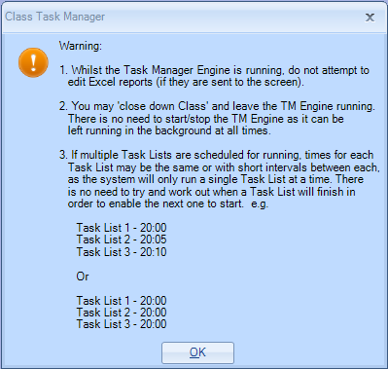
Schedules for individual or “all” users may be displayed.
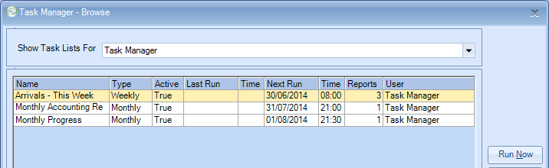
A new schedule is always created in the user’s name and that user is the only person allowed to run that schedule. There is no function that allows the running of “all” schedules.

TIP
For clients who have multiple users who wish to create and run tasks, our suggestion would be to set up one generic Class user called e.g. ‘TaskManager’. The users should log in as this user when setting up and scheduling the tasks to run, so all tasks can be run.
To add a new task select ADD from the Task Manager Browse screen.
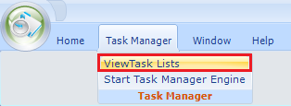
Select ALL to see all tasks.
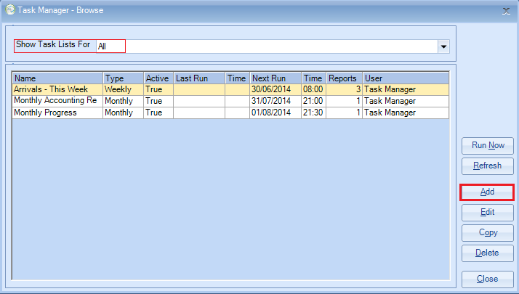
General screen:
Enter the name of the task.
A description can be entered if required.
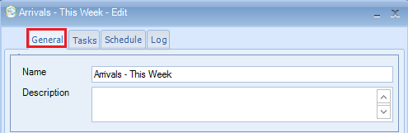

Task screen:
Select ADD
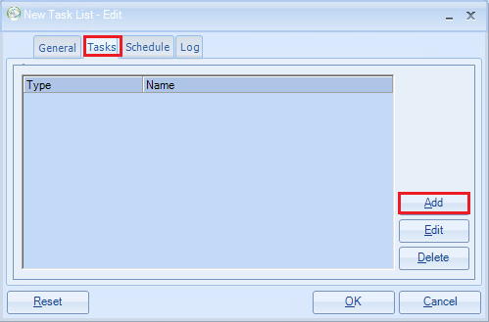
Category: Quick Reports, Statistics, Batch Print, Reports, Ledger, Export, Functions.
Report Type: This list is based on the Category chosen above.
Report: This list is based on the Report Type chosen above.
Select the required item from the drop down list.
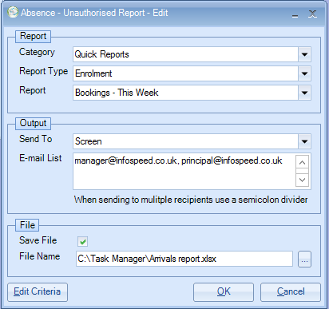

There are 7 categories and a variety of reports and report types (see below)
Category | Report Type
Quick Report | Enrolment
 | Group
 | Student
 | Accommodation
 | Agent
 | Teacher
 | Enrolment Accommodation Finance
 | Enrolment Accommodation Booking
 | Enrolment Course Finance
 | Enrolment Course Booking
 | Enrolment Classing
 | Enrolment Transfer
 | Enrolment Sundry
Statistics Reports | Accommodation Bookings
 | Class Bookings
 | Course Enrolment Bookings
 | Invoicing
 | Booking & Production
 | Enquiry Conversion
 | Agent Country Analysis
Batch Print | Batch Documentation
 | Batch Invoicing
Reports | Unprinted Invoices  Starters/Leavers Report  Accommodation Accruals Report
Ledger | Ledger Reconciliation  Ledger Control Totals  Ledger Unallocated Cash  Ledger Nominal Analysis  Ledger Receipt Analysis  Ledger Aged Debt
Export | Standard Export
Functions | Dynamics AX Import Interface  (Bespoke work only)

Output: screen, printer, email.
File: Enter file name and then chose a location on your computer to save the file
(if required).
If you chose to output via Email you will need to enter the required email address.
You also have the option to save the file if required.
(If you want it to perform multiple functions, e.g. email to 50 people and have one waiting in the printer in the morning, you would have to perform these tasks separately.)
Save File: If the report is to be saved, enter the destination file details. Excel extensions are not required e.g. ‘xls’, as the system will automatically append this.
Output is via screen/printer/email (users with MS Exchange Server Only)
If email is selected, this warning will display:
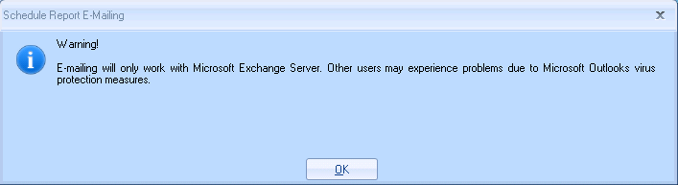
This clearly advises that unattended emailing, in practice, requires the use of MS Exchange server. This is a result of a security patch issued by Microsoft which releases a warning that a “third party” product is trying to access Outlook (Class). This warning has to be individually responded to or the email will fail. For users of MS Exchange Server, MS have provided a patch which allows this warning to be suppressed. Without this suppression of the warning message, the schedule will fail. (Please contact the support desk if you need any clarification in this area)

Edit Criteria:
On selecting ‘OK’ (first time around, the system automatically displays the “Edit Criteria” screen to enable a check to be made that the variables are correct. (Only a selected range of criteria is offered)
Choose this to check/set your report criteria dates based on the report type.
In the example screen shot below, these are the date the student ‘arrives’, NOT the date the report is run (related to a quick report)
Advance dates on the schedule after completion. If set, on successful completion, the “criteria” dates will be rolled forward according to the schedule interval e.g. a daily schedule will roll dates +1 day, a weekly schedule will roll the dates 1 week, etc.
If a schedule is started by hand e.g. “Run Now” dates are not automatically rolled forward, instead a prompt is displayed asking whether this is required.
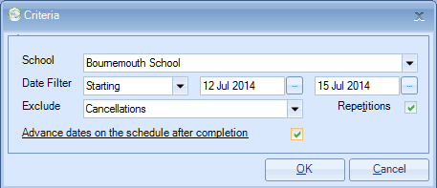
You can have one task schedule with multiple tasks attached.
The example below shows a mix of admissions, marketing & accounting processes, but if required these could have been separate schedules:
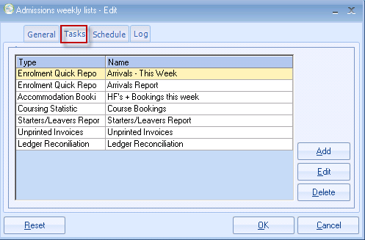
Schedule Screen:
The options for scheduling should be set as required on the below screen. At any stage, the schedule can be “Reset” and the variables re-entered.
Starting on: the first date that the task is to be scheduled to run.
Ending on: last date that the task is to be run. Leave blank if all year round
Run Indefinately: Will run forever! If ticked then the option ‘Runs’ is greyed out.
Runs: allows you to specify how many times you want this to run.
Type: How often the task should run, daily, weekly, monthly or yearly.
Schedule every: When the ‘Type’ is set to Daily, you have the option to schedule how
often in time you want this to run e.g. every 3 hours.
Daily example:
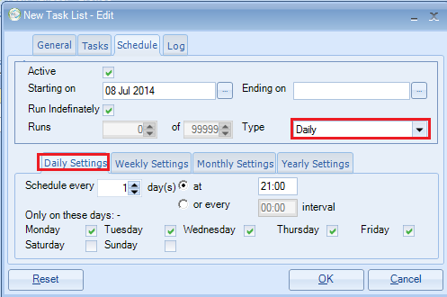
Daily every 3 hours on specific days of the week:
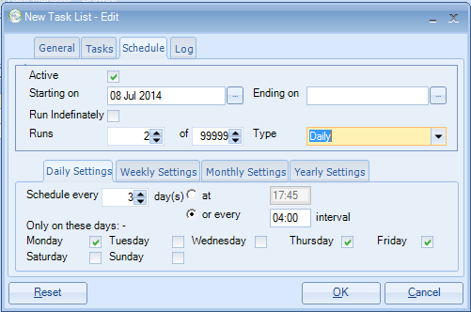
Weekly example:
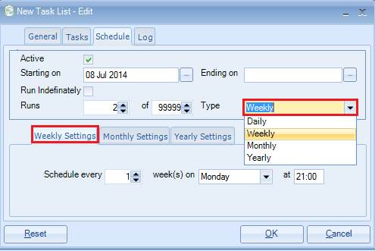

Log: a history of all tasks. Unsuccessful runs will also show on the list:
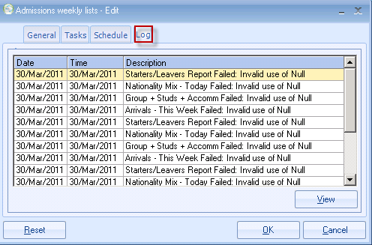

Start scheduler running:
Task Manager > Start Task Manager Engine
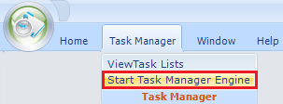
The process will start in accordance with the schedule.
If the scheduled time has already passed, the process will start immediately.
This needs to be open at all times on someone’s machine!
Do not interfere with the process once it is running - this may cause the process to fail.
TIP:
As mentioned earlier you can only run the Tasks that YOU have created NOT for everyone. Therefore, we would suggest all task are created and run as one user name, i.e. TaskManager
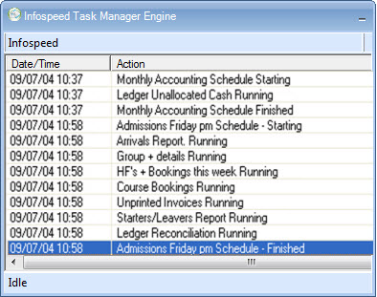
Once started, the process can be left running indefinitely.
The display above will be updated automatically.
This is the only item that needs to be kept running.
Class needs to be left open in order for the Task Manager to run process the scheduled reports.

Running a schedule now:
On completion, the system will want to know if the "schedule" date is to be rolled forward.
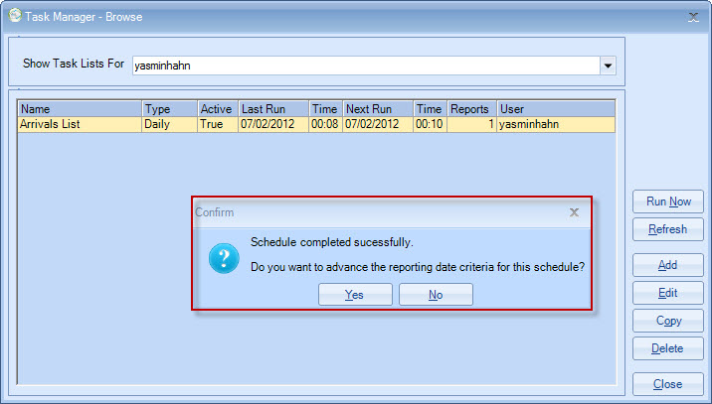

How long did the process take?
