Class.Net – Help Document

Accounting Export Module

PURPOSE:
This is for users who require weekly/monthly figures to be transferred into their own accounting system (i.e. Sage, Quick Books, Dream) without having to manually input the values. Class provides the Accounting Export module which enables accounting transactions (invoices/credit notes/receipts/accommodation payments) to be exported in an industry-standard windows file for re-importing into their own accounting system.
Tip: When setting up the export routines for the first time we would suggest that you ask the supplier of your accounting system to take a copy of your data so that this can be used for testing.
Class Support Team will assist in creating the export file but, if required, you will need assistance from the Support Team of your accounting system re. the importing.
(The accounting system must have the ability to import a standard Windows CSV file)
Process:
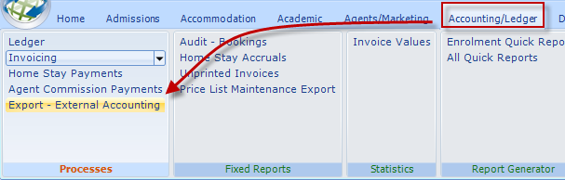

Custom Exports:
None: Will be selected most of the time.
(Agresso: This is an accounting system that requires a different export format as it is not compatible with the standard file created by Class).
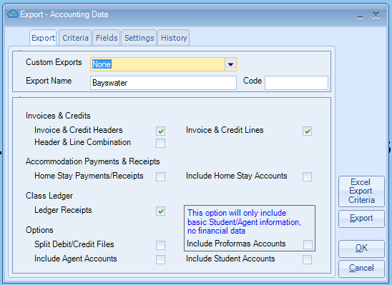

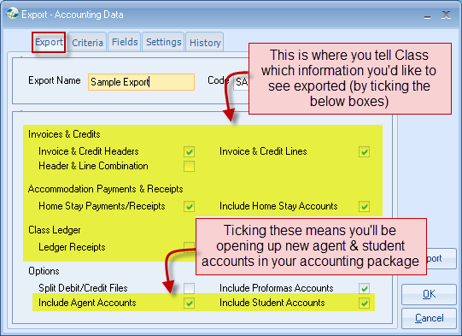
Include Agent Accounts + Include Students Accounts: If ticked the account details will be included within the export file i.e. name, address, telephone number email address.

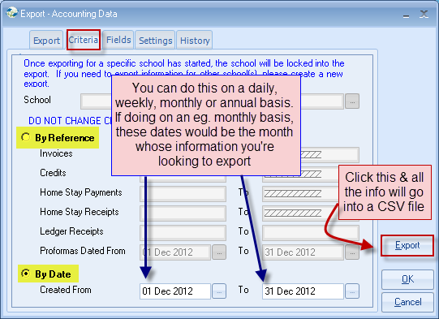
The tabs that are displayed (Agent/Student/Inv. Header/Inv. Line/Accom./Payment) will depend on what is selected on the Export tab. i.e. if you do not select anything to do with Accommodation Payments/Receipts then the Payments tab shown below will not be displayed.
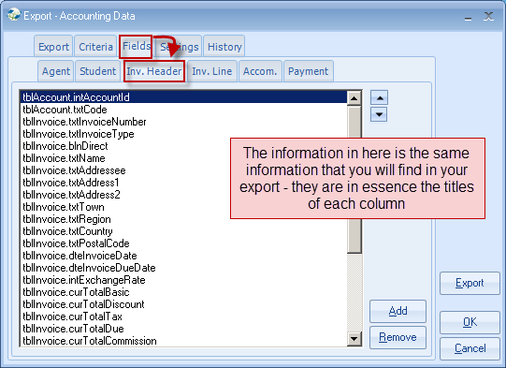
The Up/down arrows allow you to move the position of the fields.

“Add” button will allow you to add additional items to be included in the export file. This information will be taken from Class.
The “Static Value” box as indicated below gives the option of having an additional column that is required by the accounting system that you will be importing into. E.g.
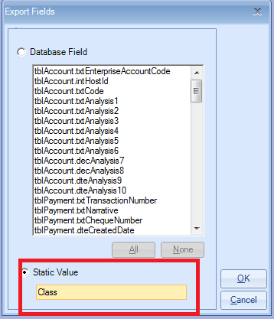
Below is an example of the file created.
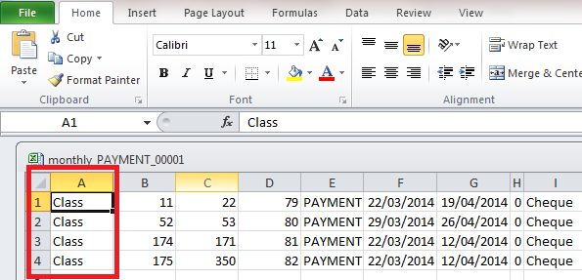

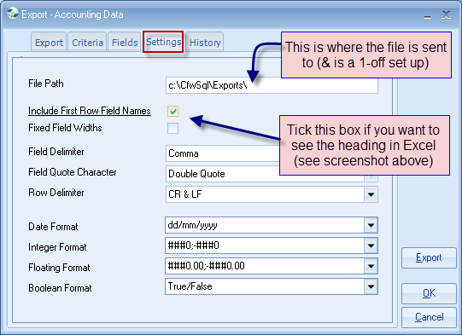
The “Include First Row Field Names” box although is often not required by the system that you are importing into it is useful to have it ticked when going through the testing as it will allow the supplier of the Accounting system to easily identify the columns.

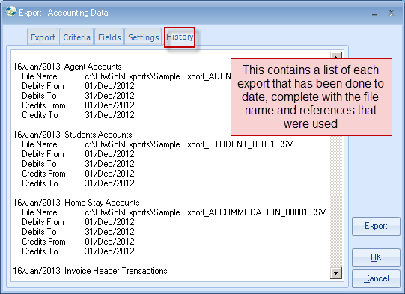

After the export file has been created the following message will be displayed.
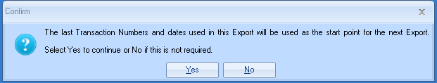
The Start Numbers and Date will be automatically entered but you will need to manually change the “To Number” and “To Date”.

