Class – Help Document


HOST FAMILY PAYMENTS

This is meant as a brief checklist only.

CLASS

Ensure that all amendments are made to Host Family Payment Details and to Student records.

Manual/Additional Payments

Additional/manual payments should be added before you carry out the Payment Run.
(Refer to help sheet SQL075 for further help with adding Manual Payments in Class)

Method
- Host Family Record
- Payments
- Manual

Highlight the student for which the manual payment is for.

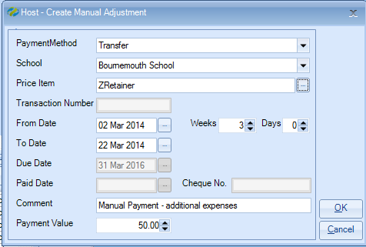

This will be included in the next Host Family payment run.
Payment Run

Method
- Accounting/Ledger (top of the screen)
- Processes
- Home stay Payments…

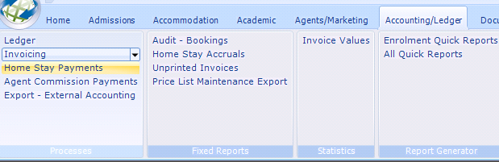
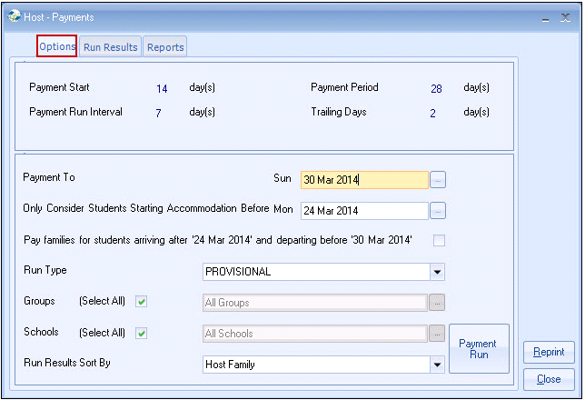

Please check this screen carefully.
The “Provisional” can be run as many times as necessary.
Click on Payment Run.
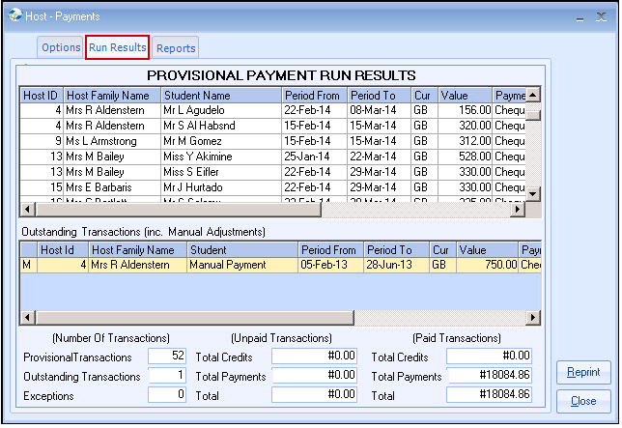

- Check the results carefully.
- Print out reports, as necessary.
- If any errors are found then the correction must be made in the students record and the Provisional Run repeated.

- Once you are happy with the results – change the “Run Type” from “Provisional” to “FINAL”, (see page 2).

REPORTS

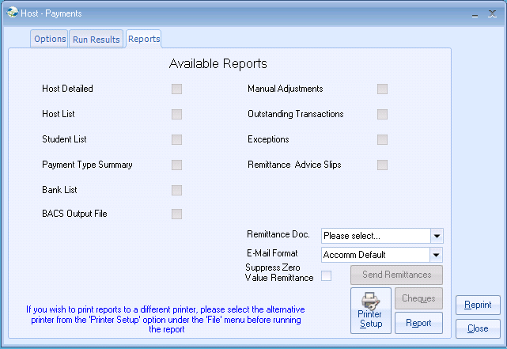

Select the required reports.

