Class – Help Document


HOW TO SET-UP THE USERS WITHIN CLASS

Problem
We have a new member of staff and need to set them up as a “User” in Class.

Solution
(The following must be performed by a user logged in to Class with full administrator rights)

Select Maintenance/Settings at the top of the screen
Select User Settings
On the Users screen click on Add
The following screen will appear:

Name: Enter the sign on you wish to use.
Enter the rest of the screen as necessary.

A password must be entered and must conform to 12 character as shown in the screen below.

System Administrator, this needs to be ticked if you wish the new user to be able to access Class “Settings”.

School/Depts

Emailing
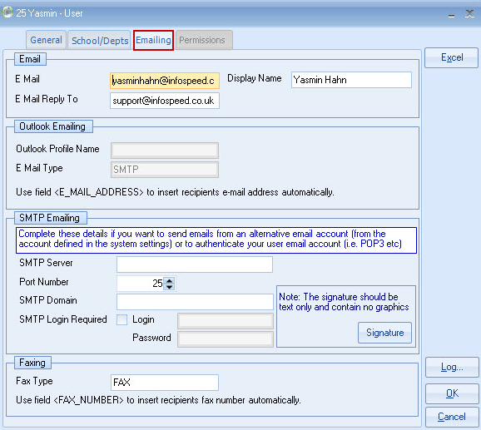

Permissions
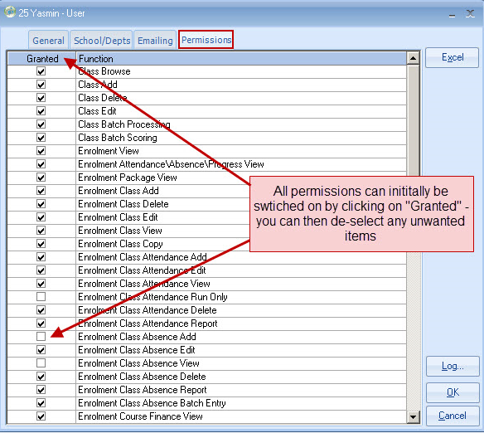

Select OK.

Role Based Permissions

This allows user ‘roles’ to be created and assigned to users. This feature can be used to replace the existing individual user based permissions or work alongside it, allowing you to assign specific roles to users as well as individual permissions outside the role itself.

To activate this feature, edit your Company details and select the user permission method you wish to use.

- Individual User Permissions - Assign individual permissions to each user (default method)
- User Role Permissions – Create ‘roles’ containing permissions for specific types of users (i.e. administration, bookings, accommodation officers, marketing personnel) and assign them to users. Users will only be granted the permissions that have been assigned to the roles.
- Individual User and Role Permissions – This option allows both individual permissions and roles to be assigned to users.

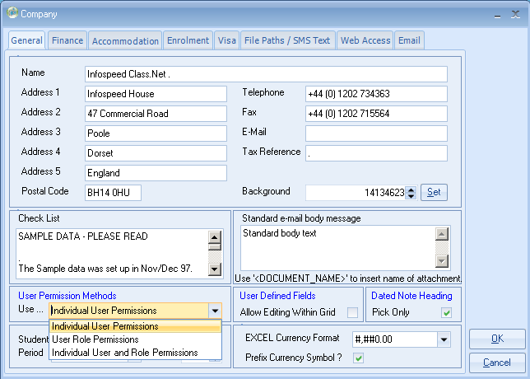

Before switching over to using role based permissions, we would suggest that you create your roles beforehand. To do this, go into the system settings module and locate the ‘User Roles’ option within the Company menu…

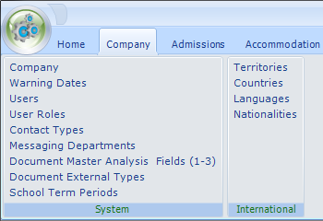

The User Role browse screen will then appear allowing you to add, edit, copy and delete roles. This screen can also be used to lists roles that have been assigned to individual users.

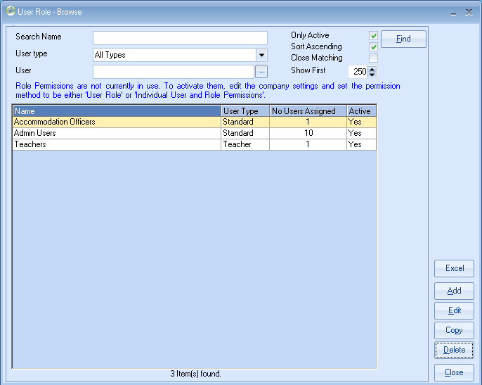

To add a role:
- click the Add button
- enter the name of the role
- select the permissions you wish to assign to the role.

When creating roles for the first time, to assist with the transition away from individual user permissions, you can default the role’s permissions list by selecting an existing user. The permissions assigned to the user will then be used to populate the role’s permission list. This option is only available when the role’s permission list is empty.

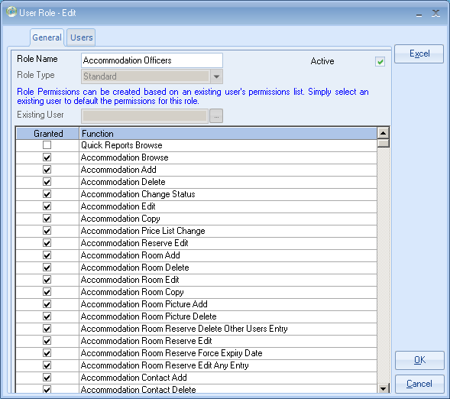

Once the permissions have been setup, you can then pick which users are to be assigned to the role. Available users which are prefixed with ‘(N/A)’ indicate that they have not yet been assigned to a role.

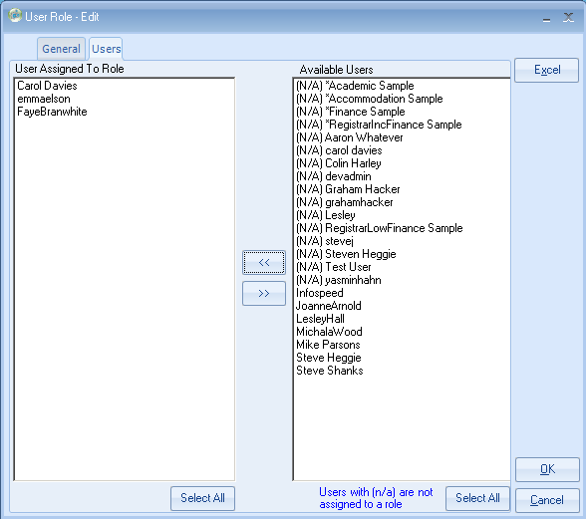

You can also access the role details by editing individual user details. When role based permissions have been selected in the Company settings, the permissions tab in the user details will list the roles which have been assigned to the user along with other roles which are available.

Users can be assigned multiple roles…

