Class – Help Document


Batch Updating of Groups

Main Purpose:
From a selected Group of students apply an update to all records.

Group Batch updating can be used to update student records in many circumstances, including the following examples:

- A Group is arriving/departing on different dates than first booked.
- Students are to study on a different course than the one originally booked.
- The course price item has been incorrectly input.
- Accommodation is to be upgraded.
- Transfer details once known can be updated.
- Arrival Status and Bookings Status can be updated.
- Classes can be changed.
- Packages can be amended.

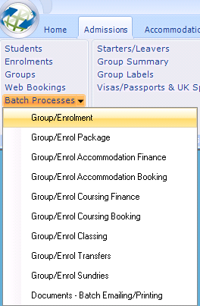

INDEX
Page
ENROLMENT - Arrivals Processing… 3
Amending students Arrival Status

ENROLMENT - Batch Updates… 5
Amending students arrival and departure dates

ENROLMENT PACKAGE - Package Batch Updates… 7
Amending the ‘Package Header’ from and to dates

ENROLMENT ACCOMMODATION - Finance Batch Updates… 8
Amending Accommodation Finance dates and price item

ENROLMENT ACCOMMODATION - Booking Batch Updates… 9
Amending Accommodation Booking dates and host payment item

ENROLMENT COURSING - Finance Batch Updates… 11
Amending Course Finance dates and price item

ENROLMENT COURSING - Booking Batch Updates… 12
Amending Course Booking dates and course name

ENROLMENT CLASSING - Batch Updates… 12
Amending Class dates and Class name

ENROLMENT TRANSFER - Batch Updates… 13
Amending all aspects of a transfer

ENROLMENT SUNDRY - Batch Updates… 15
Amending Sundry dates and price item

Additional Information 15
Group Header Screen
Adding new booking items
Enrolment
Arrivals Processing…
Which items can be updated?
Each student’s ‘Arrival Status’ can be updated from here.
i.e. Provisional to Confirmed

Step 1: Input the Group name.
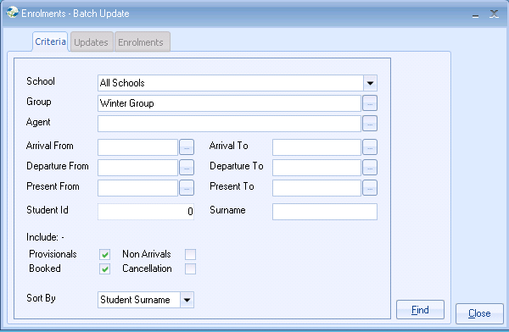

Select FIND
This should list all the students attached to the selected Group.

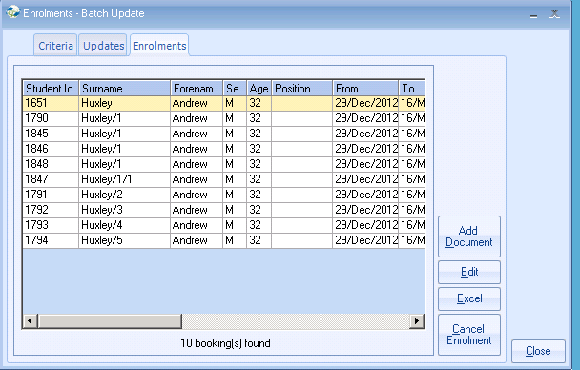

Step 2: UPDATES Tab:
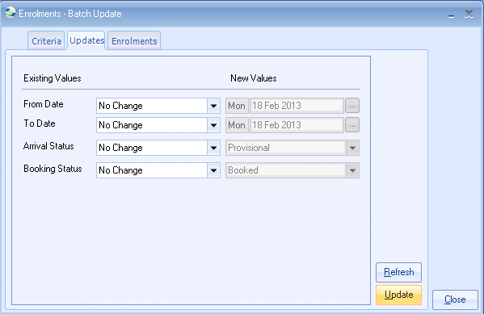

To amend the Arrival Status select the current Arrival Status from the drop down box under Existing Values. Input the new Status under New Values.
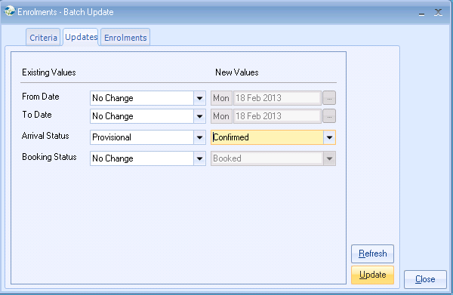
The above applies to changing the Status.
Select UPDATE to make the changes.
Select Close when finished.

Enrolment
Batch Updates…
Which items can be updated?
Each student’s Arrival and Departure Dates can be updated here.
The ‘Arrival Status’ and ‘Booking Status’ can also be updated.
Documents can be added to all enrolments in the Group.

Step 1: Input the Group name. Select FIND
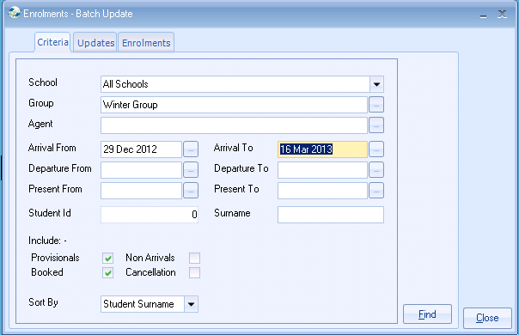

ENROLMENTS Tab:

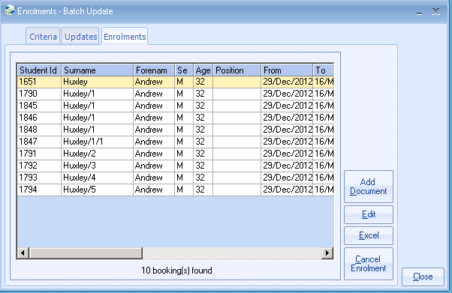
Add Document:
Select this option and choose the required document(s) from the available list.

Edit:
Each enrolment of the selected Group may be edited, by double clicking the listed results.

Cancel Enrolment:
An enrolment can be cancelled from this screen.

Step 2: UPDATES Tab:

To amend the From Date (Arrival) select the current date by selecting from the drop down box under Existing Values. Input the new date under New Values.
Note: the new value always defaults to the current date
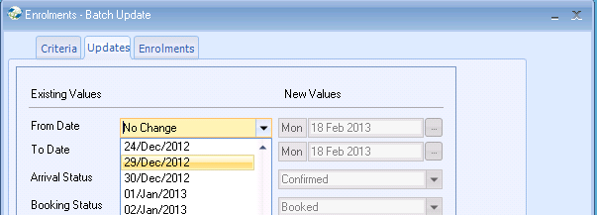
The above applies to changing the To Date and the Status.
Select UPDATE to make the changes.
Enrolment Package
Package Batch Updates…
Which items can be updated?
Only amendments to the package “Header” From and To dates.

Example:
Change Package Header ‘From Date’ to two days later.
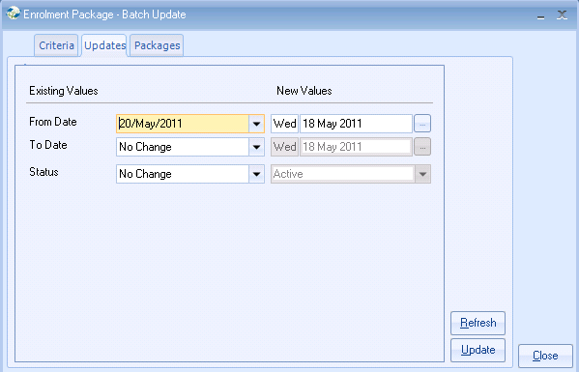

Note: only the header is updated.

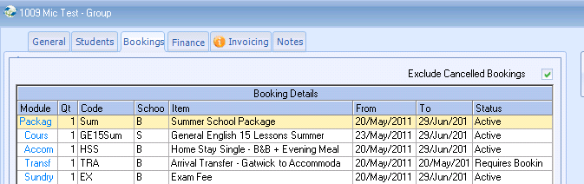

To update the items attached to the package, i.e. Course, Accommodation, Transfer, Sundry, run the batch processing for each of the corresponding items.

Select UPDATE to make the changes.

Enrolment Accommodation
Finance Batch Updates…
Which items can be updated?
The Finance updates the top section of accommodation item -
Accommodation finance From and To dates, Price Item Name (as displayed on the invoice) and Status can be changed.

Step 1: Input the group name in the criteria screen. Select Find
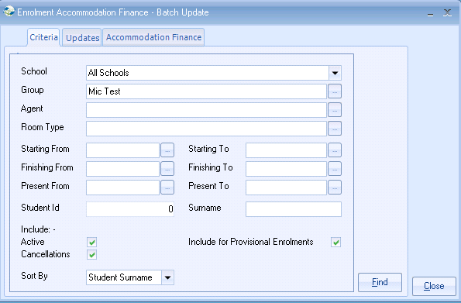

Step 2: Make the necessary amendment(s).
Below the Price Item is being changed from Home Stay Single B&B to Twin B&B.
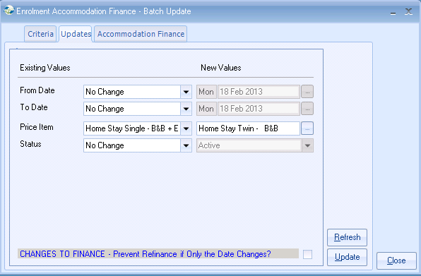

Note: when making amendments to the Finance side of a booking the finance will be recalculated unless the “Prevent Refinance…” option is ticked.

This is highlighted in blue text on the “Updates” screen.

Select Update

Once completed the following screen is displayed. Select Close.
Select Close to complete the update.

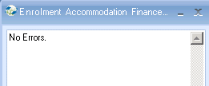

Enrolment Accommodation
Booking Batch Updates…
Which items can be updated?
The Booking updates the bottom section of cAcommodation item -
Accommodation Booking From and To dates, Payment Item Name (as paid to the family) and Status can be changed.

Step 1: Input the Group name in the criteria screen. Select Find
Include: The default is ‘Booked’, but if the students in the Group have not yet been placed with a family, ensure ‘Awaiting’ is also ticked otherwise no records will be found. Select FIND.
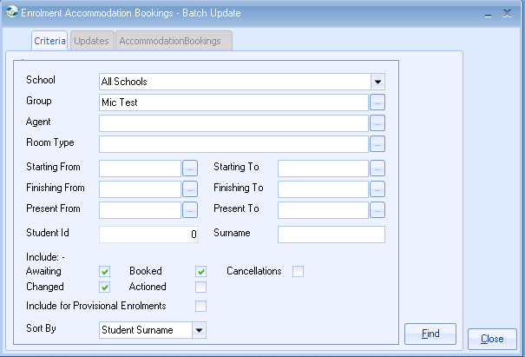

Step 2: Make the necessary amendment(s).
Below the host family Payment Charge is being changed from Full Board (FB)
to Part Board (PB).

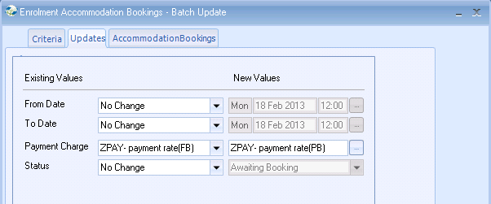
No refinancing is involved when making this amendment.

Students must be booked in to their families individually within the Group itself.

Select UPDATE to make the changes.
Enrolment Coursing
Finance Batch Updates…
Which items can be updated?
The Finance updates the top section of course item -
Course finance From and To dates, Price Item Name (as displayed on the invoice) and Status can be changed.

Step 1: Input the group name in the criteria screen. Select Find

Step 2: Make the necessary amendment(s).
Below the Course dates are being amended to start one week later than previously booked. The course is also finishing one week later.
The Group is also studying on a different course than originally booked:
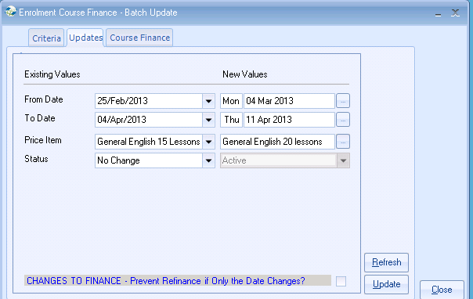

Note: when making amendments to the Finance side of a booking the finance will be recalculated unless the “Prevent Refinance…” option is ticked. This is highlighted in blue text on the “Updates” screen.

Select Update to make the changes.

Enrolment Coursing
Booking Batch Updates…
The Booking updates the bottom section of course item -
Course Booking From and To dates, Course Name and Status.

Step 1: Input the gGoup name in the criteria screen. Select Find

Step 2: Make the necessary amendment(s).
If the ‘Finance’ dates and course have been amended, then the ‘Booking’ dates and course need to be amended so that they correspond.

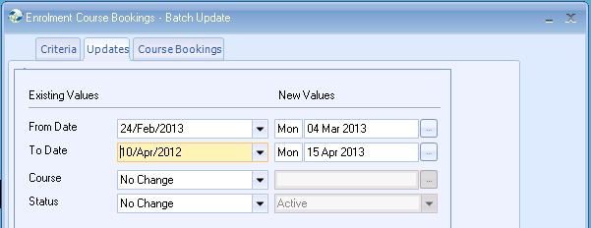

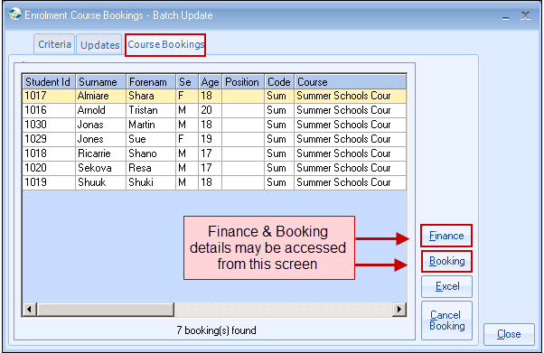
Select Update to make the changes.

Enrolment Classing
Batch Updates…
Which items can be updated?
Class From and To Dates. Class Name
Only students already classed can be updated.
New Classes cannot be added.

Step 1: Input the gGoup name in the criteria screen. Select Find

Step 2: Make the necessary amendment(s).
Below the students are being put in to a different class for the original dates.
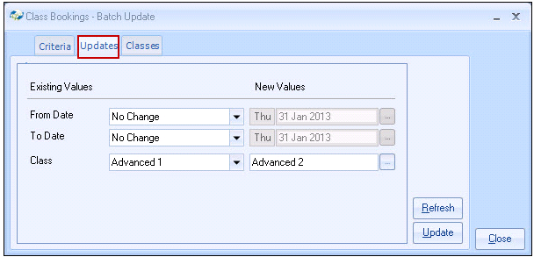
Select UPDATE to make the changes.

Enrolment Transfer
Batch Updates…
Which items can be updated?
All aspects of the transfer can be batch updated.

Step 1: Input the group name in the criteria screen.

Type: Ensure the correct transfer is ticked. i.e. Arrival or Departure.
Include: Ensure ‘Requires Booking’ is ticked if transfer not yet booked.

We would recommend that the update is run twice, once for the Arrivals and again for the Departures.
If both are run at the same time this could result in both transfers showing the same information, i.e. Pick up Time.

Select Find

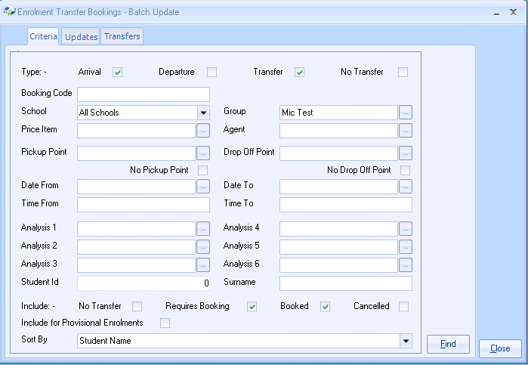

Step 2: All aspects of the transfer can be batch updated.

The Analysis fields 1 to 6 are the User Defined fields set up by yourselves.
Click on the Existing Value of the field to see what details are currently held before deciding if the New Value needs updating.

To add the Pick Up Time -
Set Existing Value to ‘blank’. Input the correct time in the New Values field.

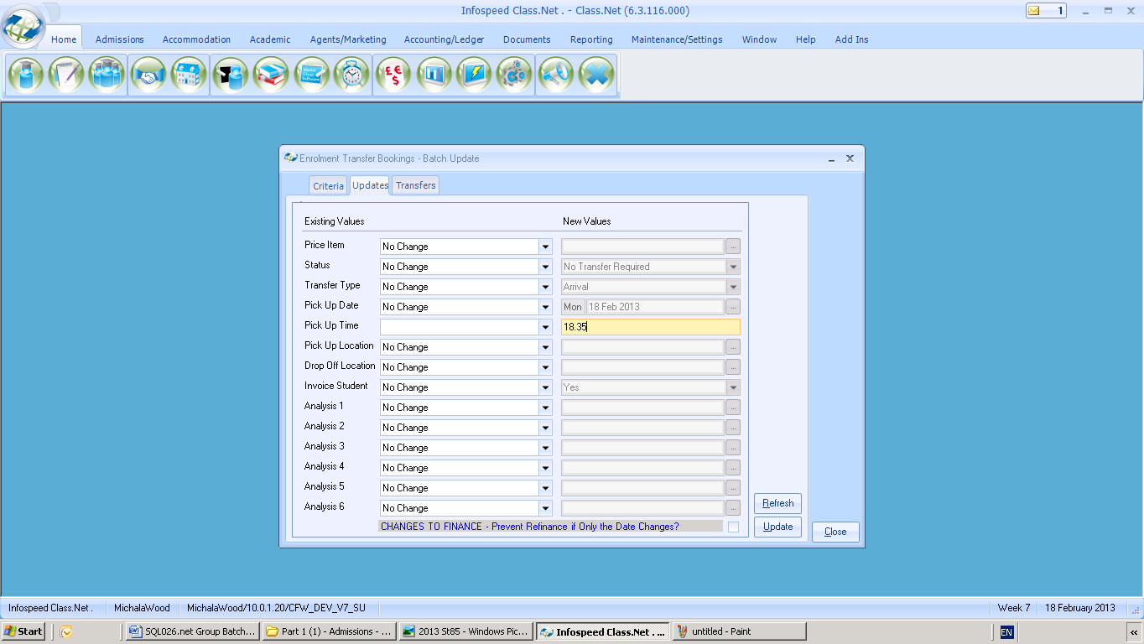

Select Update to make the changes.

Enrolment Sundry
Batch Updates…
Which items can be updated?
Sundry From and To Dates. Price Item Name, Status Name

Step 1: Input the Group name in the criteria screen. Select Find

Step 2: Make the necessary amendment(s).
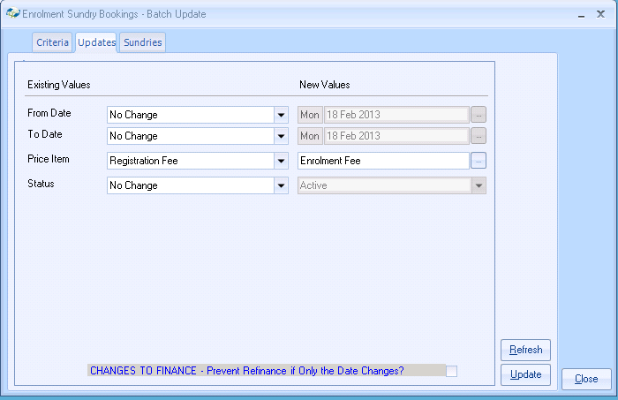
Select UPDATE to make the changes.

Additional Information:

If say, the Group is arriving three days later, then all of the above batch updates will need to be run for each of the booking items, Enrolment, Course, Accommodation, Transfer, Sundry (Booking and Finance where applicable)

Group Header Screen (General).
The information on this screen must be amended manually.

Adding new booking items.
The batch update cannot add new Courses, Packages, Accommodation, or Classes. These will have to be added manually to each student within the Group.

However, a new Transfer and Sundry item can be added directly in to the Group for all students from within the Bookings tab. Within this screen there is a button to: ‘Add Transfer’ and ‘Add Sundries’

EXCEL
All batch update lists can be sent to an Excel spreadsheet.

