Class – Help Document


Problem

A number of agents have the same discount agreement which is different discount rates for certain courses – how do I deal with this?

Solution

CREATE A SUB-PRICE LIST

For each different net price grouping create a “sub-price” list e.g. for agents who get 10% discount.

To do this:

- Admissions
- Price Items
- Maintenance

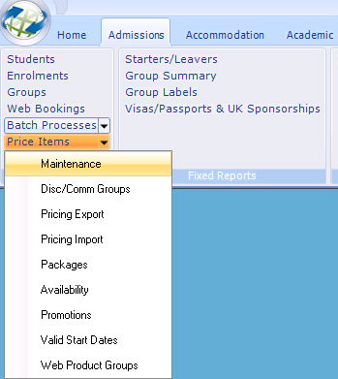

Click on Add in the top section to give your price list a name.

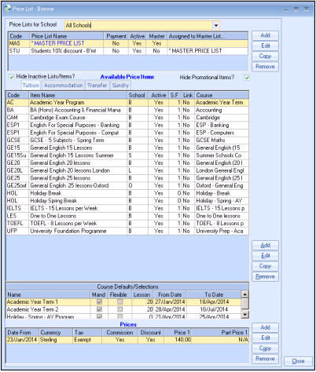

Input the Code and Name for your sub price list
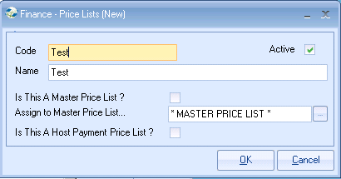
As a sub price list is being set up leave “Is This A Master Price List?” blank.
Assign the sub price list to a Master Price list from the list available.

Highlight your new sub-price list
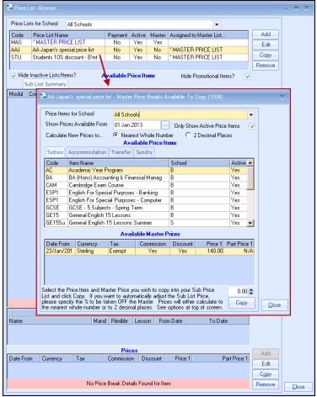

Click on Add
Now select the price item you want to add to your new sub price list and also select an item in the Available Master Prices section.
.
Note: A price item has to be added to the Master Price list before it can be added to a Sub-Price List.
Click the Copy button.

Click Close

You can now make the amendments to the prices.

Click on Edit

Amend the prices

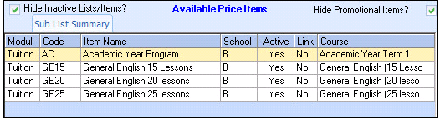

Click on OK.

This new Price List can be added in the Agents Finance Screen

