Class – Help Document


Date Wizard – Quick date changes to Enrolments

Note: For updating ‘groups’ please refer to help sheet SQL026 - Group Batch Update

From the Enrolment Browse screen, highlight the student, click on Date Wizard.


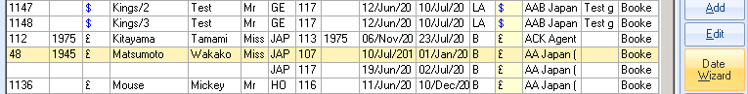

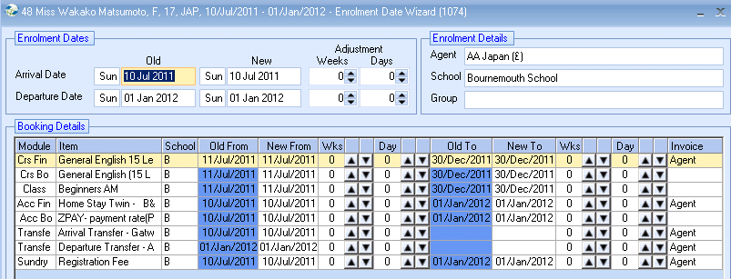
Arrival/Departure dates can be changed, with each booking element easily updated.

An option (at the bottom of the screen) allows the changes not to be re-financed (no re-invoiced or proforma change) if required.

If refinancing is not requested Finance screen dates are updated with the changes in red indicating that changes were made without accepting re-financing. An entry in the Log is also made. This also maintains the integrity of any statistical analysis e.g. Invoice analysis.

