Class – Help Document


How do I create a Package in Class?

Maintenance/Settings
Price Items section
Packages

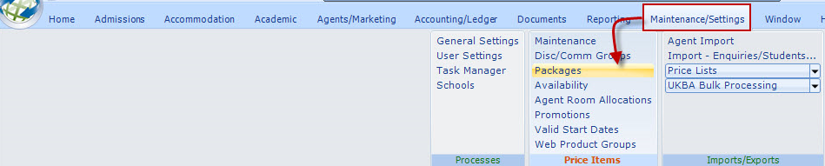

Select Add to create a new package.

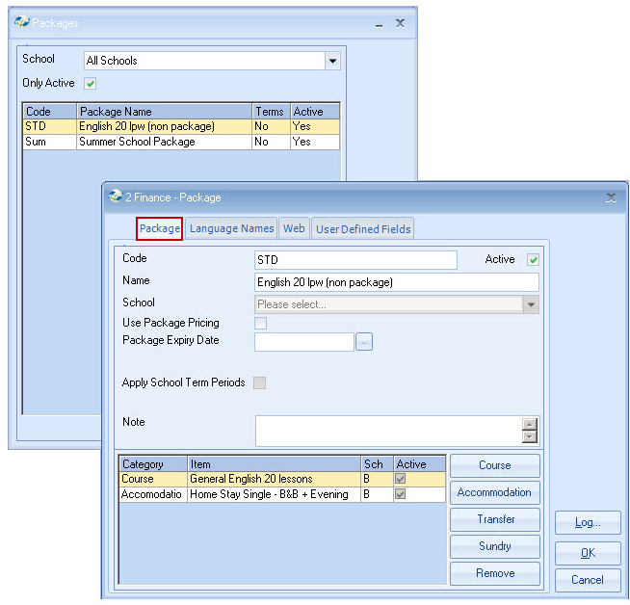
Two types of Package can be set up.

Use Package Pricing - (box ticked)
Product is sold at a Package price and can comprise of any elements, e.g. Course, Accommodation, Transfer, Sundry.
It is invoiced as a package, but the details are shown (with no price.)
E.g. Summer Vacation Package £1000.00 (value = sum of items)
Summer Vacation Course
Residential Accommodation
Arrival and Departure Transfer
(Accounting and Statistical analysis is held at detail level.)

Non Package Pricing - (box unticked)
Product is sold as single elements, the same as a normal enrolment, e.g. Course, Accommodation, Transfer, Sundry.
All items are invoiced separately. This provides a quick way of enrolling standard bookings. By entering the Package the system will book all items individually in one process.
E.g. Summer Vacation Course £650
Residential Accommodation £350
Arrival Transfer £40
Departure Transfer £40

Example: Package Pricing

Use Package Pricing - Tick if Package (comprising all items) is to be sold at a single package price.
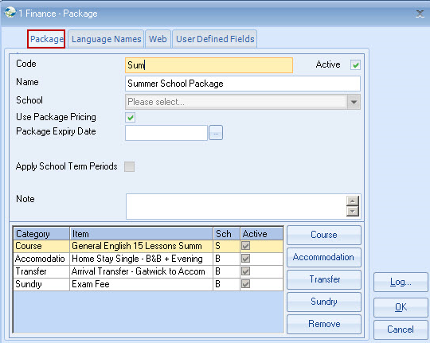

Example: Non Package Pricing

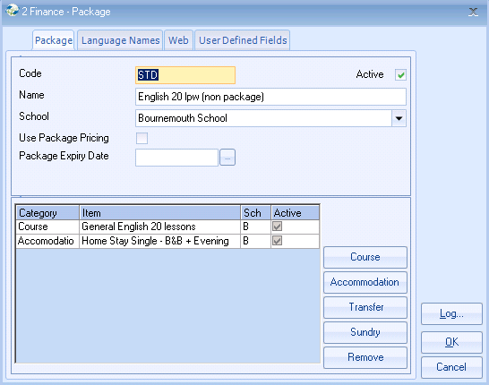

Same as Package, Except “Use Package Pricing” is not set.
All items are invoiced separately, as per an enrolment where items are entered singularly.

Code - is mandatory
Name - this will appear on the invoice - where use package pricing is set
School - select specific or All Schools

Expiry Date - enter a date if the package is not to be used after a specific date
(often left blank)

