Class – Help Document


Problem: We need to rename an Analysis Field and add a list of entries to be able to select from.

Solution:
Maintenance/Settings
General Settings Module
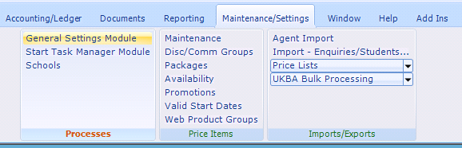

Analysis fields are available for:
Students, Enrolments, Agents, Accommodation, Teachers, Transfers.

The example below is for Enrolment Analysis:

Admissions
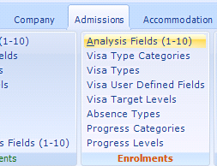

Enrolment Analysis Names
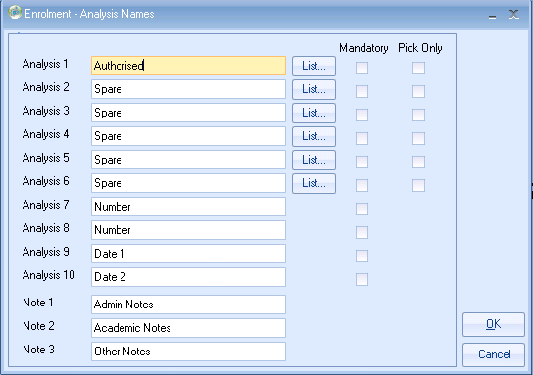
Enrolment user defined Headings. Enter a description (max 20
characters)

Note: if “Mandatory” is selected the user will be forced to enter values. Mandatory fields will be shown in red.
Note: ‘Pick Only’ option. This means that, if the option has been switched on, users will only be able to select from a pre-defined list when setting analysis field data. Analysis fields that are set to ‘Pick Only’ will have their browse buttons colour set to blue

Note:
Analysis 1-6 are used for Character values (1-30 chars)
Analysis 7-8 are used for numeric values +/- 9,999,999 (whole numbers only)
Analysis 9-10 are date fields
Note 1,2,3 refer to the Note fields attached to the Enrolment record.

List: Select List to enter values for the list box contents.

