
Class – Help Document

Problem: I need to be able to calculate the values of both accruals and
pre-payments regarding payments to host families.

Solution: Accommodation Accruals/Prepayments

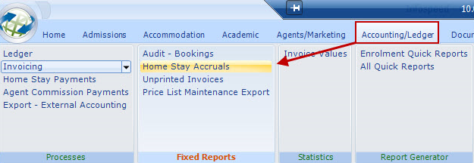

General
This provides the accountant with an accrual/prepayment list for accommodation prepayments.

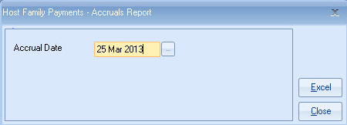

Date – Any date can be entered, typically a period end date. So for example a report could be taken out 3 months or 3 years! in arrears.

Calculation:
- The system ignores Accommodation payment runs on and after the selected date.
- Checks that the student was in accommodation between the payment date entered above and
- The last payment to the Accommodation provider prior to the date above.
- If the Accommodation Provider payment was the final payment then no accrual/prepayment is required.
- If the last payment date is less than the date above an accrual will be calculated for the period

- Up to the date above. The calculation will be a pro rata amount based on the last payment.
- It therefore cannot take into consideration possible seasonal price changes.

- If the last payment date, is greater than the date above a prepayment will be calculated for the period from the date above. The calculation will be a pro rata amount based on the last payment. It therefore cannot take into consideration possible seasonal price changes.

Report:

Days to be paid

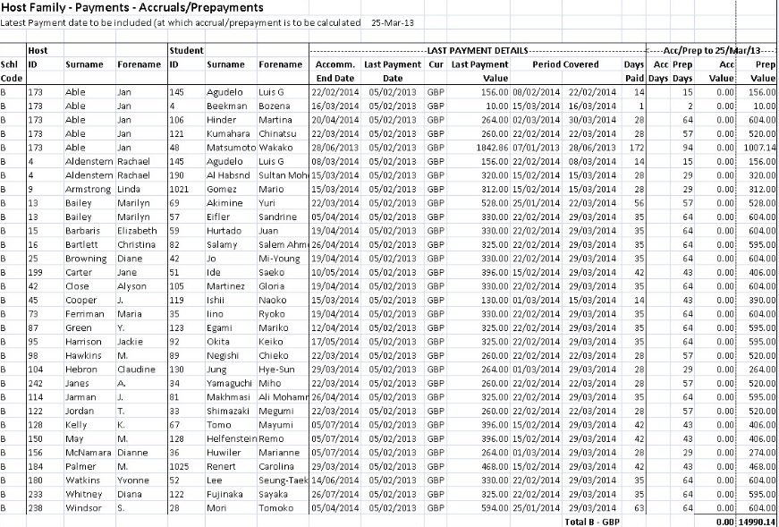

Days paid in advance

The report is sub totalled by College code, if applicable.

