Class – Help Document


Currencies – With Class Ledger in use

Maintenance/Settings > General Settings. Accounting > Currencies

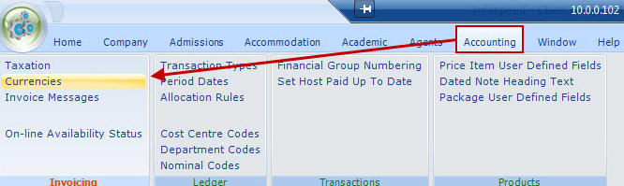

If the required currency is not listed select ADD to add a new currency
Alternatively, edit the required currency item.

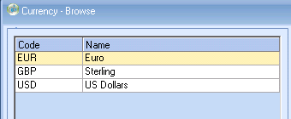

Set up the exchange rates for each currency.
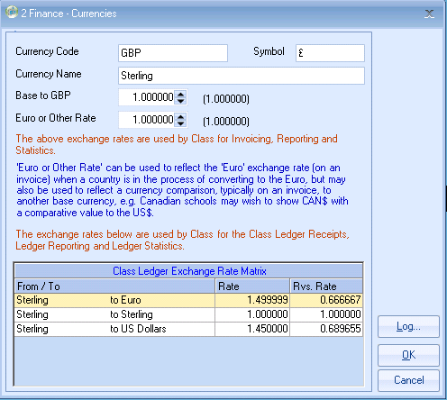

The Base to “UKP” Exchange Rate is as described above.
The Euro rate is a provision for the future.

Class Ledger Exchange Rates
$1 x by the exchange rate = Sterling.
In the below example:
€1 x 0.65 = £0.65, the corresponding Currency price list, e.g. UK to Euros is automatically created and updated.

