Class – Help Document 

Purging Documents

Problem: How can I remove old processed documents from Class

Solution

Purge Processed Documents.

To do this:

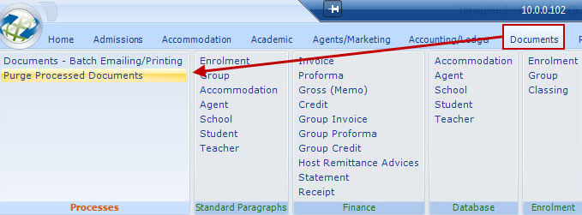

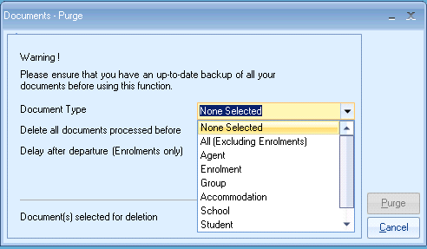

Select Document type – “enrol” for enrolment documents.
Note: Invoices/Proformas are NOT removed regardless of criteria

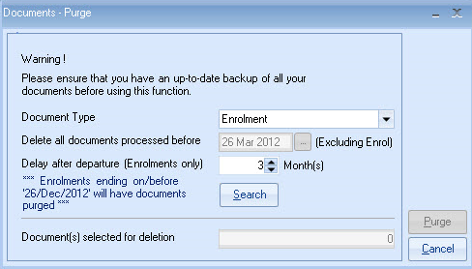

- Select “months” after departure e.g. 3
- Select Search and the system will advise number of documents to be deleted.
- The Documents screen (in the Enrolment) will continue to show that the document was produced, but the actual Word document is deleted. Attempting to display the document will automatically recreate the document.

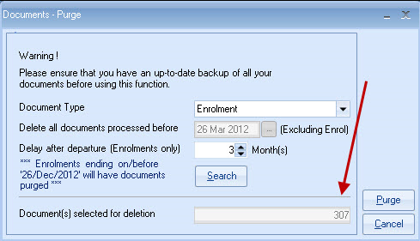

Purging non enrolment documents will display a date option for the purge.

