Class – Help Document


Problem:

- A student is not included in an Accommodation
Booking Quick Report
- Unable to book student with host (error displayed)

Things to check:

Check the students’ accommodation to ensure it is booked correctly.
To do this, double click on the accommodation line as indicated by the arrow in the diagram below.

Check that there is an Accommodation Booking attached in the bottom section of the screen. If it is blank as shown in the red highlighted area below, click on Add and choose the correct accommodation item from the list.

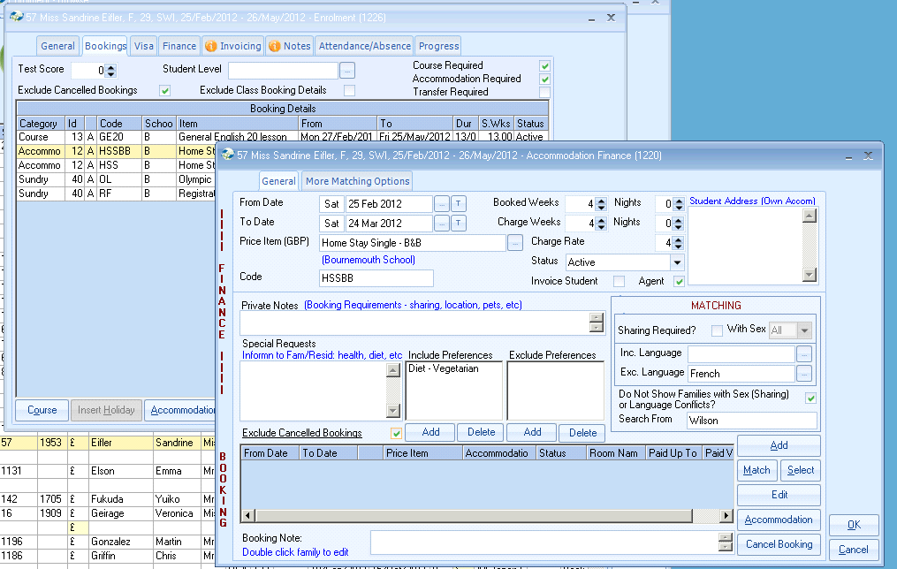

Question: why was the accommodation not booked automatically?

Go to Maintenance/Settings > Admin-General > Price Items > Maintenance...
Highlight the accommodation price item.

Under the heading called ‘Payment Price Item’ there should be an accommodation name listed.
If this is blank as shown against “Hotel C” the student accommodation booking will not be attached.

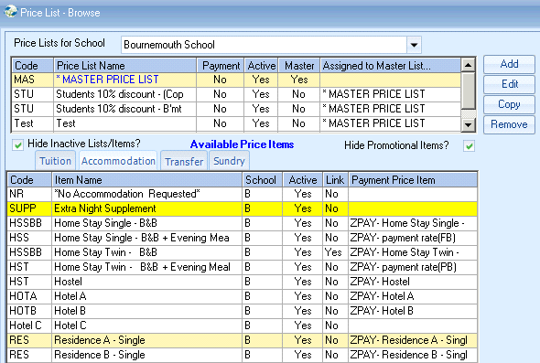

Scroll down the list and you will see items called Z… or ZPAY…
These are the Payment Price Items (normally displayed in yellow).
Check there is one to go with Hotel C

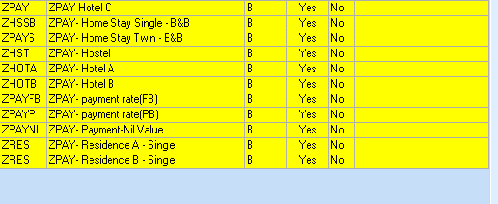

Double click on the price item to see the “Booking Defaults” is blank.

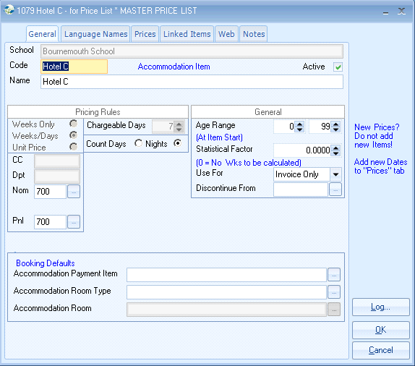

Click to open the list of Payment Items and select the correct one.

When you next book a student in to this accommodation, both the price item and the accommodation booking will automatically be attached and the student will appear in the required report and be available to assign families.

