Class – Help Document


Documents – Classing Master Documents
Designing your own Class Lists / Registers

Documents / Classing

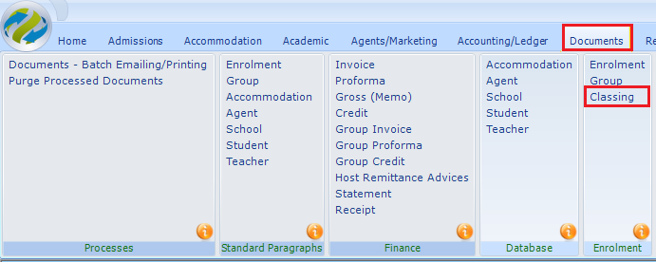

The Classing document allows user defined Class Registers/Lists to be produced.

We provide 7 example documents that are based on the standard classing reports. These can be used as your templates and you can add/remove information to get your required results.
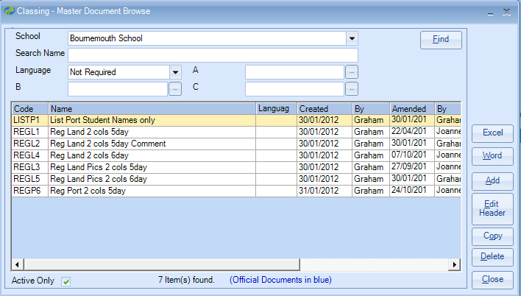

The Classing documents can only be used in “Automatic Classing” or in “Classing – Word Merge.”

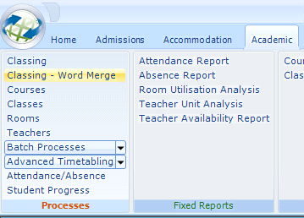

Although the creation of the document is the same as an Enrolment document the system allows multiple students per single document.

With an Enrolment document a single students details are merged into the document i.e. one document per student. In a Classing document all the students within a Class may be merged into a single document, typically a class list using multiple occurrences which consist of the merge field plus, /1], /2], /3], /4] etc.

Example document:
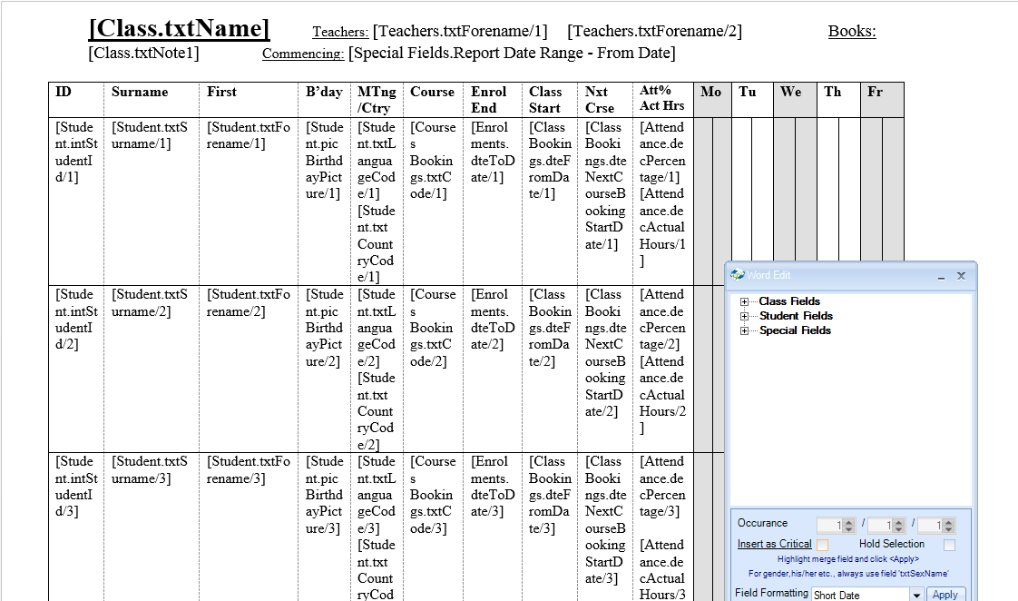

In the above example the student’s details have been repeated (to a maximum of no. of students in a Class e.g. 14)

Result:

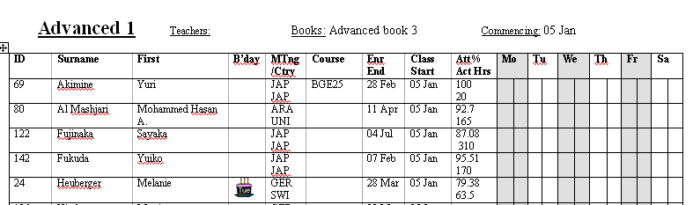

Note the option to print the birthday cake (or date) if the student’s birthday is within the selected date range. If registers/lists are not weekly then it is best to display the date.

