

Class – Help Document

Timetabling

QUICK START-UP LIST:

Below is a “Quick Start-up” sequence, but for more information refer to the Detailed Start-up List

You can experiment using your live system, and suggest having created the basic information as given below that you pick a week say, 2-3 weeks ago and proceed to allocate Classes and Teachers to the Timetable. This will have no effect on your current weeks Classing etc., but if found to be useful the data can be copied forward to a current week……good luck!

Timetable Templates
- Academic
- Advanced Timetabling
- Timetable Templates
- Add a New Timetable template
A separate timetable is required for each School, regardless of whether time slots are the same. Only one Timetable at a time can be checked for conflicts/availability.

e.g. 09.00-10.30
10.30-10.45 Break
10.45-12.15
Etc

Set colours, e.g. grey for breaks, yellow for morning slots and blue for afternoon slots. Update the # of lessons for each time slot (default = 1).

Schools
- Maintenance/Settings
- General Settings
- Schools Unavailable Types
- Set school unavailability, public holidays, school closures etc.
If school is not based on Mon-Fri starting on a Monday, then update

Rooms
- Academic
- Processes
- Rooms
Set maximum capacity for room
Adjust Code length – Timetable displays approx 4 characters.
Set Room unavailability, for other uses/bookings
Indicate if “hired in” room
Set Colour if useful, otherwise leave unset to start

Classes
- Academic
- Processes
- Classes
Set default timetable
Set default Payment Unit (Hours or Lessons)
Select Used By

Teachers
- Academic
- Processes
- Teachers
Set -Teacher unavailability, holidays, appointments etc.
Set - No. Pay Units per week, if required. (Hours or Lessons)
Set - Colour if useful, otherwise leave unset to start

Timetable Plan
- Academic
- Timetabling
- Timetable Plan
Drag Classes (to Rooms), then Teachers (to Classes) and follow prompts.

Timetable Views
Select View (Class, Teacher or Room) and print to Excel if required.

Print Timetables
Timetables are available for Teachers, Rooms, Classes and Students. Either on an individual or batch basis.

Reports
- Teacher Unit Analysis
- Room Utilisation Report

Important:
When producing the Standard “Crystal” registers/lists etc., or the Word Merge documents, the system will check if there is any timetable record (teacher or class) for that week, and if so, replace the teachers shown in the class record with those in the Timetable.

It is, therefore, recommended when “playing” with Timetabling that it is done with historical dates, until such times as the system is live.

DETAILED STARTUP LIST

Timetable Template
- Academic
- Timetabling/Timetable
- Templates

A separate template is required for each school, regardless of whether time slots are the same.

Add all likely time slots to the timetable on creation as time slots cannot be inserted at a later stage. (Time slots can only be added to the end of an existing template). For example, if an evening time slot is seasonally or occasionally operated then include in the template. The time slot can be marked “inactive” for periods when not required. If a timetable is used and then found to be incorrect, set as inactive and create a new one.

Class does not check across multiple templates for conflicts/overlaps i.e. Teachers, Rooms, and Classes, as each timetable is discrete. So for example, if a Teacher was booked in the same time slot in 2 separate Timetables Class would not warn of the conflict.

Multiple timetables should be used where separate departments exist, requiring different time slot intervals e.g. 1 hour slots instead of 45mins slots.

A single template is best, where possible

Create a template for ALL time slots – Set colour for bookable time slots e.g. yellow for mornings, blue for afternoons. These can be changed later if required.

Add the number of lessons for the slot. In the above example 90mins covers 2 x 45min lessons.

Non Bookable time slot - Set colour to grey

Typical Template:

Schools
- Maintenance/Settings
- Processes - Schools
- Set Unavailability (public holidays etc)

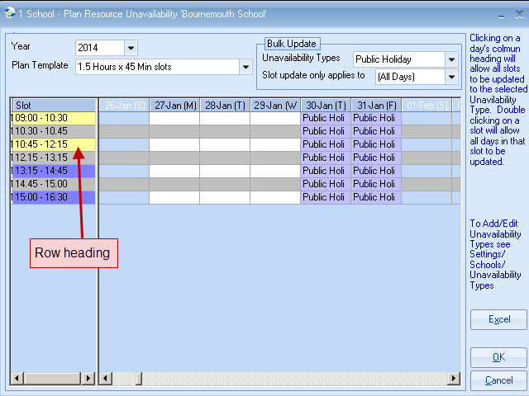

- Scroll the calendar until a public holiday date appears, then select Unavailability types - Select as appropriate e.g. Public Holiday
- Slot update only applies to – Select as appropriate e.g. All days
- Click date heading e.g. 27 August, and you will see “Public Holiday” appear in all the time slots for that day.

- Individual time slots can be selected as required.
- Row (Time slot) Headings can also be selected.

Unavailability types are created in:
- Settings
- Schools
- Unavailability types.

If school is not based on Mon-Fri, starting on a Monday, then update the School Timetable

Student Timetable Default Note.
Use this to record a note which will appear on all Student Timetables

Rooms
- Academic
- Rooms

- Set maximum capacity for each room
- Adjust Code length - Timetable only displays approx first 4 characters!
- Set Room unavailability
- Indicate if “hired in” room
- Set Colour (if useful – leave blank initially)

Classes
- Set Default Timetable
- Set Default Payment Unit if required (Hours or Lessons)
- Change Used By, if it is a dummy Class only for Timetabling e.g. a Class for “reserve” teachers or a marking Class.

Default Timetable
Payment Unit

- Set default Payment Unit. (If not required leave = 1)
Typically this will be 1, which may represent a lesson or an hour.
Class multiplies the number of lessons assigned to the time slot in the template (e.g. 90min time slot = 2 lessons) by the “payment unit” above and reports on this in the Teacher Unit analysis.

- The “value” attributed to this Class could be adjusted according to the type of lesson, for example:
If General English = 1.00, then Business English could equal 1.20 i.e. 20% more than General English.

- Resource Type – Leave set = Both
Dummy Classes can be setup for recording non “Class” work, e.g. marking, preparation time, standby time etc. In this case set the Resource Type to Timetabling only.

Teachers
- Academic
- Teachers

Set Teacher unavailability, holidays, appointments etc.
It is useful to note that time slots for the whole year can be updated by selecting the Unavailability type e.g. “not available,” then clicking the time slot e.g. 15.00-16.30, indicating that the teacher does not work in that time period.

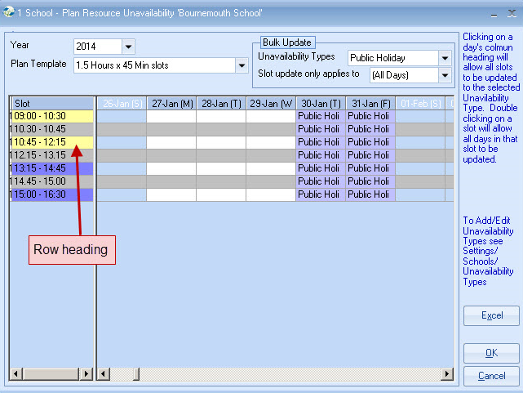

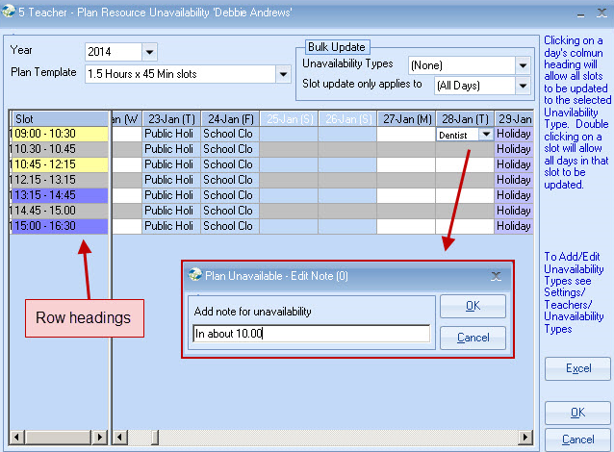

Additional information can be added by double clicking the cell. This information “in about 10.00” will be available when setting the Timetable.

Set No. Pay Units per week (Hours or Lessons)
Set Colour (if useful)

No. Pay Units per Week

The No. of Pay units can be set (Hours, Lessons, or Slots), indicating the contractual or budgeted weekly units for the teacher. In the Timetable this is compared and shown with the actual units.

Grade – 6 char field which shows on the Teacher Unit Analysis report.

Timetable Plan
- Academic
- Timetabling
- Timetable Plan
Add Classes, then Teachers and follow prompts.

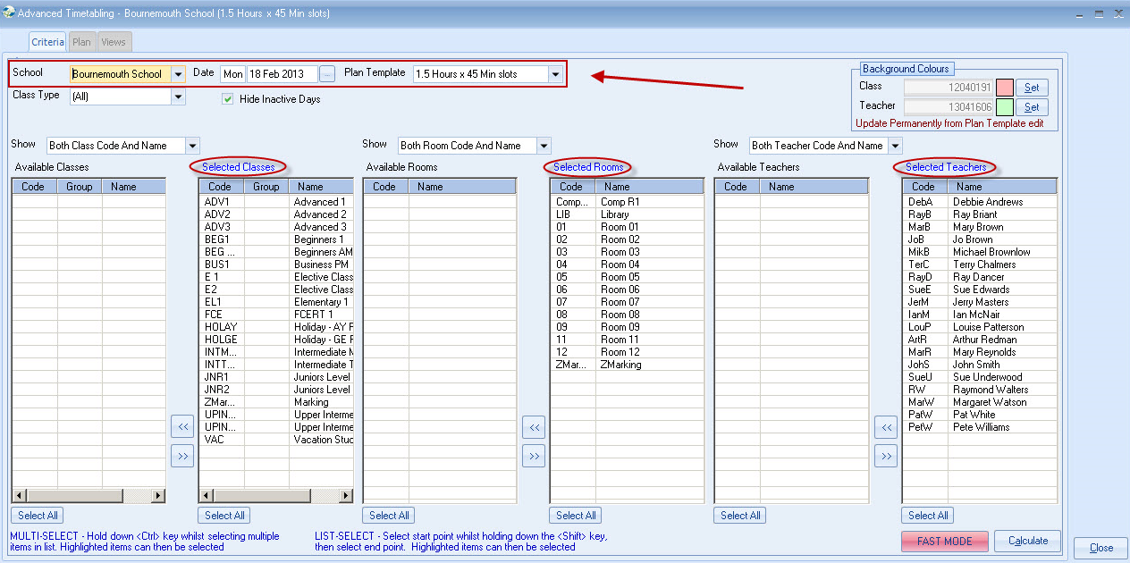

- Select: School, Start date, and Template.
- Class and Teacher colours may be changed (for testing best colours) but once decided, update permanently in Timetable Templates (Edit).
- Select Calculate to display Timetable.

- Classes need to be added first, followed by Teachers.
- Drag Classes/Teachers as indicated.
- A number of checks take place and warnings displayed of conflicts/over booking situations. Screen colours also change to indicate continued presence of possible conflicts.

For example: 2 Teachers in 1 Class
Cell shows in Orange, Double click to show second (or third etc) teacher. Teachers can be dragged to another Class or returned to the Teacher List.

Classes can be dragged to another Room, and if a teacher(s) has already been allocated, then the teacher is automatically moved to the new room as well.

Hovering over a RED teacher cell will display any message.
Alternatively, teachers with any unavailability (background highlighted) can be selected (double click) to show details.

Insert Once – This will simply drop the teacher into the selected class and is how the system has worked historically.

Insert in All Empty Classes – When the teacher is dropped into a class, they will also automatically be dropped into every other occurrence of the class where no teacher has been assigned to it.

Replace in all classes – When a teacher is dropped into a class where a teacher has already been assigned, the existing teacher will be replaced along with every other occurrence of that teacher where they have been assigned to that class.

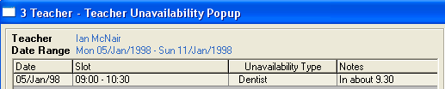

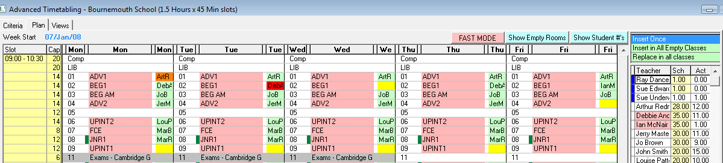

The “Fast” Mode will remove all the colours and some validation, but will make the drag/drop process a lot quicker.
Experiment with the other button around the screen.

Timetable Views
Select View (Class, Teacher or Room), output to Excel if required.

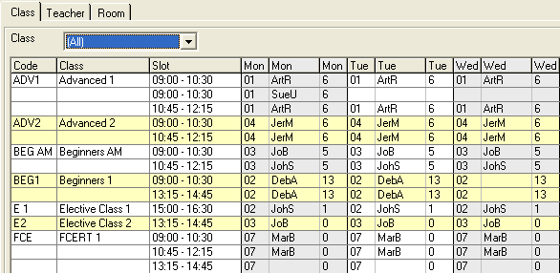

Batch Timetable Production
Timetables are available for Teachers, Rooms, Classes and Students. Individual timetables can also be produced via the individual Class record. A note at the bottom of each Student’s timetable can be pre-set (but changed at run time) – See School (Timetable).

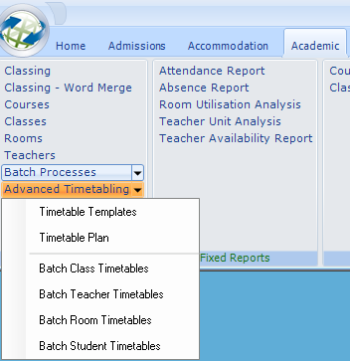

- Timetables can be emailed or printer
- An “extended” version of the following timetable is also available.

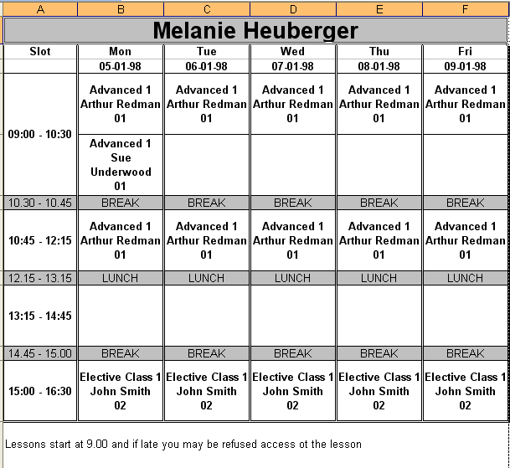

Reports

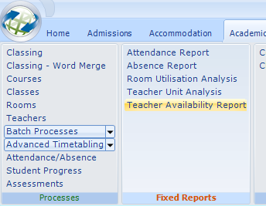

Teacher Unit analysis

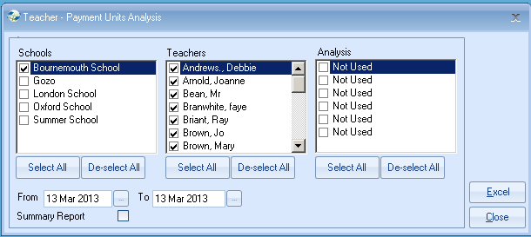

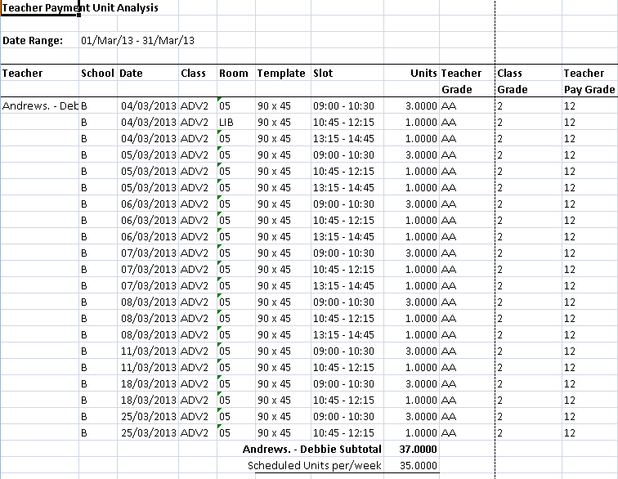

Teacher Availability Report

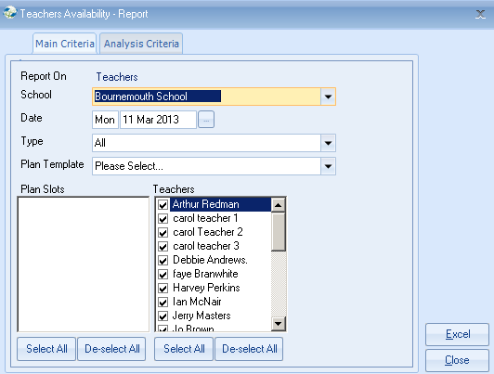

Analysis criteria is available on the second tab.
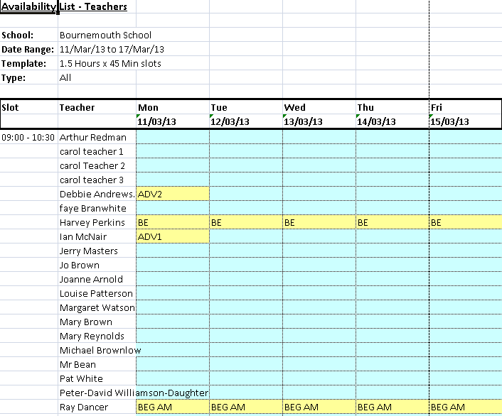

Room Utilisation Report
The report excludes Dummy/Hired in Rooms. See explanation at bottom of report for calculations.

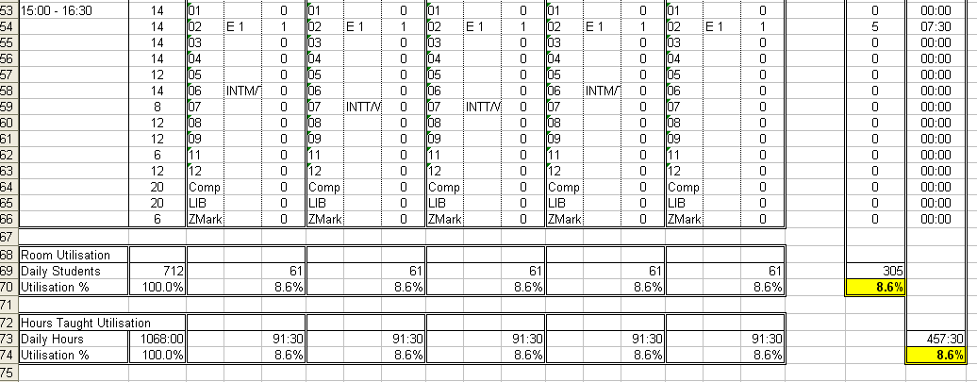

Timetables can also be produced individually for Students, Teachers, Classes and Rooms directly from each individual record.

Important:
When producing the Standard “Crystal” registers/lists etc., or the Word Merge documents, the system will check if there is any timetable record (teacher or class) for that week, and if so, replace the teachers shown in the class record with those in the Timetable.

It is, therefore, recommended when “playing” with Timetabling that it is done with historical dates, until such times as the system is live.

