

Class.Net – Help Document

Availability

Availability can be created for tuition, accommodation, transfers and sundry.

Maintenance/Settings > Availability:
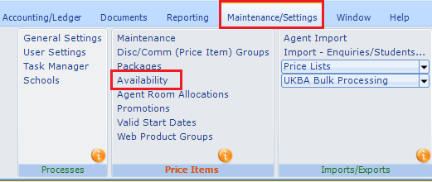

Availability works for both Class and Class Web options, but has particular relevance to web bookings, where human intervention is not available to make the decision on whether or not a booking can be accepted!

Availability enables the setting of daily/weekly limits for a product or group of products. For example, a “Home Stay” group (which links all the home stay accommodation Price items together) could be used to stop over booking occurring on particular days or weeks. Similarly, an individual residence which has a limited number of beds could be set to prevent over booking.

Tuition items can also have availability set to ensure courses are not overbooked on a weekly basis.

The Availability function also allows “Minimum” and “Maximums” to be set, allowing for the following type of controls:

- 2 weeks = minimum course booking duration
- 4 weeks = maximum course booking duration
- Summer Course = 2 week minimum/4 week maximum, at start of summer, but 2 week minimum/2 week maximum for the last 2 weeks of the summer. The minimum/maximum values can be adjusted on a day by day basis to reflect the options available.

Examples:
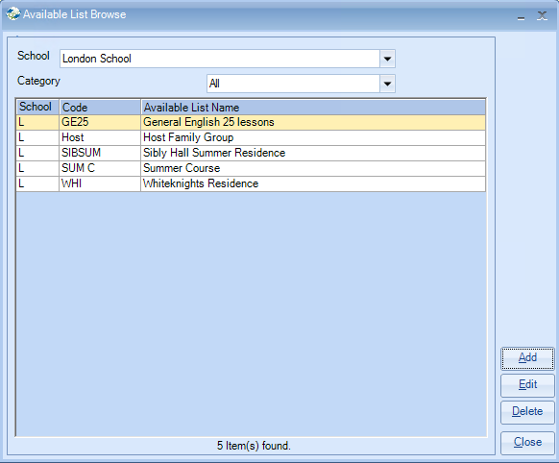

Select the category and give the item a name.

Accommodation: Whiteknights Residence – all year residence:

Ensure the Value (numbers available) and enter the date range – select Update
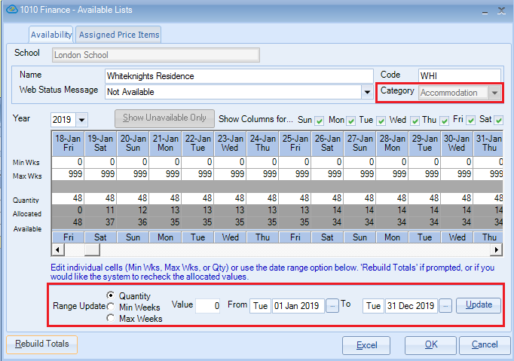

Quantity = number of spaces available (for accommodation this would be the number of beds available)

The Quantity available can be entered either on a cell by cell basis or by using the “Range Update” option. This sets the availability and may be changed to reflect day by day situations. For example, a residence may have variable availability during the summer period.

Minimum and Maximum values can be entered in the same way.

Assigned Price Items

Price items need to be assigned so Class knows which Price Item(s) are to be controlled by this function. In the above example Residence Price Items have been selected.

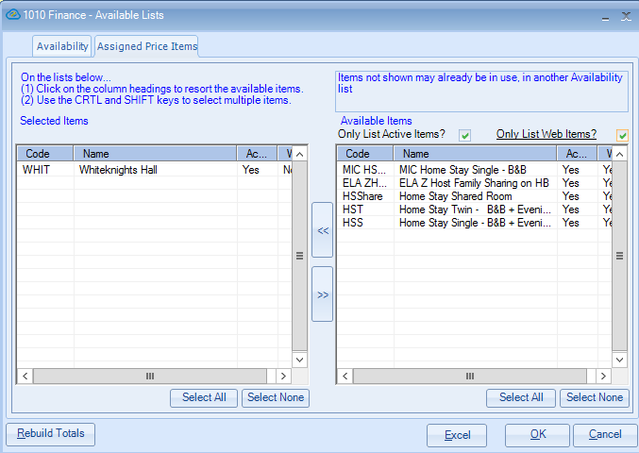

Please note the filters at the top of the screen, particularly the “Only list Web Items,” which will restrict the list to only those which have been Web enabled.

When OK is selected the “Rebuild Totals” function will automatically calculate the current position. Class will then maintain these values automatically.

When viewing the availability, the “Rebuild” option can be run to recheck the displayed totals, although Class will maintain them automatically.

The example below shows a summer course which runs for just 2 weeks.
The course can only be booked for the 2 week duration.
Therefore, the Min Weeks and Max Weeks have both been set to 2.

When the course is added only a 2 week booking will be available for the weeks of the availability.

Select Min Weeks – enter the value (2). Enter the date range – select Update
Select Max Weeks – enter the value (2). Enter the date range – select Update
