Class – Help Document


Automatic pre-Classing of students before they arrive

Students can be classed (into the future) directly from the booking entry.

What Courses?
Any course, although it has maximum benefit where the course automatically defines the class in which the student will be taught e.g. a course not requiring level testing.

Other options
- Even with General English or Cambridge courses, which may require level testing prior to classing, it may be helpful to pre class students into a “new Cambridge Class” or “new GE Class” class, so academics can clearly see the inflow of new students (and extensions) out into the future.

(From the automatic classing “move” screen (using the drag/drop option) the students can then be moved to the most appropriate class.

- With imagination more useful breakdowns may be achievable!

How?
In a course add a default class
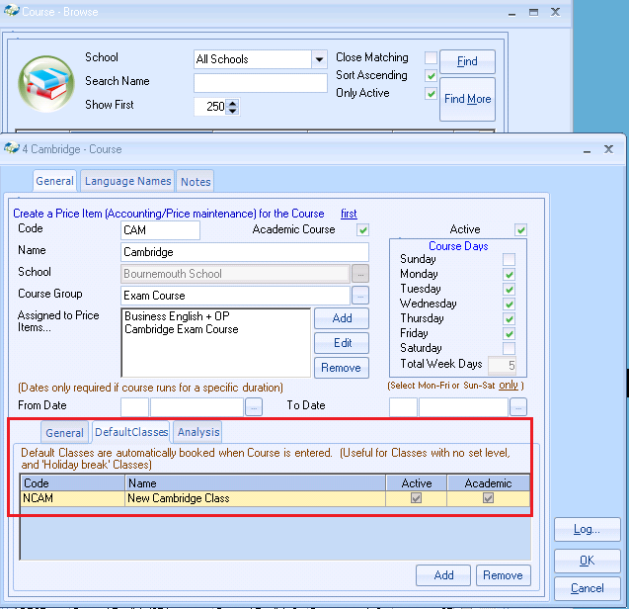

When you add this course to an enrolment the Class will automatically be included.

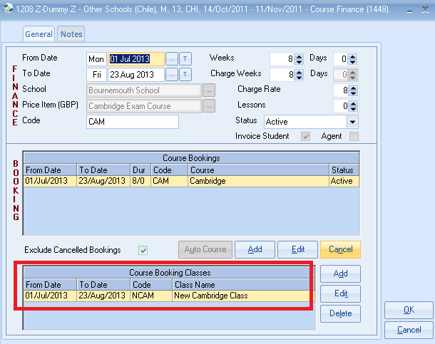

Automatic Classing
The student(s) can be moved to their correct class through the drag & drop facility.

