Class – Help Document


How to produce a profile document for a group.
(one document listing each student in the group)

Create the master document - Documents > Enrolment > Group…
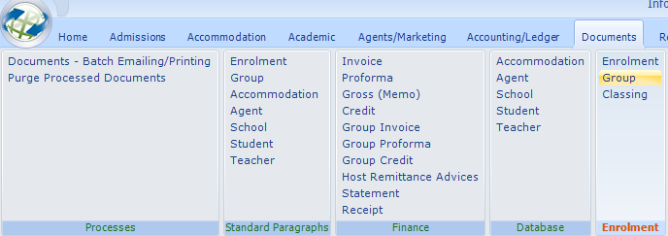

Select ADD to create a new document.
Enter document name.

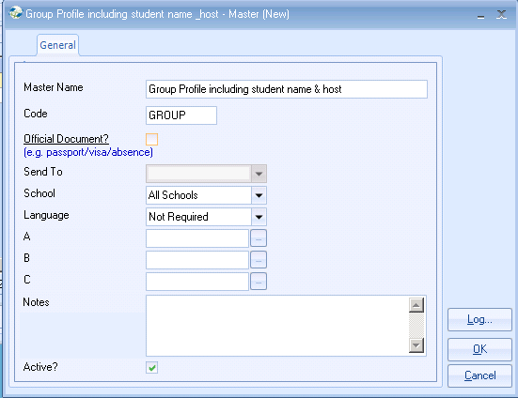

Example Document:

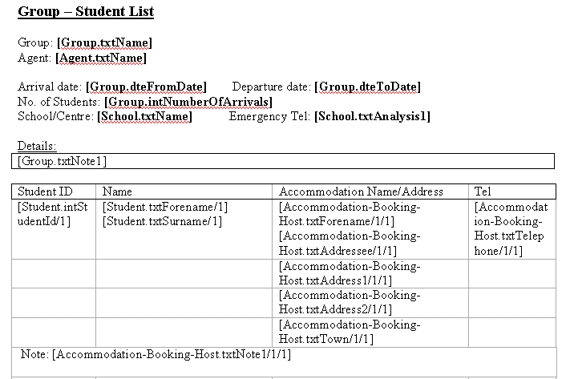
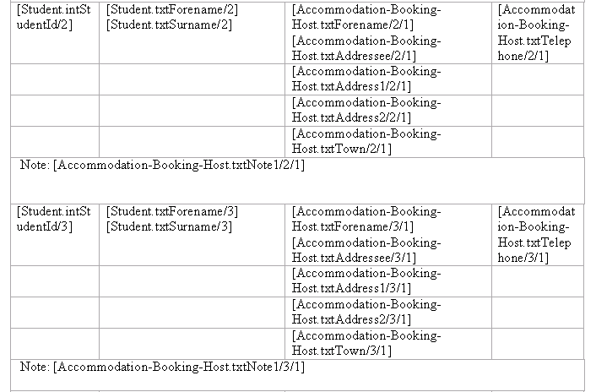

Add the required fields from the ‘Word Edit’ box.

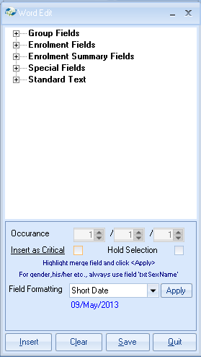

You will notice in the example document that the fields are duplicates several times. If you receive groups with up to say 50 students arriving, you must enter the fields for that number of occurrences. E.g.

[Student.txtForename/1] [Student.txtSurname/1]
[Student.txtForename/2] [Student.txtSurname/2]
[Student.txtForename/3] [Student.txtSurname/3]
[Student.txtForename/4] [Student.txtSurname/4]
[Student.txtForename/5] [Student.txtSurname/5]
[Student.txtForename/6] [Student.txtSurname/6]

Once the master document is complete select SAVE from the Word Edit box.

To merge the document:

- Go in to the group and click on the ‘Documents’ button on the right hand side of the screen.
- Select ADD
- Chose the document name from the list.
- Select ‘View Doc’ to display on the screen before printing.

