Class – Help Document


AGENT MAILING - Document Emails

Problem

I need to produce a list of Agents to email a mail shot.

Solution.

Step 1.

Within Class create a new “Agent” type Document.

In this document insert the required merge fields and text.
Example document:

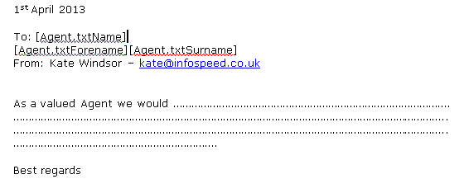

Select “Save” from the Word Edit box to save & close the document.

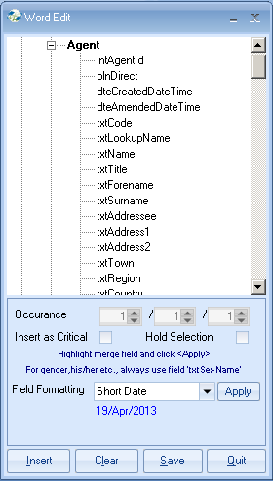

Step 2.

- Go to Quick Reports and create a new report.
- Ensure the report type is set correctly as “Agent”.

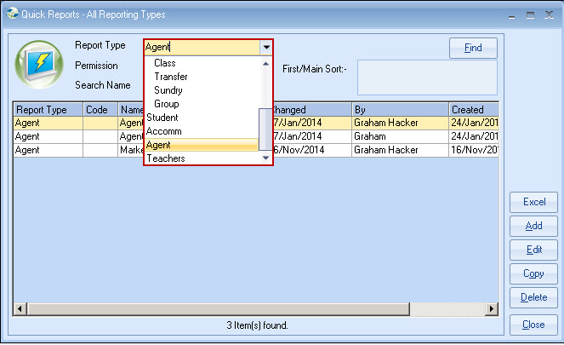

- Add fields and criteria to the report that will select the required records that are to be included in the mailing (similar to the following).

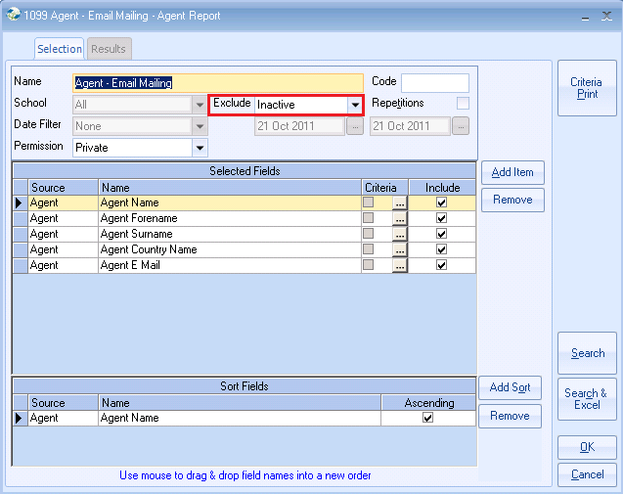

- Exclude – Inactive:
The above selection will include all Active Prospective and Suspended Agents.
To run the report for just Active agents you will need to add the following field and criteria to the report:

Criteria: Equal To Active

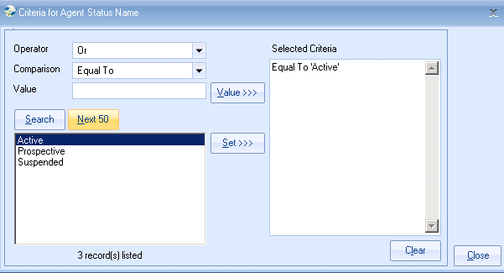

To include just agents from say country China, add the following field and criteria:

Field: Agent Country Name
Criteria: Equal To ‘China

- Select Close
- Click on ‘Search’ to display all the Agents that match the selected criteria.

By including the agents email address in the report you can quickly see if any agent email addresses are missing.

Note:
Double clicking on the name of the agent in the list will take you directly to their Class record, where you can update their email details.

To Send a Document

- Click on “Send Document

Master Document – search and select the document to be sent to the selected agents by using the Find button.

Send By – E-mail to email all agents in the list.
or set to Printer if you wish to print the documents.

Send To All – unticked box will only produce a letter for the first agent in the list. Ticked box will produce a letter for all agents in the list.

Send Now – ensure this box is ticked to email/print the documents immediately.

Select OK to start the merge.

Note:
Each of the emailed documents will be added to the agent’s record within the Documents screen.

