Class – Help Document


Group Date Wizard

This feature enables the dates of a whole group of students to be amended from a single screen…

(Also see help sheet SQL026 – Group Batch Update)

- Go to the group browse screen, highlight the group to be amended and select the Date Wizard button.
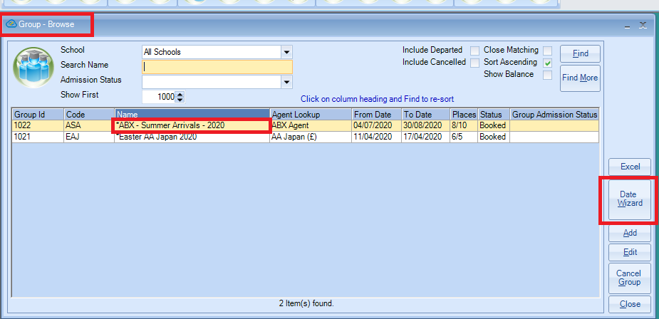

- The name of the group is listed in the header.
- The screen is split in to two sections:
Group Header – this displays the current Group Arrival & Departure dates.
Booking Details – this displays all elements of the student’s bookings.
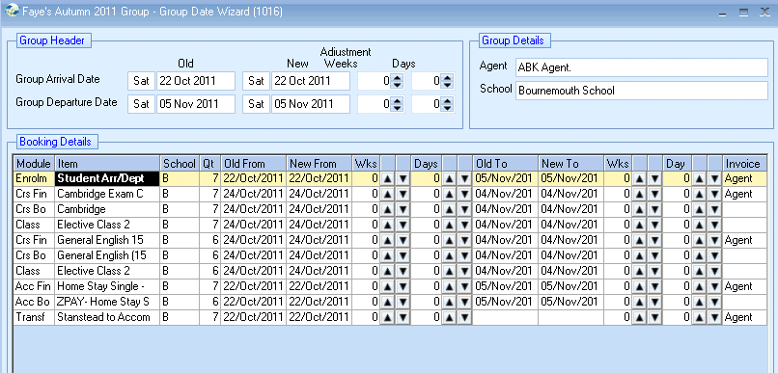
Example for use:
A group has been delayed due to visa issues and will now be arriving a week later and departing a week later.

- Firstly, amend the Group Header details.
- Use the up arrow to amend the Weeks to 1
- You will notice the “New” arrival and departure dates have moved on by 1 week.

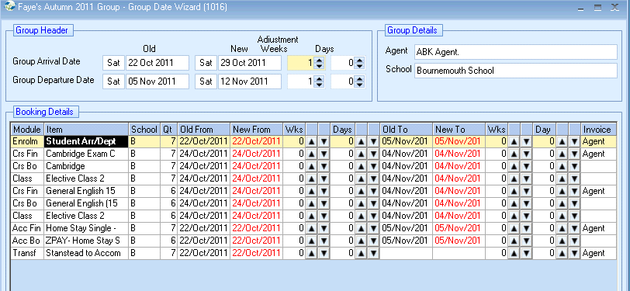

Once the header dates have been updated you will notice that the booking dates are displayed in red. This indicates that they are not in line with the header dates and therefore, also require updating.

Firstly, work down the list of “New From” dates and click on the up arrow once to change each item to show Wks “1”

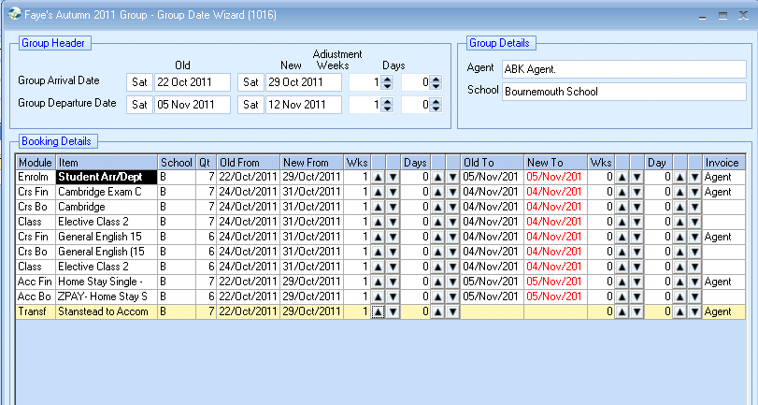

Now work down the list of “New To” dates and click on the up arrow once to change each item to show Wks “1”

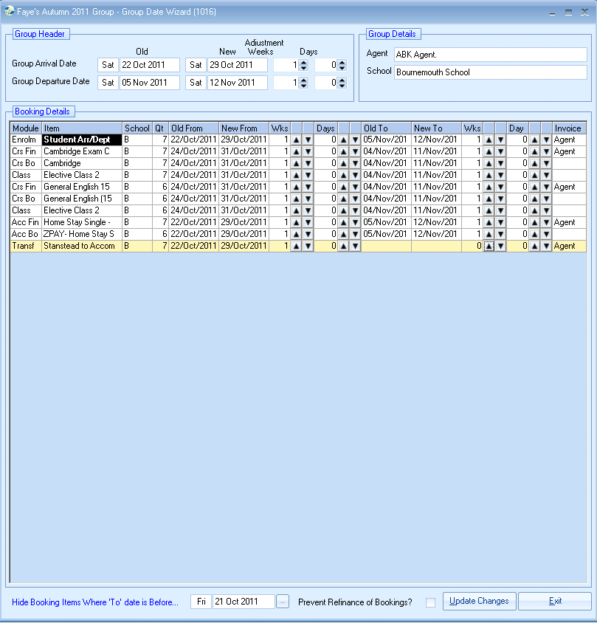

All the dates should now be displayed in black.

“Prevent Refinancing of Bookings?”
If you have organised a special group price with the agent we would recommend this is ticked to stop the finance from being recalculated.

Once happy with the dates select “Update Changes”
Select YES

This will work through the group and update all dates for all students.
Once the process is complete the new dates will be listed.
Select Exit.

For Information:

- Promotional items are not shown in the list but are automatically updated or cancelled by Class based on the promotion’s settings.

- You do not have to amend all the dates, for example you may just want to amend the course finance and course booking dates under the Booking Details.

- If a group is arriving and/or departing earlier use the down arrow to minus the number of weeks/days.

