Class – Help Document


Invoice Batch Print

- Accounting/Ledger
- Invoicing
- Batch Print

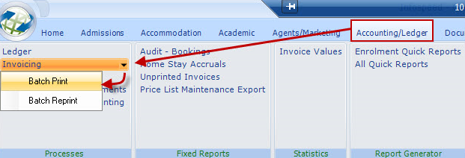

General:
The invoice batch print should be run at least once every month to ensure Proformas are converted to Invoices/Credits (for posting to the Nominal Ledger).

Users not printing Proformas on a “one by one” basis (as enrolments are created/amended) should run the batch print on a daily basis.

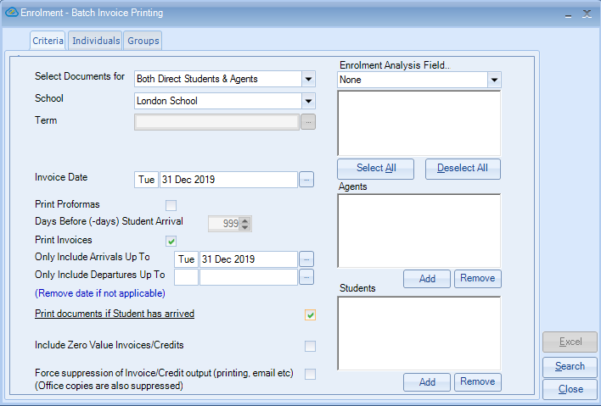

If you are a Class administrator or if you have the user permission ‘Invoice Batch override Invoice date’ ticked, you will be able to enter an ‘Invoice Date’ more than 30 days in the past.

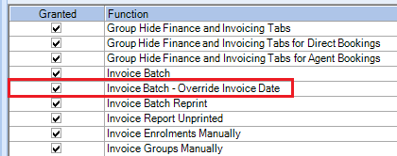
Proformas meeting the criteria set out in the Agent Rules are converted to invoices/credits and Unprinted Proformas meeting the criteria are also created.

Agent Rules from agents record / Finance

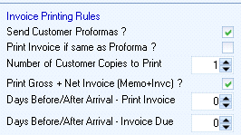

- Documents may be printed or emailed according to the Agents/Students rules.
- Individual and Group (separate tab) bookings are listed. Individual/Group items can be selected or deselected as required.

Note – Groups
Group bookings are not selected automatically to print, and Group Gross (Memo) invoices are not printed in the batch run. If required they should be printed direct from the Group.

Force suppression of Invoice/Credit output (printing, email, etc) -
This will enable the documents to be processed but not physically sent out,
so for example if the student/agent has paid from the proforma, they wouldn’t wish to receive a final invoice. The final invoice must be processed for accounting purposes, but at this point you would force suppression so the documents are not resent.

Make your required selection and select Search

Individuals

Untick any invoices you do not wish to process in this batch.
System integrity
If credits are deselected from printing, then the related invoice will also be deselected.

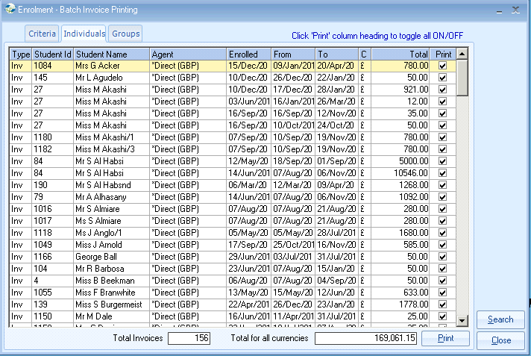

Groups

Tick the items you wish to print in this batch
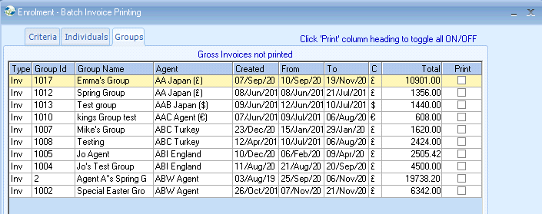

Output:
- Print or Email documents
- A control report is output to Excel advising all invoices printed

- An Exception report is also printed listing unprinted items with reasons:
- Provisional bookings, not eligible for invoicing*
- Invoices on Hold

* Assuming system setting rules set “NOT to print invoices for provisional bookings”

You can “reprint” a batch of invoices:

- Accounting/Ledger
- Invoicing
- Batch Reprint
- The selection screen is self-explanatory.

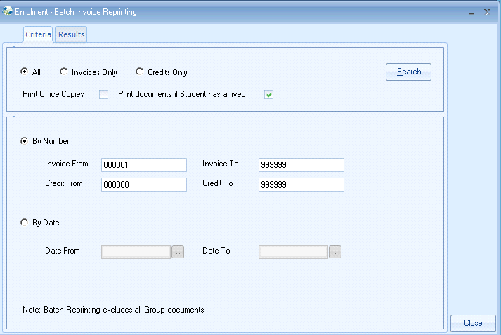

You can produce a list of unprinted invoices:
- Accounting/Ledger
- Unprinted Invoices

