Class – Help Document


Agent/Student Statements

Problem

How do I produce Agents/Student Statements?

Solution.

Go into Class Ledger

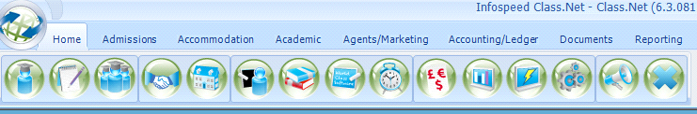

Select:
- Reporting
- Statements
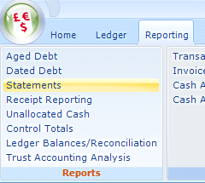

The following screen is displayed so that you can select the accounts that you wish to produce statements for.

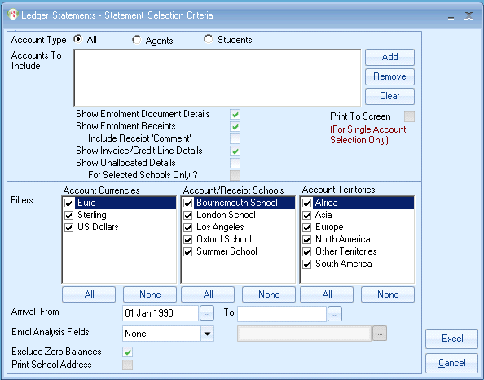

OR

You can also produce a statement from within the Account

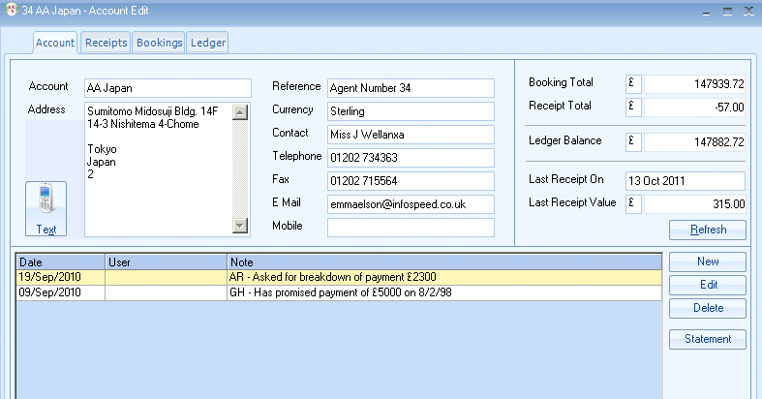

OR

From within the main Agents main record, select the Students tab and there is a statement button at the bottom of the screen.

