Class – Help Document


Import Groups

Overview
The import function allows a file of Groups to be imported into Class.
Typical uses would be a list of students that are sent to you by an agent to be imported into Class.

You will need to create a Group firstly, from the screen below select Add.

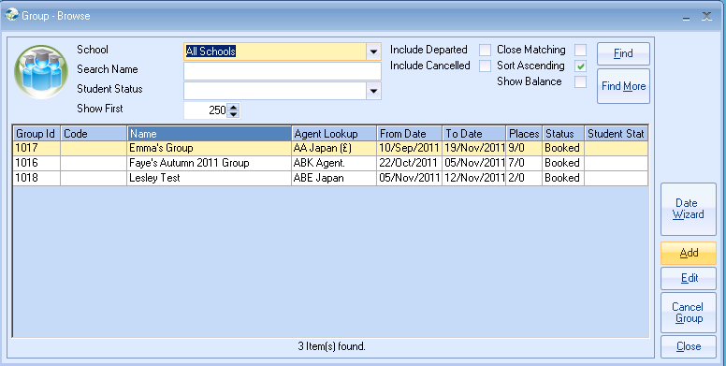

Add the first student to the group adding the course, accommodation, transfer and sundry items.

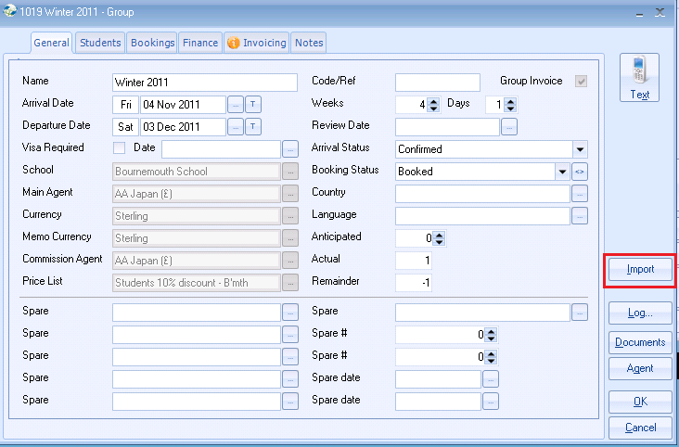
Once you have added the first student to the group, select Import.

Import File Format

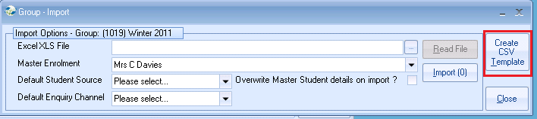

Select columns to be included on Excel Template
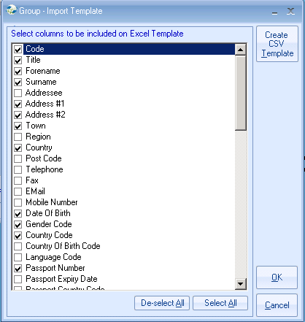

Select Create Excel Template to see details of the layout and the rules that are applied.
It must be saved as an xls type document to import correctly. Then click on the Group – Import template screen.

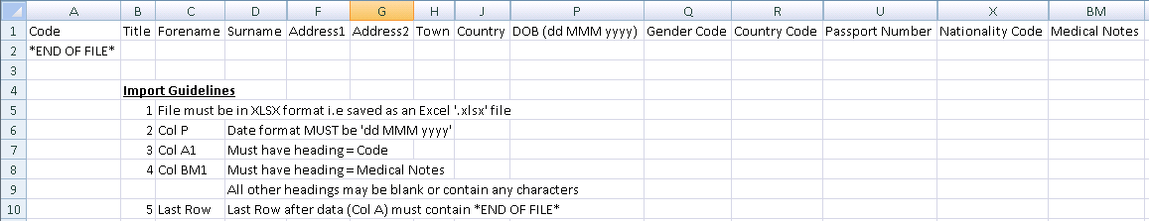

Import Process

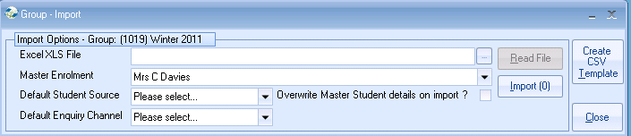

Enter file name, or use the browse button to search for the import file. Select from the other options as required (“Import as” is mandatory).
Select “Read File,” to initiate the checking process. A count will appear in the top right hand corner.

On completion the screen will indicate how many records are to be imported.

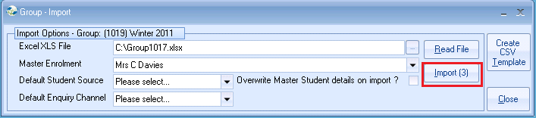

Select the Master Student Enrolment you want to copy.

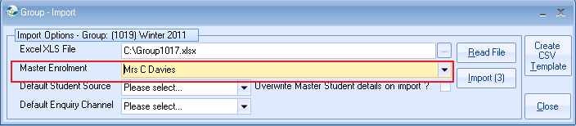
Select Import.

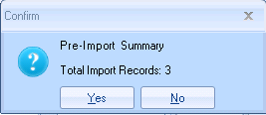

Select Yes to the number of records you are importing.

An Import Summary will advise the results of the Import
Then back in the group all the imported students will be listed.

NOTE:

When the group Import button is selected it checks to see if there are any matching students in the database.
The search will check to see if there are similar matches on the Forename, Surname, SexId, DOB and Country Code.
If a match is found then that student name and DOB will be added to a message. This message be displayed after the code has gone through all the rows for the imports. The user then can choose yes or no to continue with the import.

