Class – Help Document

Adding School Logo to Desktop

Solution
To add the school logo do it is displayed on each of the screens carry out the following.

- Go into System Settings

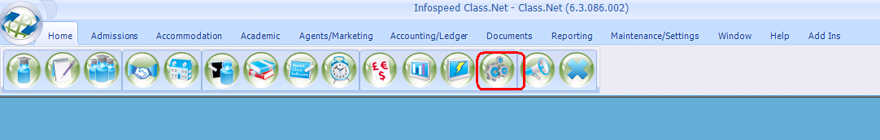

- Select Company
- Select Company

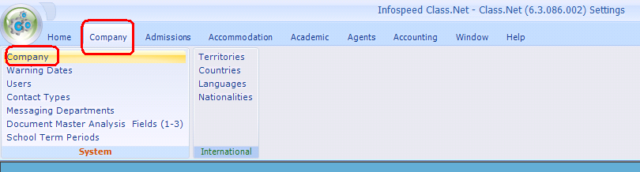

- Select the File Paths/SMS Texts tab

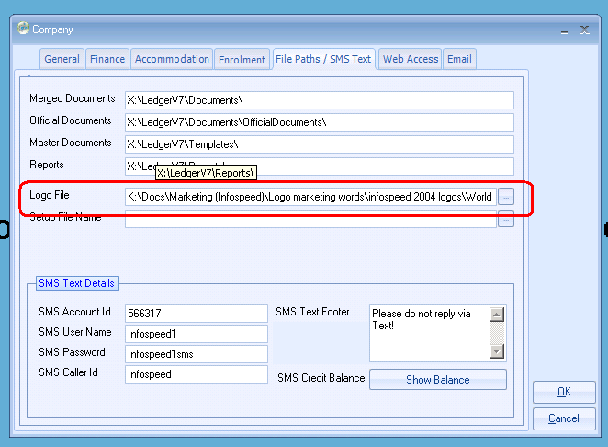

- Select the icon in the top left-hand corner
- Select View
- Ensure there is a tick alongside Company Logo

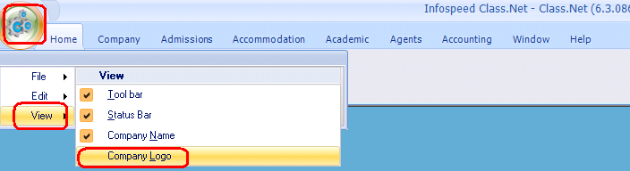

You will need to log out and back into Class for this to be displayed.

