Class – Help Document


How to choose date formats in document templates

You can choose any variety of date formats to insert into your document templates, depending on your preferences.

Below is your template with the Word Edit box to its left:

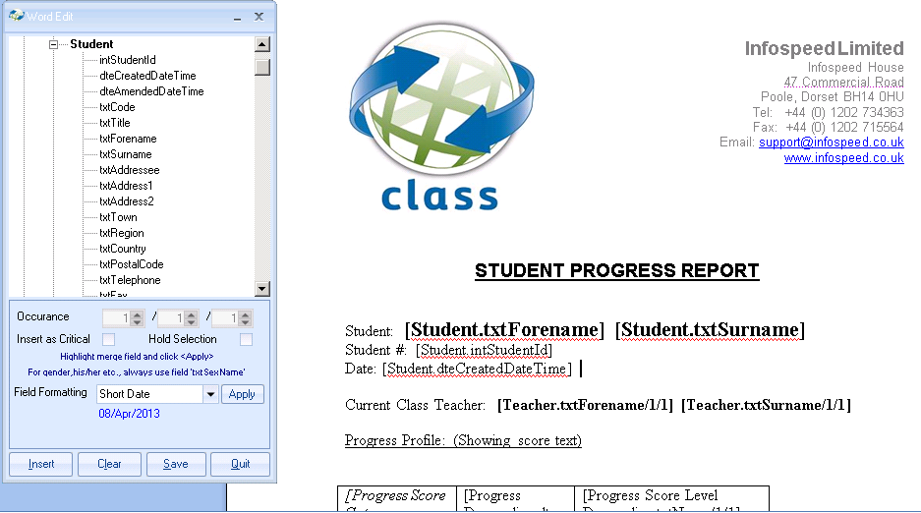

If you would like to change the date format of the below field, then highlight it …

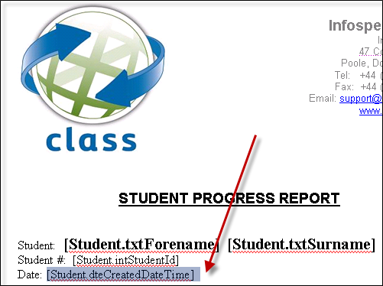

…and then click on Field Formatting in the Word Edit box:

From here, you can choose the following date fields:

“Short date” – 08/Apr/2013
“Medium date” – 08-Apr-13
“Long date” – 08 April 2013
“General date” – 08/Apr/2013 14:13:15
“dd-MM-yy” – 08-04-13
“dd-MMM-yyyy” – 08-Apr-2013
“dd-MMMM-yyyy” – 08 April 2013
“dd-MMM-yyyy HH:mm” – 08-Apr-2013 14:15

Once you have clicked on “Apply” in the Word Edit box (in this case “Long Date”), your document template addition will look like this:
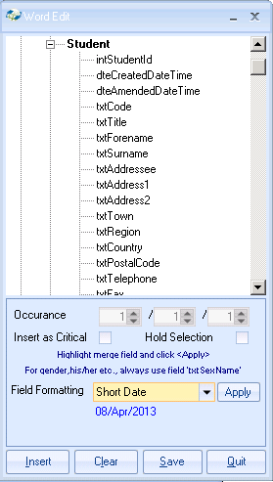
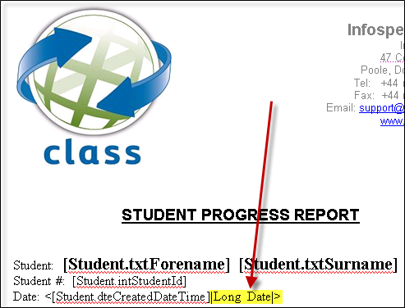

When you come to produce your document, the appropriate format you have chosen will then be applied.

