Class – Help Document

Price Items - Cost Values

Costs values can be added to each Price Item and then also reported on.

To set them up go into a Price Item

Cost Value – input the cost value
Cost Fixed – if the cost is fixed irrespective of how long the student is with you then tick this box.

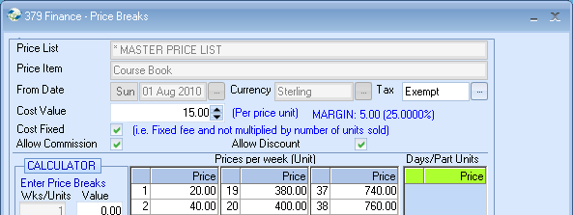

When items are booked, checks are made to see if the item is being sold below the cost value.
Any commission that has been awarded is taken off the due value and this is then checked against the calculated costs.
If it is found to be below the costs price, then the due value will be highlighted in red in the enrolment or group finance details…

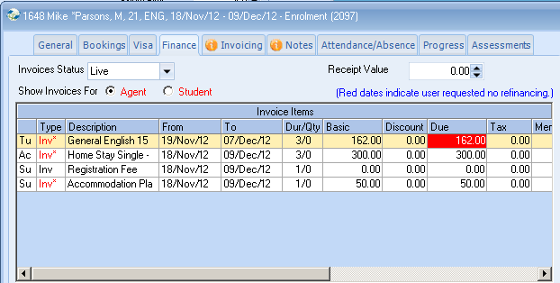

NOTE: The invoice line cost value can only be changed and authorised if a user has the ‘Enrolment Invoice Line Cost Edit’ or ‘Group Invoice Line Cost Edit’ permissions. To authorise cost values, a user has to edit the invoice line and select the ‘Authorise’ button.

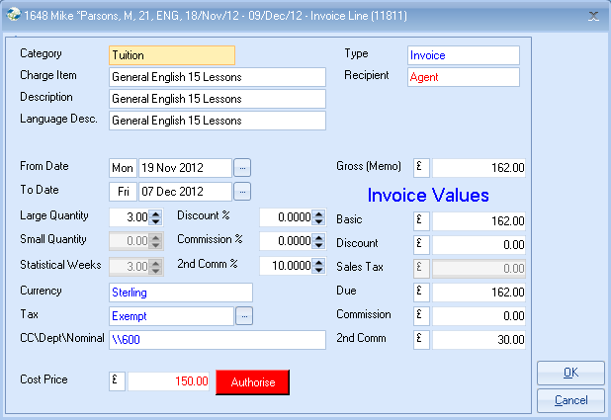

Once selected, you will be prompted to enter a reason for why the item is being undersold.

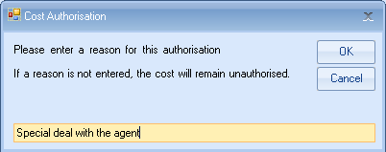

An audit log entry will then be added to the enrolment history showing who authorised the cost and when…

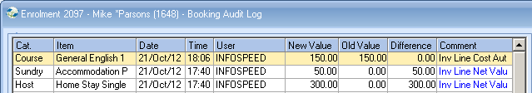

If costs are left unauthorised and an attempt is made to produce a proforma or invoice, you will receive the following warning.

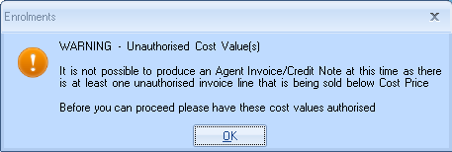

The batch invoicing function will list invoices that are awaiting authorisation. The unprinted invoices report has an option allowing all invoices that contain unauthorised costs to be listed.

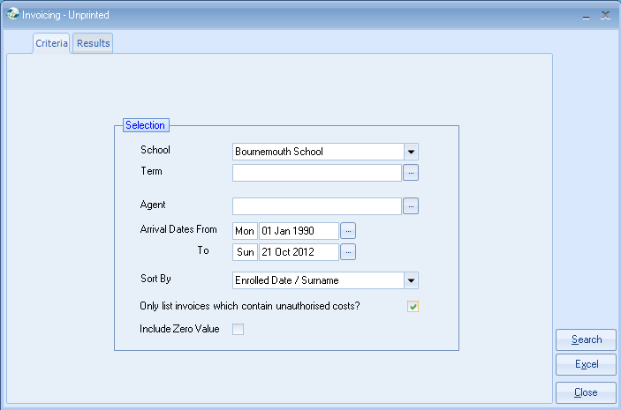

From the results, you can then simply double click on an item to edit the enrolment and authorise it.

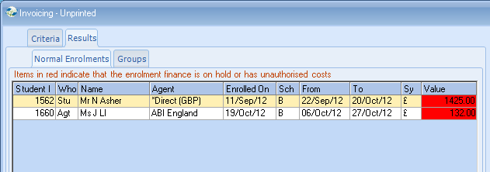

Reporting

The invoicing statistics function has also been updated to allow costs price and margin analysis.

