Class.Net – Help Document

Agent – Discount and Commission

This document explains the difference between agents discount and agents commission (as far as Class is concerned).

Although some schools use the words “discount” and “commission” in different ways, here is a brief explanation of the way in which Class interprets these terms.

DISCOUNT

This is when the agent is invoiced ‘net’ of their discount and they pay the ‘net’ value keeping the discount for themselves.

The majority of agents are set as ‘net’.
Gross Agent (Reserve Commission): this box is unticked for net agents –

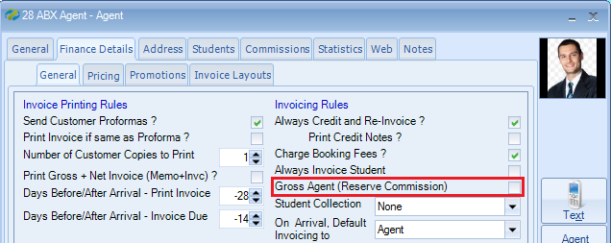

Within the agents Pricing screen the Disc % will be deducted from the gross values to calculate the ‘net’.

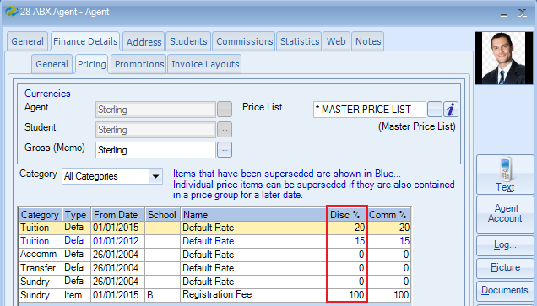

The student will be assigned to the Main Agent:
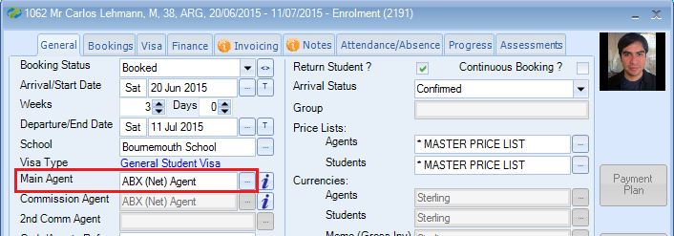

Example invoice fields:

The discount value can be shown on the agent invoice together with the gross and net values.
Total Value = Net

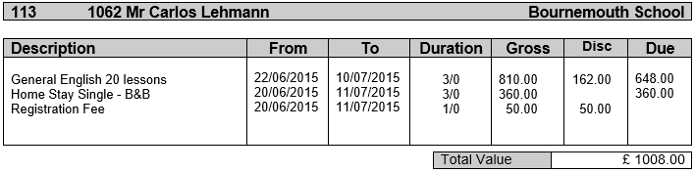

COMMISSION

This is when the agent is invoiced ‘gross’ and pays the ‘gross’ value.
The commission is reserved for payment at a later date.

Gross Agent (Reserve Commission): this box is ticked for gross agents –

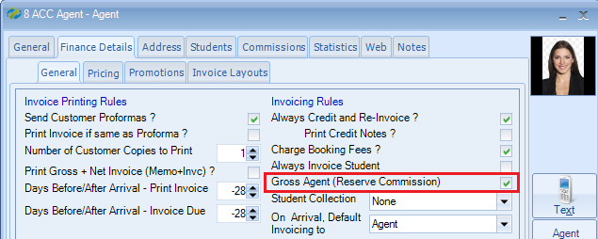

Within the agents Pricing screen the Comm % will be calculated and set aside to be released at a later date. The invoice will show the gross value.

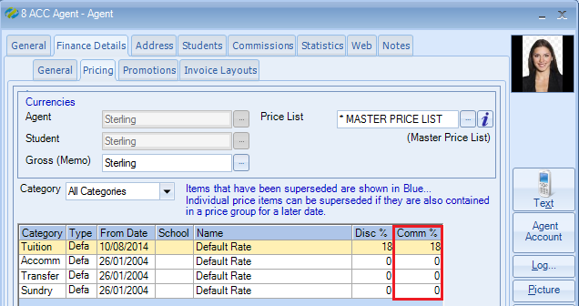

Please note: When setting up a commission agent with the Comm % you must also enter the value within the Disc % column as shown above. i.e. 18%.

The student will be assigned to the Main Agent:

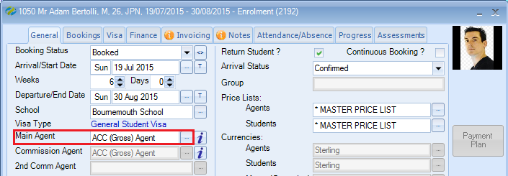

Example invoice fields:

- The commission value can be shown on the agent invoice together with the gross value.
Total Value = Gross

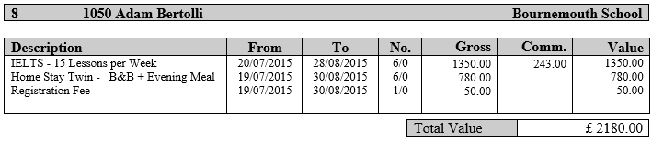

- Often just the Gross value is displayed.

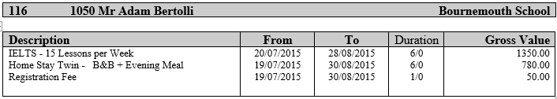

Agent record:
When the final invoice has been produced the commission value is displayed with the status ‘Hold’. This can be released for payment at a later date.
Please refer to help document HS039 for paying the agents commission.

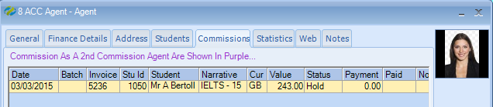

COMMISSION

Other examples for the use of Commission:

1) A student books direct but is recommended to your school via one of your agents. The student will be invoiced ‘gross’ and will pay the ‘gross’ value, but you want to give the agent some commission for recommending the student to your school.

2) A student is booked via an agent and completes their study.
The student then decides to extend their stay and will pay the fees themselves.
A new enrolment is added so the student can pay. As the agent introduced the student to the school you can set the agent to receive commission.

For both of the options above the enrolment will be set as follows:

Main Agent = direct booking agent (student receives invoice)
Commission Agent = recommended agent (commission added to agents record)

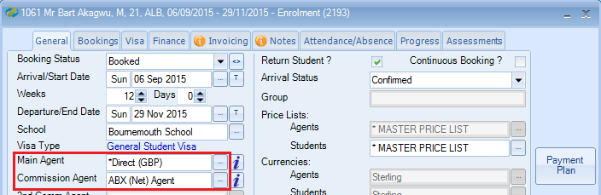

2nd Commission Agent

The 2nd commission agent is mainly used for Embassy bookings where the student is coming via an Embassy but an agent also needs to receive a commission.

- The Embassy will be the Main Agent as they will be responsible for the invoice.
- The agency will be set as the 2nd Commission agent.

In the example below the student is booked via the Saudi Arabian Embassy, they will be responsible for the payment.

ABQ agent is the 2nd commission agent and a commission percentage will be put aside for payment at a later date.

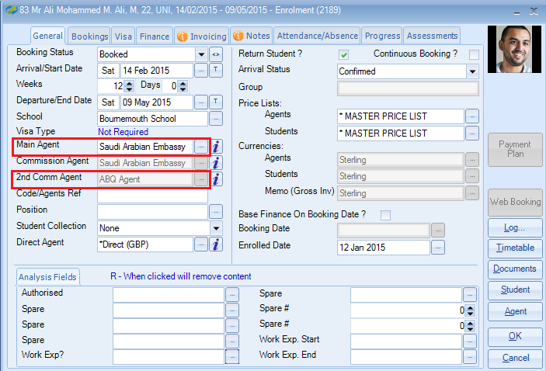

The finance will show the 2nd agents commission value.

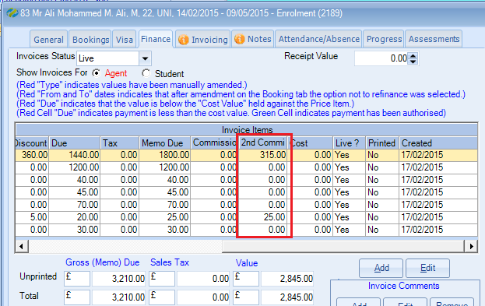

When the Final invoice has been produced the commission will appear in the agents commission screen.

Commission as a 2nd Commission Agent will show in purple…

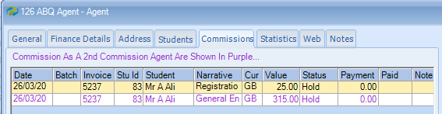

Please refer to help document HS039 for paying the agents commission.

