Class.Net – Help Document

Documents – Student Leaving Certificates

This document explains how to produce student leaving certificates as a batch.

There are two stages to this process:
- Create a document template
- Create a quick report to find the leavers in order to merge the documents

- CREATE A MASTER DOCUMENT
Go to: Documents / Enrolment
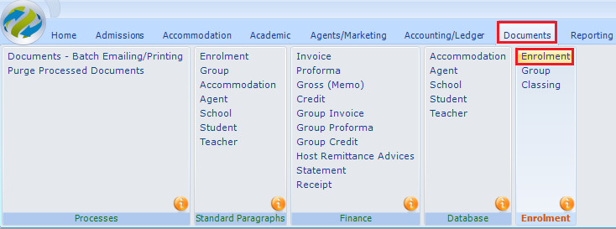

A list of your existing master documents will be displayed.
Select ADD to create a new document

Input the document details:
Send To: ensure this is set to Student if the document is to be emailed to the students email address.
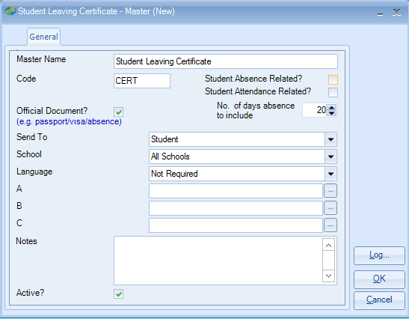

A new blank document will be displayed on screen together with a “Word Edit” box.
To add merge fields to the Certificate click to the left of the required category to open up the available fields.

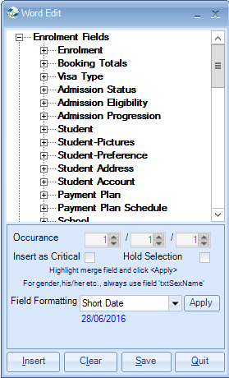

To add the student name click to the left of ‘Student’ and double click on the relevant field to insert the code into the document, e.g. txtForename txtSurname.

Alternately, highlight the required field(s) and select ‘Insert’

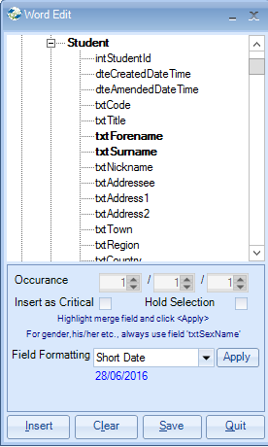

Below is an example of a master certificate document with text and merge fields:
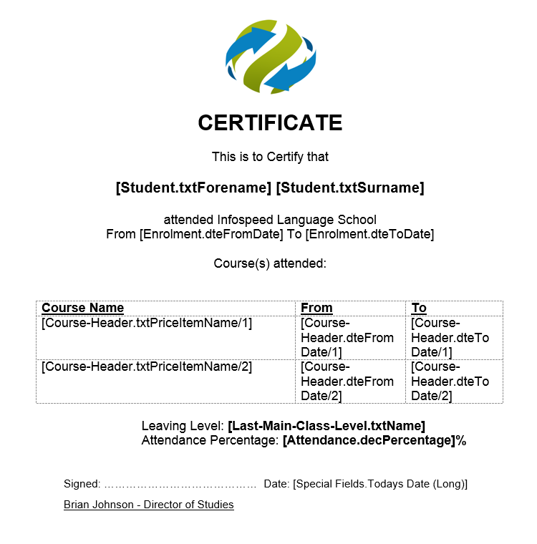

Once the text and merge fields have been added to the document it must be saved.
It is important to save the document by selecting “SAVE” within the “Word Edit” box.

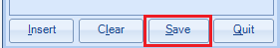

- CREATE A QUICK REPORT
Go to: Reporting / Quick Reports
Report Type = Enrolment – General

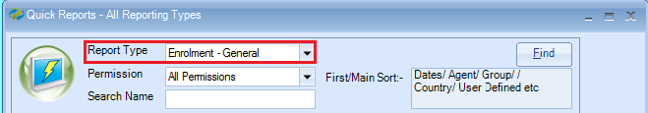

Select ADD to create a new report.

Name: Enter the report name
School: If you have multiple schools select the required school
Date Filter: set to “Finishing” to capture the leavers
Dates: Ensure you include the Saturday & Sunday dates as this report type is based on the student’s departure date, not the course end date. It is a good rule to select Wednesday to Wednesday dates as this will capture late departures.

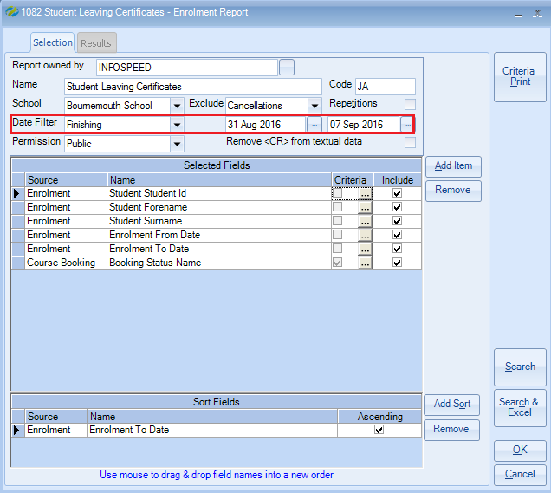

To add the fields to the report click on the “Add Item” button

Within the “Add Field” box click to the left of the required category to open up the available fields.

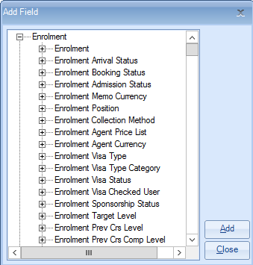
To add the student name click to the left of ‘Student’ and double click on the relevant field to insert the code into the report, e.g. txtForename txtSurname.

Alternately, highlight the required field(s) and select ‘Add’

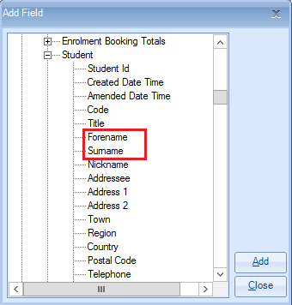

If you wish to include the students course name(s) on the certificate you will need to add the course status name to the report and set criteria to ensure only the students ‘active’ courses are shown.

The field is found under: Course Booking > Booking Status - Name
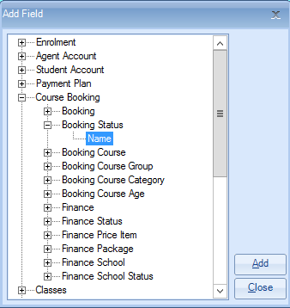

Within the report the field will look like this.
To add the criteria click on the criteria box as shown below:

Highlight “Active”
Select “Set>>>”
Selected Criteria = Equal To ‘Active’
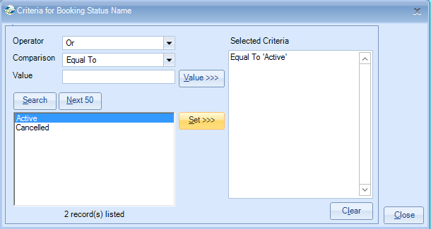

Select Close

At least one sort field must be added to the report:

When the report selection and criteria is completed select SEARCH.

This will display a list of departing students based on the date selection.

Merging the certificate document:

Select “Send Document“
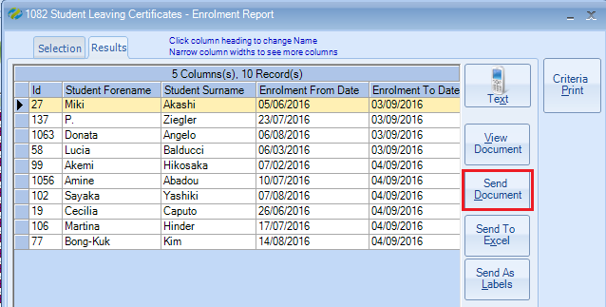

Master Document: select the master certificate document
Send By: if you wish to print all of the certificates set to Printer
Send To All: tick this to print certificates for all selected students
Send Now: the documents will be produced now

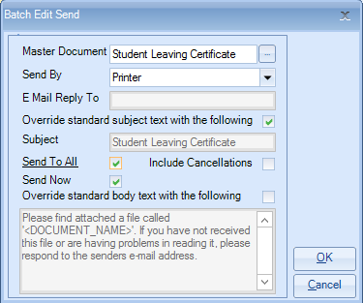

Select OK to print the certificates as a batch.

NOTE:
Send By: ‘Default’ will process by ‘email’ or ‘printer’ depending on the students setttings

