Class.Net – Help Document

Student Enquiry Labels / Follow up

How to produce labels for Student enquiries?

This can be achieved by using the Quick Reports.

The example below explains how to produce mailing labels for student enquiries who require a follow up.

From the main menu select: Reporting / Quick Reports
Alternatively, use the shortcut picture

Report Type – select Student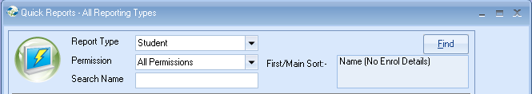

Click ADD to create a new report.

Report owned by: this will show your Class login and is linked to the Permission
Name: Give your report a name
Code: a suggestion is to enter your initials
Date Filter – this is not applicable for ‘Student’ type reports.
Permission:
Public – other users can amend the criteria and run this report.
Public Read Only – other users can run this report but not amend the criteria.
Private – only the ‘owner’ can amend and run the report.

Adding the Required Fields to the Report:

Select Add Item

Open Student / Student
Highlight the fields to be included in the labels….

Example:
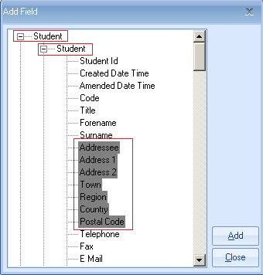

Scroll down and also add the field ‘Follow Up’

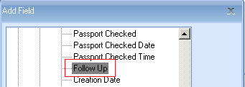

Select ADD to place the field in to the report.
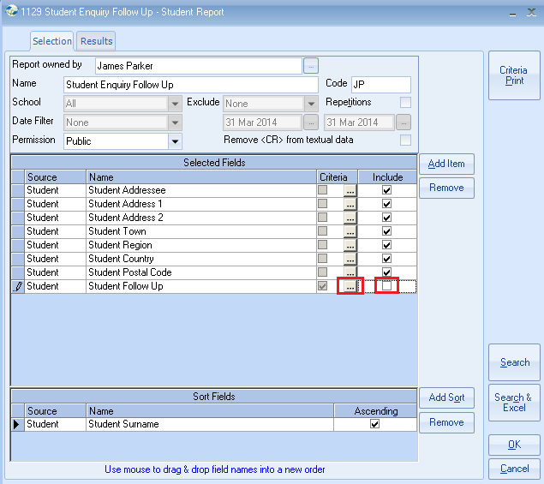

Untick the include box so the field does not print on the labels

Criteria:
Select the box for the field that you want to choose the criteria for

Either highlight each of the dates you wish to follow up on
Select SET
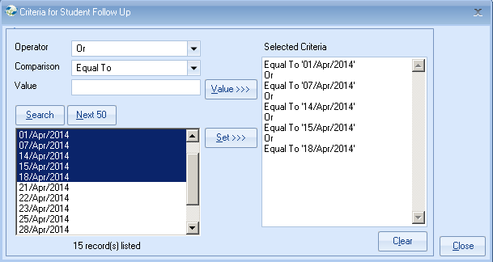

OR use the comparison ‘Greater or Equal’ and ‘Less Or Equal’

Examples:
“Greater Or Equal”
Select first required date from the list
Select Set
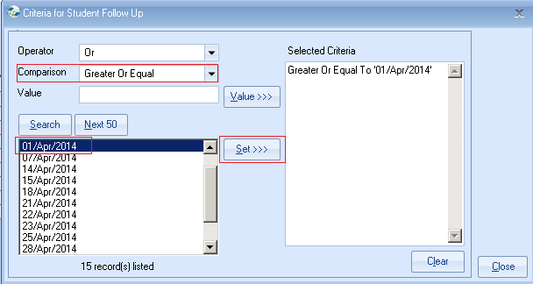
Operator = AND
Operator - Less Or Equal
Select last required date from the list
Select Set
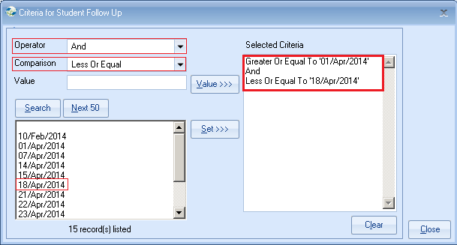

Close

Adding Sort Fields:

The report must contain at least one sort field.
Select Add Sort -

Open Student / Student
Highlight ‘Surname’
Select Add

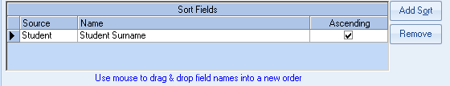
Close

Once happy with your selection select Search
This will display the list of students that match your selection criteria.

The number of records found is listed at the top of the screen.

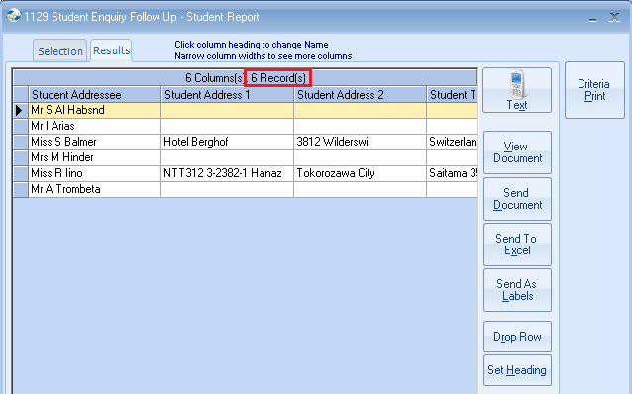

What can I do now I have the list of students?

Option 1) Produce Labels
Select Send As Labels

Label Format Choose your required label size from the list given.

If your label size is not listed, select User Defined and type the code in the Label Code field.

New Line After - untick any items that your wish to appear on the same line.
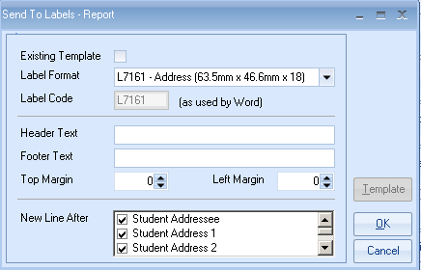
Select OK

Please read the following message which explains about using <Alt><Tab> if the screen appears to freeze.
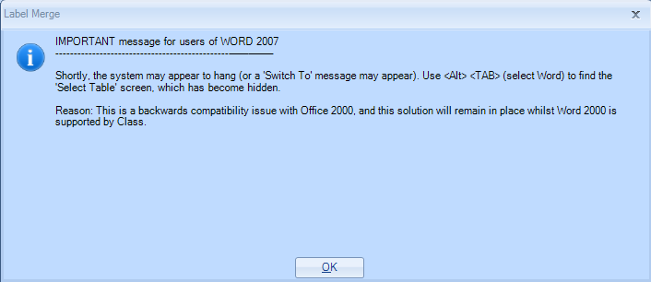
Select OK.

(This is the message that can be hidden and <Alt><Tab> is required to display it)

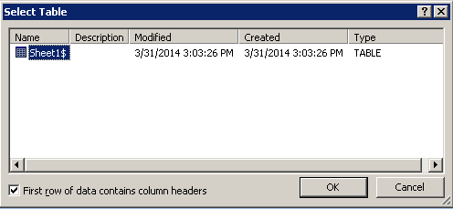
Select OK

This will go through a process of creating an Excel Spreadsheet listing the selected records and then create a Word label document with the merged names and addresses ready for printing.

Example merged labels
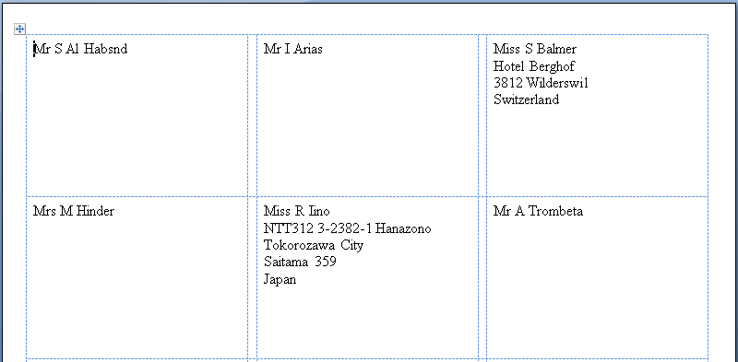

This document can be saved for future use.

Alternatively close both the Word document and Excel sheet.

TIPS:
Within a ‘Student’ quick report you can also use the criteria to be selective by a number of other fields. Some examples are:
Enquiry Source, Enquiry, Channel, Analysis Fields.

Option 2) Produce an Excel report

Select ‘Search & Excel’ to produce the report
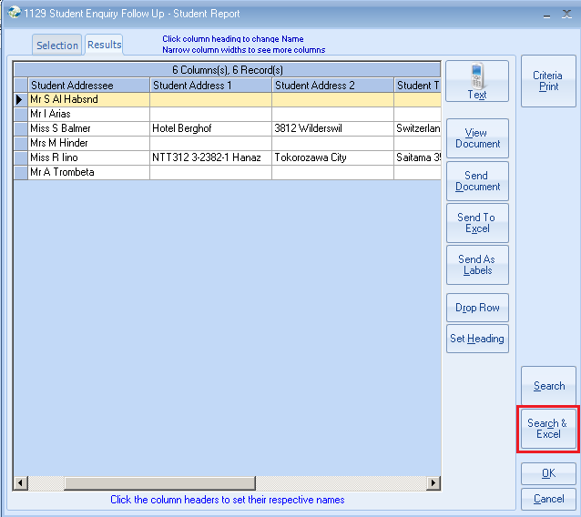

Option 3) Produce letters

Select ‘Send Document’
Master Document – select document name from the list
Send To All
Send Now
