Class.Net – Help Document

Clearing logged in Users and locked records
Occasionally within Class, users or records (tables) can become locked.

This document explains how to clear logged in users and also how to purge files that have become locked.

Clear logged in users

Occasionally a user who is not logged in to Class still shows as logged in.
This can happen for a number of reasons including being logged out of Class due to the PC/Class freezing.

In this instance you might see a message similar to “in use by ‘user name’”

Example:
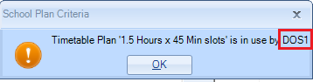

Firstly ensure the user in question is logged out of Class and that no other user has logged in with this users name.

An administrator of Class will need to perform the following process.

Click on the Class icon at the top left hand side of the screen.
Select File > Users Logged In.

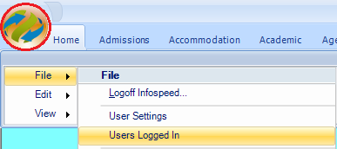
This will display a list of logged in users.

Highlight the user to be cleared.
Select ‘Clear’

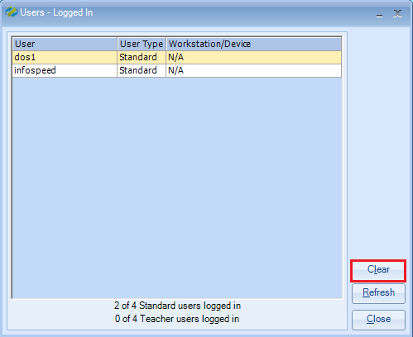

You will see a warning message of which you can select Yes / No.

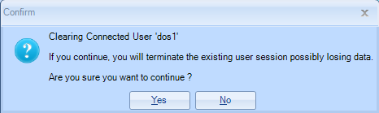

The user can now log back in to Class and try to continue working.

Clear locked files (tables)

If once the user has been cleared the same in use message is displayed then you will need to purge the locked file.

Again, an administrator of Class will need to perform this process.

Click on the Class icon at the top left hand side of the screen.
Select File > Locking (View/Purge)

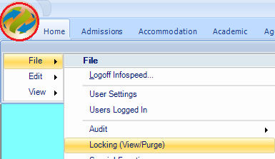

If the list shows various lines of information with multiple user names, use the User dropdown to search for the user in question.

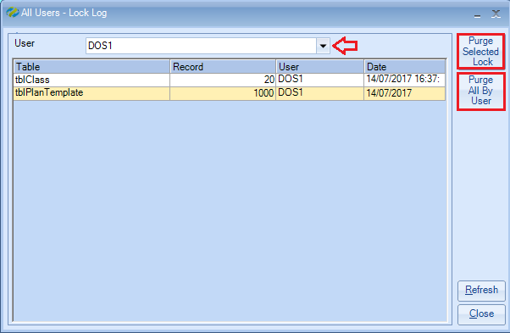

Select Purge All By User to clear the locked file(s) for this user.

You will be asked if you are sure - select Yes / No.

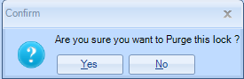

You will also notice the option: Purge Selected Lock.
You would use this option if a user has a specific file locked and no other users can access the file, i.e. a teachers record.

Once the file has been purged the user can log back in to Class and continue working.

If once the above process has carried out the user/file is still locked, please contact the support desk at support@infospeed.co.uk for further assistance.

