

Class.Net – Help Document

Accommodation – Daily Booking Chart

How do I get a list of host families showing all of their beds together with beds occupied/vacant?

The following selection will give a list of families showing each room with the number of beds in use and available day by day for a given period.

This can be achieved by running the Accommodation - Booking Chart - Daily…

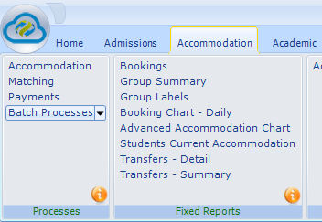

Note:
If the Advanced Accommodation Chart option is greyed out this is because it is an additional Module that has not been purchased.
Please contact Infospeed for further information and costs.

The selection screen allows a wide range of options.

Explanation of the various fields in the Daily Bookings Chart and the report it produces

Type e.g. Host Family, Residence, Hotel
Interval – the number of weeks between the “From” and the “To” dates.
Room Types e.g. single, twin, multi-bedded, ensuite.
Hide Columns – instead of the report being displayed with a column per day by removing ticks can be reduced.
Preferences e.g. Cats-No, Smoking-No

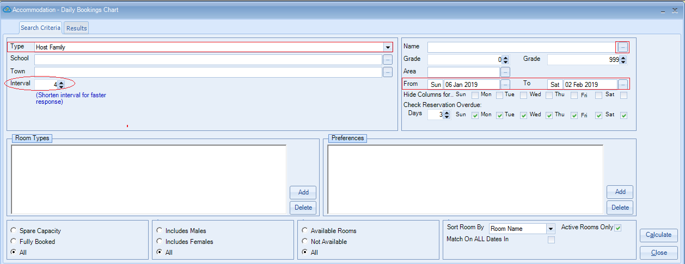

Selection options at bottom of screen

Spare capacity
Will list all families but when you highlight them only rooms with spare capacity are displayed.

Fully Booked
Will list all families but when you highlight them only rooms that are fully booked are displayed.

Include Males/Females
Will list all families but when you highlight them only rooms that have males/females in them will be displayed.

Available Rooms
Will list all families but when you highlight them only rooms that are “available” are listed e.g.. not flagged as being on holiday.

Not Available
Will list all families but when you highlight them only rooms that are “unavailable” are listed i.e. family on holiday.

Sort Rooms by Capacity
Within each family the rooms are listed in order of capacity

Match on All Dates in Range
Will list all families but when you highlight them only rooms that meet the selection for the whole date range will be listed.

Once you have made your selection click on Calculate (bottom right of screen)

RESULTS:

As you highlight each family their bookings/availability are displayed
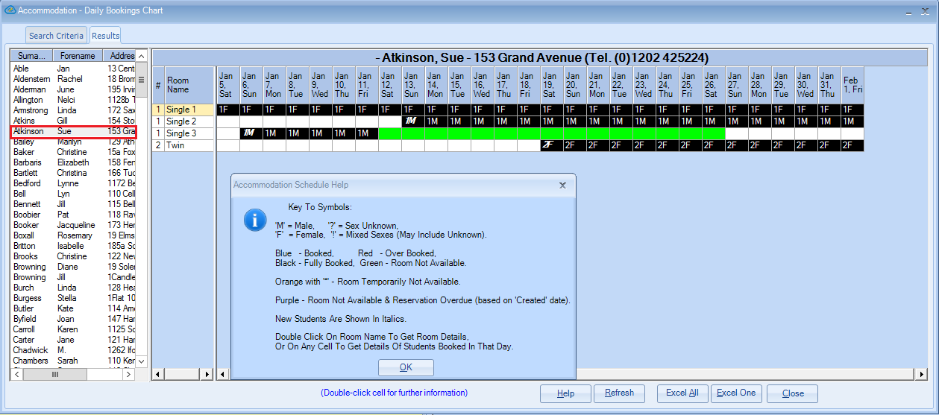

The ‘Help’ screen is displayed by clicking on the Help button at the bottom of the schedule.

Refresh – will update the “Result” screen taken into account any changes to Host Families or Enrolments since it was last displayed.

What is this report helpful for?

This report is used to provide at a glance details of when rooms are occupied, at a specific accommodation.
This enables schools to maximise the booking efficiency of accommodation facilities, particularly to those with a large number of rooms, such as residence buildings.

It can also highlight the following booking errors:

- Rooms overbooked (although the system warns when making the booking).

- Booking students into a room that is “Not Available” (e.g. it is being redecorated).

- Booking students of mixed sexes in to the same room.

- Lastly, it can provide some basic details of the students currently booked into a room.
This can be useful in deciding in which room to place a new student, so that they can be
matched.

