# 

# Class.Net – Help Document

**Date & Time formatting in Class.**

**Changing an American date format.**

**This document explains how to amend the date and time settings on your PC to work with Class**

**Class uses the settings from your PC.**

**If your settings are not in the format required for Class you could receive an error message.**

**A common Class error relating to the date format is:**

Error Number: 13   
Description: String was not recognized as a valid DateTime.

This document also shows how to change your date settings from American format and also how to set the time as the 24 hour clock.

**Changing the settings:**

Open the ‘**Control Panel**’

You can do this by holding the Windows key + the letter R on your keyboard, as shown below:

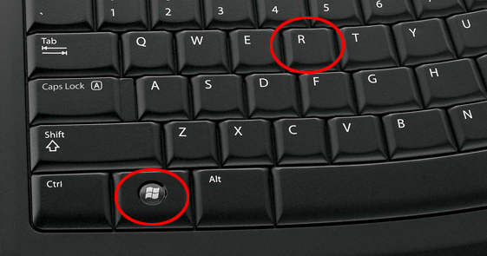

Now type: **control panel**

Select **OK**

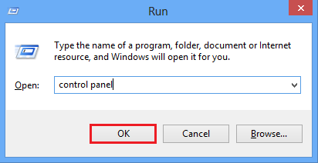

From within the **Control Panel** select **Clock, Language and Region**

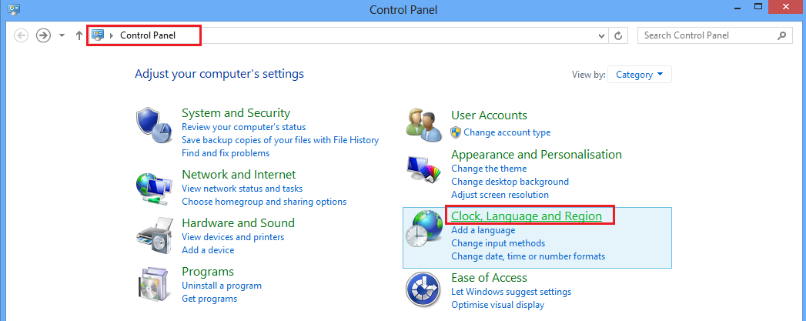

Select **Region**

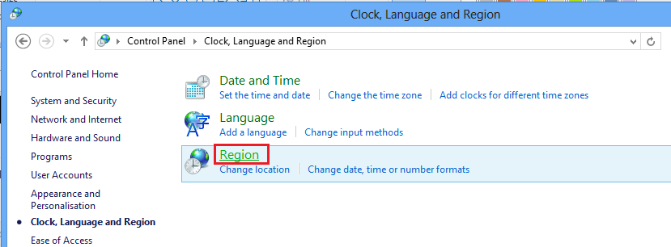

**Format** – ensure this is set to: English (United Kingdom)

**Date and time formats** - The correct settings are as below-   
 Short date: dd/MM/yyyy

Long date: dd MMM yyyy

Short time: HH:mm

Long time: HH:mm:ss

To change these settings select **Additional Settings**

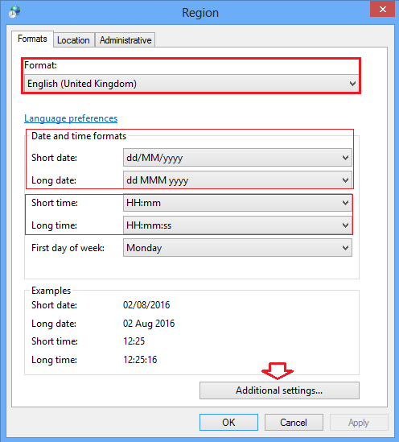

**Numbers:**

**Decimal symbol** -Thismust be a full stop.

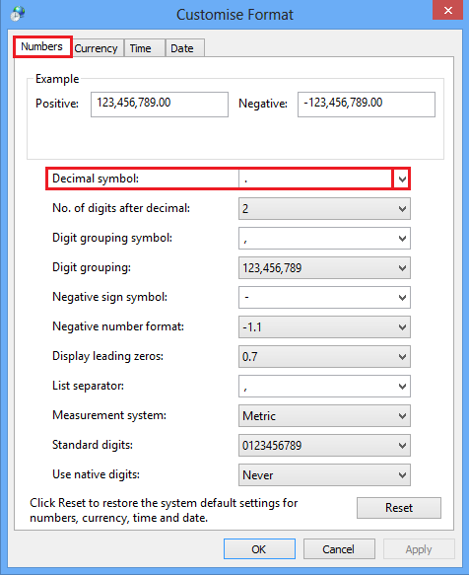

**Date**:

**Date Formats -**

Ensure the details are displayed similar to the details below.

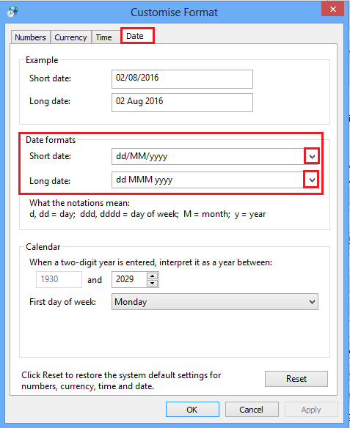

**Time:**

**Time formats** -

‘hh’ = 12 hour clock

‘HH’ = 24 hour clock

If your time format includes ‘tt’ you must remove this as Class doesn’t work with this format.

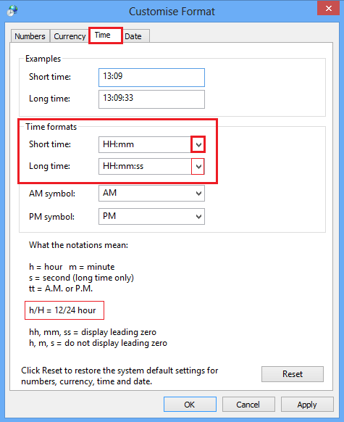

Once you are happy with all of the setting select **APPLY**

Select **OK**

Log out of Class and back in and check the dates.

If you cannot find the screens above or have any further problems, please can you let me know what version of windows you are running and I will be able to assist further.