Class.Net – Help Document

Quick Reports – Agent List

How to produce a list of Agents?

This can be achieved by using the Quick Reports.

The example below explains how to produce a list of all active agents.
It also shows how the criteria can be used to give a further breakdown.

From the main menu select: Reporting / Quick Reports
Alternatively, use the shortcut picture

Report Type – select “Agent”

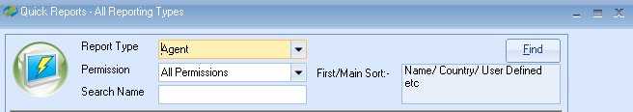

Click ADD to create a new report.

Report owned by – this will show your Class login and is linked to the Permission.
Permission:
- Public – other users can amend the criteria and run this report.
- Public Read Only – other users can run this report but not amend the criteria.
- Private – only the ‘owner’ can amend and run the report.

Name: Give your report a name
Code: a suggestion is to enter your initials

Date Filter – this is not applicable for ‘Agent’ type reports.

Now you can add the required fields to the report

Select Add Item

Open Agent / Agent
You may want to add the Agent Name, Country, email address and mobile number for example.

Example:

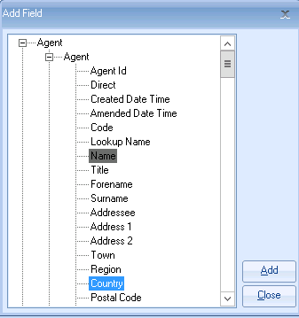

Select ADD to place the fields in to the report.
Select Close

The report must contain at least one sort field
Select Add Sort -
Open Agent / Agent
Highlight ‘Name’
Select Add
Select Close

Example of report:

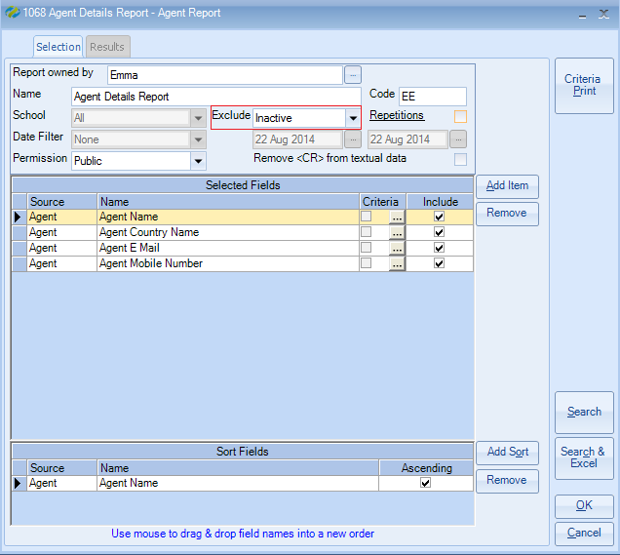

Exclude: ‘Inactive’
Within an agent record there are up to four available status options:
Active, Prospective, Inactive, Suspended

If your report is set to ‘exclude inactive’ it will include only agent records that are active, prospective and suspended.
Therefore, if you wish to report on only ‘active’ agents and/or ‘prospective’ agents you must add an additional field to the report with criteria as follows:

Select Add Item

Open Agent / Agent Status
Highlight ‘Name’

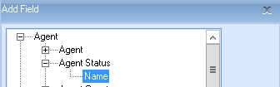

Select ADD to place the field in to the report.
Close

Untick the Include box so that the status does not appear in the results.

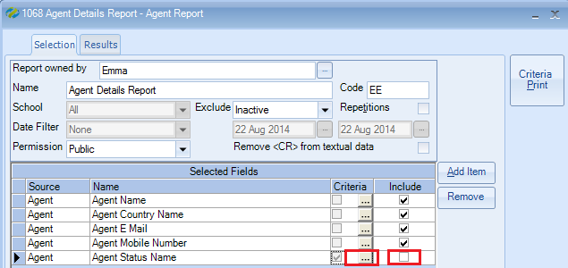

To add the criteria, select the box with three dots.

Criteria:

For Active agents only, highlight Active
Select Set
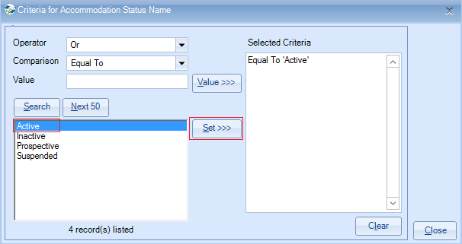
Select Close

Alternatively for both Active and Prospective agents, highlight both items
Select Set

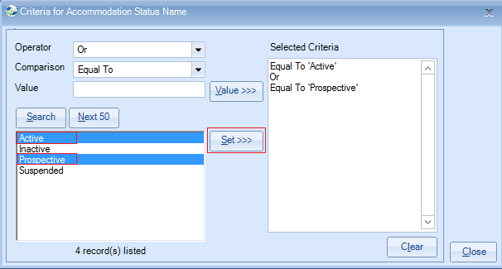
Select Close

Once happy with your selection select Search.

This will display the list of agents that match your selection criteria.
The number of records found is listed at the top of the screen.

Select Search & Excel to produce the list in an Excel Spreadsheet

TIPS:
Within an ‘Agent’ quick report you can also use the criteria to be selective by a number of other fields. Some examples are:
Country, Analysis Fields, Visited, Reviewed.

